

Requirement & Design Specification

MIDORI JAPANESE LEARNING SYSTEM (MJLS)

Version: 1.0

– Da Nang, July 2026 –

Record of Changes

Version | Date | A*  M, D | In charge | Change Description
V1.0 | 15/2 | A | KienNTHE11
*A - Added M - Modified D - Deleted

Contents
Record of Changes 2
I. Overview 6
1. User Requirements 6
1.1 Actors 6
1.2 Use Cases 6
2. Overall Functionalities 13
2.1 Screens Flow 13
2.2 Screen Descriptions 15
2.3 Screen Authorization 21
2.4 Non-UI Functions 25
3. System High Level Design 26
3.1 Database Design 26
3.2 Code Packages 29
II. Requirement Specifications 30
1. Authentication 30
1.1 UC-01_Register 30
1.2 UC-02_Login 31
1.3 UC-03_Logout 32
1.4 UC-04_View profile 33
1.5 UC-05_Edit profile 34
1.6 UC-06_Change password 34
1.7 UC-07_Forgot password 35
1.8 UC-08_View HomePage 36
2. Admin 37
2.1 UC-09_Approve/Reject Exams 37
2.2 UC-10_Approve/Reject Flashcard 38
2.3 UC-11_ Approve/Reject Grammar 40
2.4 UC-12_Unlock/Lock User Account 41
2.5 UC-13_Approve/Reject Teacher Account 42
2.6 UC-14_View User Analytics 43
3. Teacher 44
3.1 UC-15_Add Vocabulary 44
3.2 UC-16_Edit Vocabulary 45
3.3 UC-17_Delete Vocabulary 46
3.4 UC-18_Add Grammar Lessons 47
3.5 UC-19_Edit Grammar Lessons 48
3.6 UC-20_Delete Grammar Lessons 50
3.7 UC-21_Add Listening Lessons 51
3.8 UC-22_Edit Listening Lessons 52
3.9 UC-23_Delete Listening Lessons 53
3.10 UC-24_Create Exams 54
3.11 UC-25_Edit Exams 55
3.12 UC-26_Delete Exams 56
3.13 UC-27_Add Shadowing Lessons 58
3.14 UC-28_Edit Shadowing Lessons 59
3.15 UC-29_Delete Shadowing Lessons 60
3.16 UC-30_Add Flashcard 61
3.17 UC-31_Delete Flashcard 61
3.18 UC-32_Edit Flashcard 61
4. Student 61
4.1 UC-30_Learn Vocabulary 61
4.2 UC-31_Learn Grammar 63
4.3 UC-32_Practice Shadowing 64
4.4 UC-33_Practice Flashcard 65
4.5 UC-34_Practice Dictation 66
4.6 UC-35_Practice Exam 67
4.7 UC-36_View Learning Progress 69
4.8 UC-37_AI Sensei 70
4.9 UC-38_View Rankings 71
III. Design Specifications 72
1. Authentication 72
1.1 Register 72
1.2 Login 75
1.3 Logout 76
1.4 View Profile 78
1.5 Edit Profile 80
1.6 Change password 82
1.7 Forgot Password 83
1.8 Forgot Password 86
2. Admin 89
2.1 Approve/Reject Exams 89
2.2 Approve/Reject Flashcard 90
2.3 Approve/Reject Grammar 92
2.4 Unlock/Lock User Account 95
2.5 Approve/Reject Teacher Account 97
2.6 View User Analytics 98
3. Teacher 100
3.1 Add Vocabulary 100
3.2 Edit Vocabulary 103
3.3 Delete Vocabulary 107
3.4 Add Grammar Lessons 109
3.5 Edit Grammar Lessons 111
3.6 Delete Grammar Lessons 114
3.7 Add Listening Lessons 116
3.8 Edit Listening Lessons 119
3.9 Delete Listening Lessons 121
3.10 Create Exams 123
3.11 Edit Exams 126
3.12 Delete Exams 128
3.13 Add Shadowing Lessons 130
3.14 Edit Shadowing Lessons 132
3.15 Delete Shadowing Lessons 135
3.16 Add Flashcard 137
3.17 Edit Flashcard 140
3.18 Delete Flashcard 144
4. Student 146
4.1 Learn Vocabulary 146
4.2 Learn Grammar 150
4.3 Practice Shadowing 153
4.4 Practice Flashcard 157
4.5 Practice Dictation 162
4.6 Practice Exam 165
4.7 View Learning Progress 168
4.8 AI Sensei 170
4.9 View Rankings 173
IV. Appendix 176
1. Assumptions & Dependencies 176
2. Limitations & Exclusions 176
3. Business Rules 177
4. Application Messages List 181

I. Overview

1. User Requirements

1.1 Actors
# | Actor | Description
1 | Admin | The Admin manages, monitors, and maintains the MIDORI system. Responsibilities include managing users, approving teachers, monitoring system performance, sending notifications, configuring settings, and ensuring the platform operates securely and efficiently.
2 | Teacher | The Teacher manages and provides learning content within the MIDORI system. Responsibilities include creating and managing grammar, vocabulary, listening, shadowing, and exam materials, e, and managing personal profiles.
3 | Student | The Student is the main user of the MIDORI system who learns and practices Japanese through vocabulary, grammar, flashcards, listening, AI Shadowing, and online exams. Students can track learning progress, interact with the AI Sensei for support, view leaderboard rankings, and manage personal profiles within the platform.
4 | Guest | A guest is a user visit website without loging in

1.2 Use Cases

a. Diagram(s)

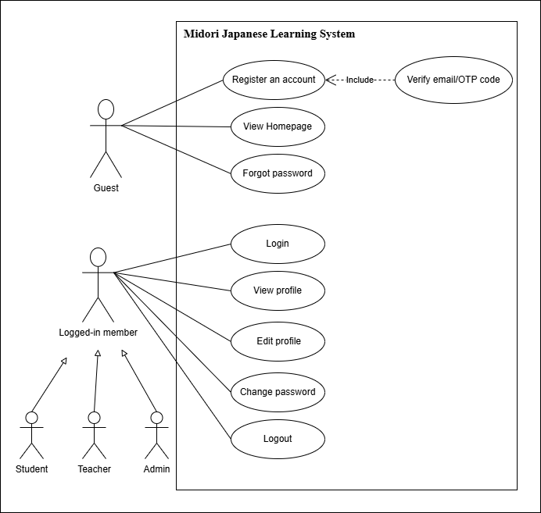
Figure 1. Authentication use case diagram
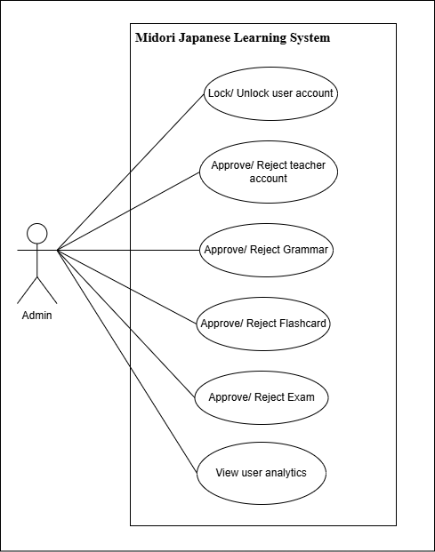
Figure 2. Admin use case diagram

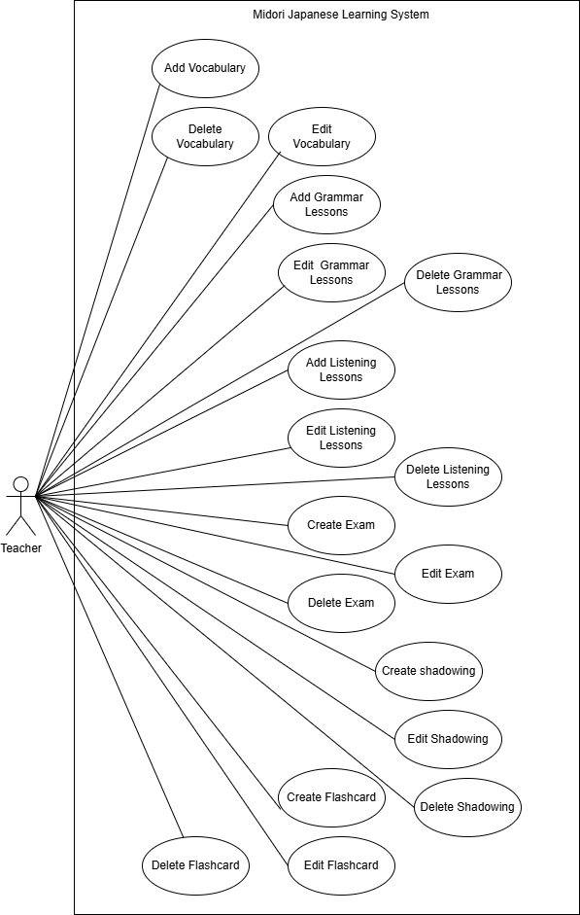
Figure 4. Teacher use case diagram

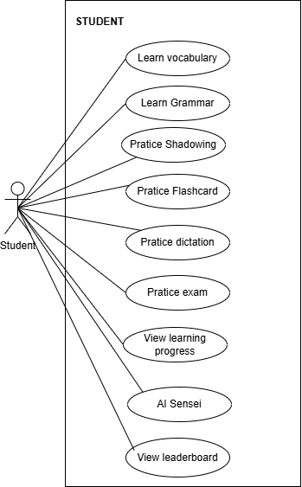
Figure 5. Student use case diagram

b. Descriptions

ID | Feature | Use Case | Use Case Description
UC-01 | Authentication | Register | Register a new account to access the features of the platform. Includes verifying via email/OTP.
UC-02 | Authentication | Login | Users with an account can log into the platform by entering a valid username/email and password, or by authenticating through their Google account.
UC-03 | Authentication | Logout | Log out the Platform
UC-04 | Authentication | View profile | Logged-in members can view their personal profile information.
UC-05 | Authentication | Edit profile | Extends "View Profile". Users can update information like name, date of birth, etc.
UC-06 | Authentication | Change Password | Extends "View Profile". Users can update their security password by providing their old password.
UC-07 | Authentication | Forgot password | Allows users to reset their password via an email OTP verification link if they cannot log in.
UC-08 | Authentication | View HomePage | Allows guests or logged-in users to browse the public landing page.
UC-09 | Content Management | Approve/  Reject Exams | Admin reviews and approves or rejects exam papers created by Teachers before publishing.
UC-10 | Content Management | Approve/  Reject Flashcard | Admin reviews and approves or rejects flashcard sets created by Teachers before publishing.
UC-11 | Content Management | Approve/  Reject Grammar | Admin reviews and approves or rejects grammar created by Teachers before publishing.
UC-12 | User Management | Unlock/Lock User Account | Admin can manually activate or provision a new user account.
UC-13 | User Management | Approve/  Reject Teacher Account | Admin can reject registration applications from individuals applying for a Teacher role.
UC-14 | User Management | View User Analytics | Admin can track, view, and analyze user engagement and system usage statistics
UC-15 | Vocabulary Management | Add Vocabulary | Teachers can add new words, definitions, pronunciation, and examples to the vocabulary pool.
UC-16 | Vocabulary Management | Edit Vocabulary | Teachers can update existing vocabulary details.
UC-17 | Vocabulary Management | Delete Vocabulary | Teachers can remove vocabulary items from the platform.
UC-18 | Grammar Management | Add Grammar Lessons | Teachers can create and publish new grammar lessons.
UC-19 | Grammar Management | Edit Grammar Lessons | Teachers can modify existing grammar lesson contents.
UC-20 | Grammar Management | Delete Grammar Lessons | Teachers can delete outdated or incorrect grammar lessons.
UC-21 | Listening Management | Add Listening Lessons | Teachers can upload audio tracks and create new listening lessons/exercises.
UC-22 | Listening Management | Edit Listening Lessons | Teachers can edit audio files, transcripts, or questions of existing listening lessons.
UC-23 | Listening Management | Delete Listening Lessons | Teachers can remove listening lessons from the system.
UC-24 | Exam Management | Create Exams | Teachers can create and configure new examination papers for students.
UC-25 | Exam Management | Edit Exams | Teachers can modify questions, answers, or settings of existing exams.
UC-26 | Exam Management | Delete Exams | Teachers can remove exam papers from the system.
UC-27 | Shadowing Management | Add Shadowing Lessons | Teachers can upload audio and transcripts to create new shadowing lessons.
UC-28 | Shadowing Management | Edit Shadowing Lessons | Teachers can modify audio files, scripts, or settings of existing shadowing lessons.
UC-29 | Shadowing Management | Delete Shadowing Lessons | Teachers can remove shadowing lessons from the system.
UC-30 | Flashcard Management | Add Flashcard Set | Teachers can create a new flashcard set by entering the required information. The system saves the set and makes it available for learning activities.
UC-31 | Flashcard Management | Edit Flashcard Set | Teachers can modify the information and content of an existing flashcard set. The system saves the changes and updates the set details.
UC-32 | Flashcard Management | Delete Flashcard Set | Teachers can delete a flashcard set that is no longer used. The system removes the set and updates the flashcard set list.
UC-33 | Learning | Learn Vocabulary | Students can browse a list of vocabulary, learn meanings, and practice pronunciation.
UC-34 | Learning | Learn Grammar | Students can read and learn grammar structures through provided lessons.
UC-35 | Learning | Practice Shadowing | Students can practice their speaking and intonation by repeating audio clips (shadowing technique).
UC-36 | Learning | Practice Flashcard | Students can review vocabulary items using automated interactive flashcards.
UC-37 | Learning | Practice Dictation | Students can complete dictation exercises by listening to audio materials and entering the words or sentences they hear.
UC-38 | Learning | Practice Exam | Students can take practice exams and mock tests to assess their current proficiency level.
UC-39 | Progress Tracking | View Learning Progress | Students can review their learning history, completion rates, and test score charts.
UC-40 | AI Feature | AI Sensei | Students can interact with an AI tutor for real-time guidance, corrections, and conversational practice.
UC-41 | Leaderboard | View Rankings | Students can check the platform leaderboard to see how they rank compared to other learners.

2. Overall Functionalities

2.1 Screens Flow
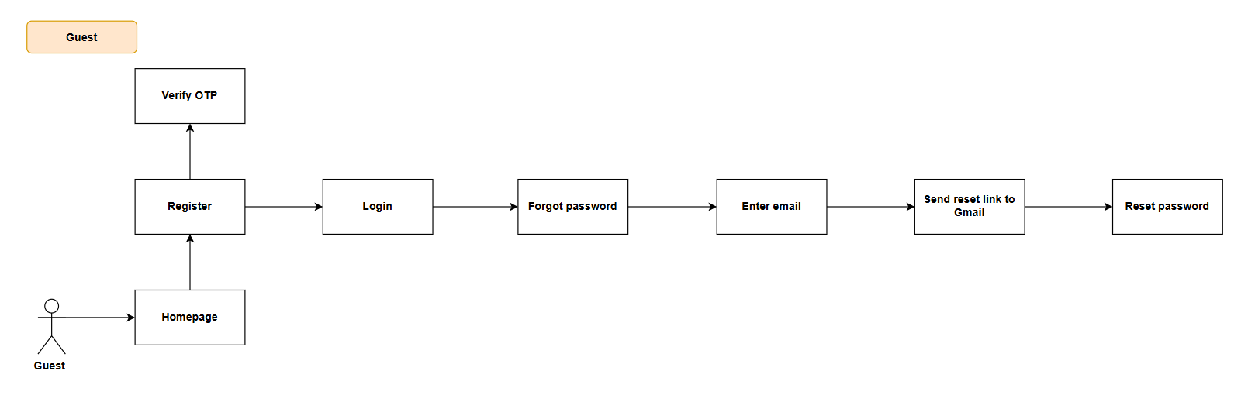

Figure 6. Screen flow Diagram – Guest

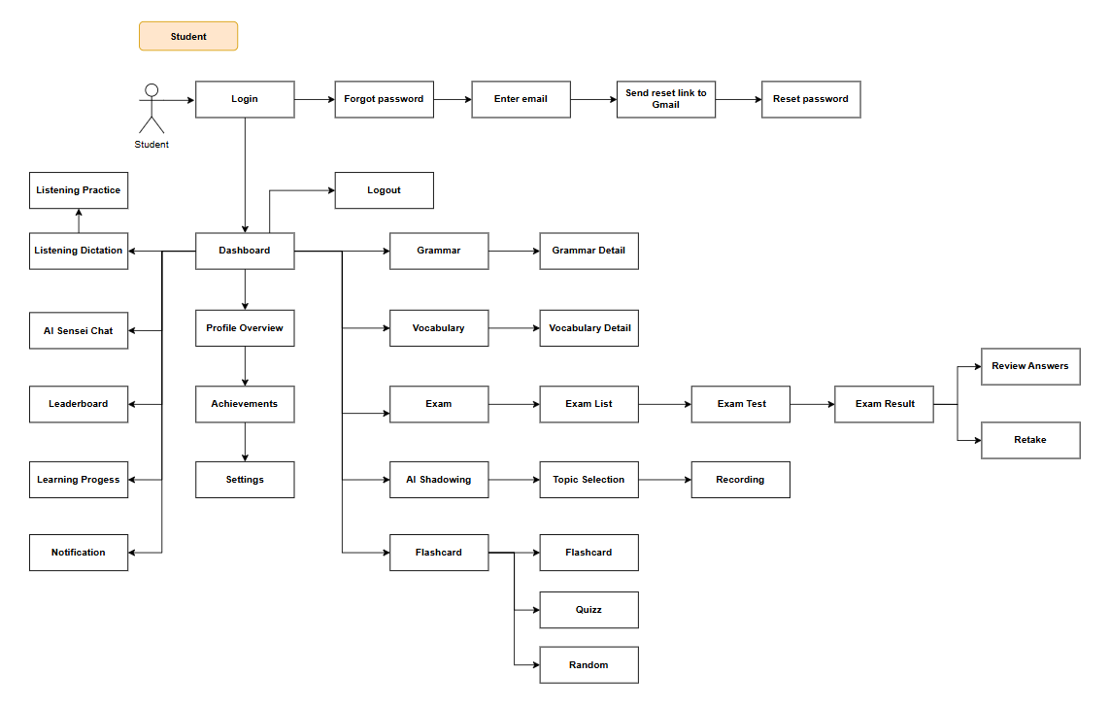
Figure 7. Screen flow Diagram – Student
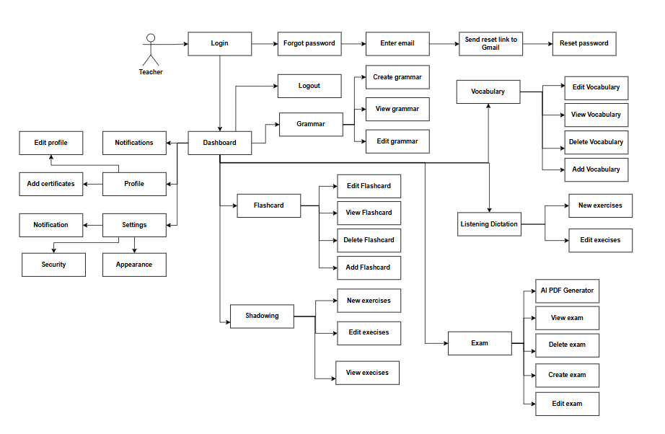
Figure 8. Screen flow Diagram – Teacher
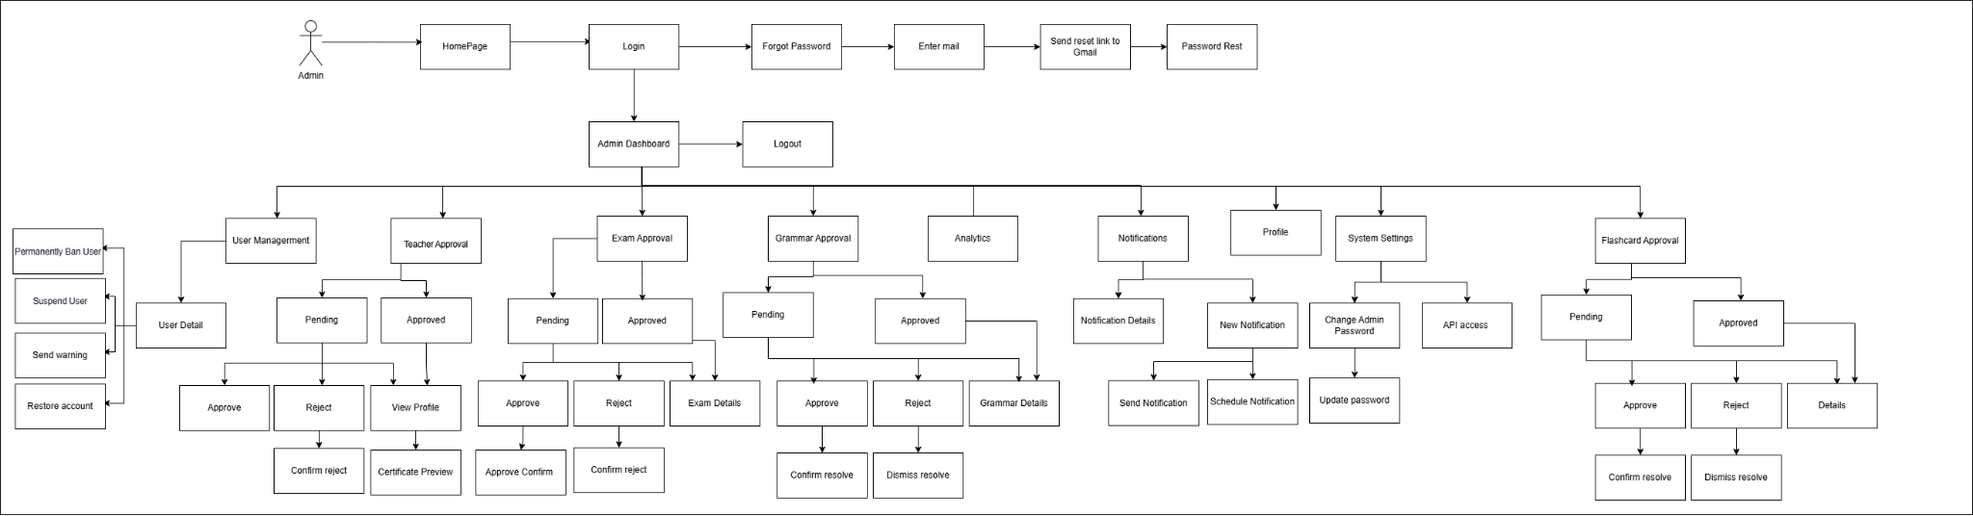
Figure 9. Screen flow Diagram – Admin

2.2 Screen Descriptions
 | Feature | Screen | Description
1 | Guest Access | Guest | Allows users to access the system as a guest without logging in
2 | Homepage Navigation | Homepage | The starting page where users can choose to register or log in.
3 | User Registration | Register | Allows new users to create an account.
4 | User Login | Login | Allows registered users to log in using their credentials.
5 | Google Login | Login | Allows users to quickly sign in using their Google account without entering email and password manually.
6 | OTP Verification | Verify OTP | The system sends an OTP to verify the user's email address.
7 | Forgot Password | Send Reset Link | The system sends a password reset link to the user's registered Gmail/email address when the user requests a password reset
8 | Password Reset | Password Reset | Allows users to set a new password using the reset link sent to their email address.
9 | Student Dashboard | Dashboard | students can access all learning features and track their activities.
10 | Profile Overview | Profile Overview | Displays the student's personal information, learning statistics, and account summary.
11 | Achievements Tracking | Achievements | Allows students to view badges, certificates, and learning achievements earned during their study journey.
12 | Grammar Learning | Grammar | Allows students to browse grammar lessons and learning materials.
13 | Grammar Details | Grammar Detail | Displays detailed explanations, examples, and exercises for a selected grammar topic.
14 | Vocabulary Learning | Vocabulary | Allows students to study vocabulary organized by lessons or categories.
15 | Vocabulary Details | Vocabulary Detail | Displays meanings, pronunciations, examples, and usage of selected vocabulary items.
16 | Exam Management | Exam | Allows students to access available exams and assessments.
17 | Exam List | Exam List | Displays all available exams that students can take
18 | Take Exam | Exam Test | Allows students to complete an examination within a specified time.
19 | View Exam Results | Exam Result | Displays scores, performance analysis, and feedback after completing an exam.
20 | Review Answers | Review Answers | Allows students to review submitted answers and compare them with correct answers.
21 | Retake Exam | Retake | Allows students to retake an exam for additional practice or score improvement.
22 | AI Shadowing Practice | AI Shadowing | Provides AI-powered speaking practice through shadowing exercises.
23 | Topic Selection | Topic Selection | Allows students to choose a topic before starting a shadowing session.
24 | Voice Recording | Recording | Allows students to record their voice for pronunciation and speaking evaluation.
25 | Flashcard Learning | Flashcard | Allows students to study vocabulary and concepts using digital flashcards.
26 | Flashcard Quiz | Quiz | Tests students' knowledge through flashcard-based quizzes.
27 | Random Flashcard Mode | Random | Presents flashcards randomly for review and memorization practice.
28 | Listening Dictation | Listening Dictation | Allows students to practice listening comprehension by transcribing audio content.
29 | Listening Practice | Listening Practice | Provides listening exercises to improve comprehension and pronunciation skills.
30 | AI Sensei Chat | AI Sensei Chat | Allows students to interact with an AI tutor for learning support, explanations, and practice conversations.
31 | Leaderboard | Leaderboard | Displays rankings of students based on learning performance and achievements.
32 | Learning Progress Tracking | Learning Progress | Allows students to monitor their study progress, completed lessons, and performance statistics.
33 | Notification Center | Notification | Displays announcements, reminders, exam updates, and learning-related notifications
34 | Teacher Dashboard | Dashboard | Provides teachers with an overview of content management, and teaching activities.
35 | Teacher Profile | Profile | Allows teachers to manage personal information and professional credentials.
36 | Edit Profile | Edit Profile | Allows teachers to update their personal information and professional details.
37 | Add Certificates | Add Certificates | Allows teachers to upload and manage teaching certificates for verification purposes.
38 | Security Settings | Security | Allows teachers to configure account security settings such as password protection and authentication options.
39 | Appearance Settings | Appearance | Allows teachers to customize the system interface and display preferences.
40 | Grammar Management | Grammar | View grammar lesson list
41 | Create Grammar Lesson | Create Grammar | Allows teachers to create and submit new grammar lessons for review and approval.
42 | View Grammar Lesson | View Grammar | Allows teachers to view grammar lessons they have created.
43 | Edit Grammar Lesson | Edit Grammar | Allows teachers to modify existing grammar lessons before or after submission.
44 | Vocabulary Management | Vocabulary | View vocabulary list
45 | Add Vocabulary | Add Vocabulary | Allows teachers to create and add new vocabulary entries to the learning system.
46 | View Vocabulary | View Vocabulary | Allows teachers to browse and review vocabulary content.
47 | Edit Vocabulary | Edit Vocabulary | Allows teachers to update vocabulary information, examples, and explanations.
48 | Delete Vocabulary | Delete Vocabulary | Allows teachers to remove vocabulary entries that are no longer needed.
49 | Flashcard Management | Flashcard | Allows teachers to create, edit, delete, and manage flashcards.
50 | Add Flashcard | Add Flashcard | Allows teachers to create flashcards for vocabulary
51 | View Flashcard | View Flashcard | Allows teachers to review existing flashcards.
52 | Edit Flashcard | Edit Flashcard | Allows teachers to update flashcard content.
53 | Delete Flashcard | Delete Flashcard | Allows teachers to remove flashcards from the system.
54 | Shadowing Exercise Management | Shadowing | Allows teachers to manage AI Shadowing practice activities.
55 | Create Shadowing Exercise | New Exercises | Allows teachers to create new speaking and pronunciation exercises for shadowing practice.
56 | Edit Shadowing Exercise | Edit Exercises | Allows teachers to modify existing shadowing exercises.
57 | View Shadowing Exercise | View Exercises | Allows teachers to review available shadowing exercises.
58 | Listening Dictation Management | Listening Dictation | Allows teachers to manage listening dictation practice content.
59 | Create Listening Exercise | New Exercises | Allows teachers to create new listening dictation exercises.
60 | Edit Listening Exercise | Edit Exercises | Allows teachers to update listening dictation exercises.
61 | Exam Management | Exam | Allows teachers to view exam
62 | AI PDF Generator | AI PDF Generator | Allows teachers to automatically generate exam documents and learning materials in PDF format using AI.
63 | Create Exam | Create Exam | Allows teachers to create new exams and assessment questions.
64 | View Exam | View Exam | Allows teachers to review existing exams and their contents.
65 | Edit Exam | Edit Exam | Allows teachers to modify exam information, questions, and settings.
66 | Delete Exam | Delete Exam | Allows teachers to remove exams from the system.
67 | Admin Dashboard | Admin Dashboard | The central management screen where administrators access all system functions.
68 | Logout | Logout | Allows administrators to securely sign out of the system.
69 | User Management | User Management | Allows administrators to manage all user accounts within the system.
70 | View User Details | User Detail | Displays detailed information about a selected user account.
71 | Suspend User | User Management | Allows administrators to temporarily disable a user account.
72 | Permanently Ban User | User Management | Allows administrators to permanently block a user from accessing the system.
73 | Send Warning | User Management | Allows administrators to send warning messages to users who violate policies.
74 | Restore Account | User Management | Allows administrators to reactivate a suspended user account.
75 | Teacher Approval Review | Teacher Approval | Allows administrators to review teacher registration requests.
76 | View Pending Teachers | Pending Teachers | Displays teacher applications waiting for approval.
77 | Approve Teacher | Teacher Approval | Allows administrators to approve teacher registration requests.
78 | Reject Teacher | Teacher Approval | Allows administrators to reject teacher registration requests.
79 | Confirm Rejection | Confirm Reject | Requires confirmation before rejecting a teacher application.
80 | View Approved Teachers | Approved Teachers | Displays all approved teacher accounts
81 | View Teacher Profile | View Profile | Allows administrators to review teacher profile information.
82 | Certificate Preview | Certificate Preview | Allows administrators to preview teacher certificates before approval.
83  84 | Exam Approval Management | Exam Approval | Allows administrators to review and manage submitted exams.
85 | View Pending Exams | Pending Exams | Displays exams waiting for administrator approval.
86 | Approve Exam | Approve Exam | Allows administrators to approve submitted exams.
87 | Confirm Exam Approval | Approve Confirm | Requires confirmation before final exam approval.
88 | Reject Exam | Reject Exam | Allows administrators to reject submitted exams.
89 | Confirm Exam Rejection | Confirm Reject | Requires confirmation before final rejection.
90 | View Approved Exams | Approved Exams | Displays exams that have already been approved.
91 | View Exam Details | Exam Details | Displays detailed information about a selected exam.
92 | Grammar Approval Management | Grammar Approval | Allows administrators to review grammar content submitted by teachers.
93 | View Pending Grammar | Pending Grammar | Displays grammar lessons awaiting approval.
94 | Approve Grammar Content | Approve Grammar | Allows administrators to approve grammar content
95 | Confirm Grammar Approval | Confirm Resolve | Requires confirmation before approving grammar content.
96 | Reject Grammar Content | Reject Grammar | Allows administrators to reject grammar submissions.
97 | Dismiss Grammar Request | Dismiss Resolve | Finalizes the rejection of grammar content.
98 | View Grammar Details | Grammar Details | Displays detailed information about grammar lessons.
99 | Analytics Dashboard | Analytics | Provides reports, statistics, and system performance insights.
100 | Notification Management | Notifications | Allows administrators to create, view, and manage system notifications.
101 | View Notification Details | Notification Details | Displays detailed information about a notification.
102 | Send Notification | Send Notification | Allows administrators to send announcements to users.
103 | Create New Notification | New Notification | Allows administrators to compose a new notification.
104 | Schedule Notification | Schedule Notification | Allows administrators to schedule notifications for future delivery.
105 | Profile Management | Profile | Allows administrators to view and manage their profile information.
106 | System Settings | System Settings | Provides access to administrative configuration settings.
107 | Change Admin Password | Change Admin Password | Allows administrators to update their account password.
108 | Update Password | Update Password | Saves the administrator’s new password after validation.

2.3 Screen Authorization

Screen | Guest | Student | Teacher | Admin
Home Page | x
Register | x
Select role | x
Fill in registration information | x
Login |  | x | x | x
Log in with Email/Password |  | x | x | x
Log in with Google |  | x | x | x
Log Out |  | x | x | x
Forgot Password | x | x | x
Enter email | x | x | x
Send reset code | x | x | x
Email sent confirmation page | x | x | x
Verify OTP | x | x | x
Enter 6-digit OTP code | x | x | x
Resend OTP code | x | x | x
Reset Password | x | x | x
Enter new password + confirm | x | x | x
Password strength meter | x | x | x
Reset Success | x | x | x
Dashboard |  | x | x | x
Track learning progress | x
View platform statistical charts |  |  |  | x
Profile |  | x | x | x
View profile information |  | x | x | x
Edit profile |  | x | x | x
Upload/ change Avatar |  | x | x | x
Manage Certificates |  |  | x | x
Change Password |  | x | x
Enter current password |  | x | x
Enter new password + confirm |  | x | x
Password strength validation |  | x | x
System Settings |  | x | x | x
AI Learning Settings |  |  |  | x
Platform Settings (Light Mode, Dark Mode ) |  | x | x | x
Notifications |  | x | x | x
View notification list |  | x | x | x
Manage Notifications |  |  |  | x
Vocabulary |  | x
View lesson list by JLPT level (N5–N1) |  | x
Learn vocabulary within the lesson |  | x
Grammar |  | x
View grammar list |  | x
Grammar Index |  | x
Grammar Structure |  | x
Flashcards |  | x
Practice flashcards |  | x
Listening |  | x
Dictation exercises |  | x
Shadowing |  | x
Listen to native audio |  | x
Speak & Record |  | x
AI pronunciation evaluation & scoring |  | x
AI Sensei |  | x
Chat with AI sensei |  | x
Leaderboard |  | x
View community leaderboard |  | x
Vocabulary Management |  |  | x
View vocabulary list |  |  | x
Edit vocabulary lessons |  |  | x
Grammar Management |  |  | x
View grammar list |  |  | x
Add/edit grammar |  |  | x
Flashcards Management |  |  | x
View flashcard list |  |  | x
Add/edit flashcard |  |  | x
Listening Management |  |  | x
View video listening list |  |  | x
Add/edit video listening |  |  | x
Add/edit transcript |  |  | x
Shadowing Management |  |  | x
View video shadowing list |  |  | x
Add/edit video shadowing |  |  | x
Exam Management |  |  | x
View exam list |  |  | x
Create/edit exams |  |  | x
User Management |  |  |  | x
View all users list |  |  |  | x
Lock / Unlock accounts |  |  |  | x
Teacher Approval |  |  |  | x
View pending teachers list |  |  |  | x
Approve/ refuse teachers |  |  |  | x
Exam Approval |  |  |  | x
View pending exam list |  |  |  | x
Approve / Reject exams |  |  |  | x
Content Moderation |  |  |  | x
Approve grammar/ flashcards content |  |  |  | x

2.4 Non-UI Functions

# | Feature | System Function | Description
1 | <<Feature Name>> | <<Function Name1>> | <<Function Name1 Description>>
2 | …

3. System High Level Design

3.1 Database Design

a. Database Schema
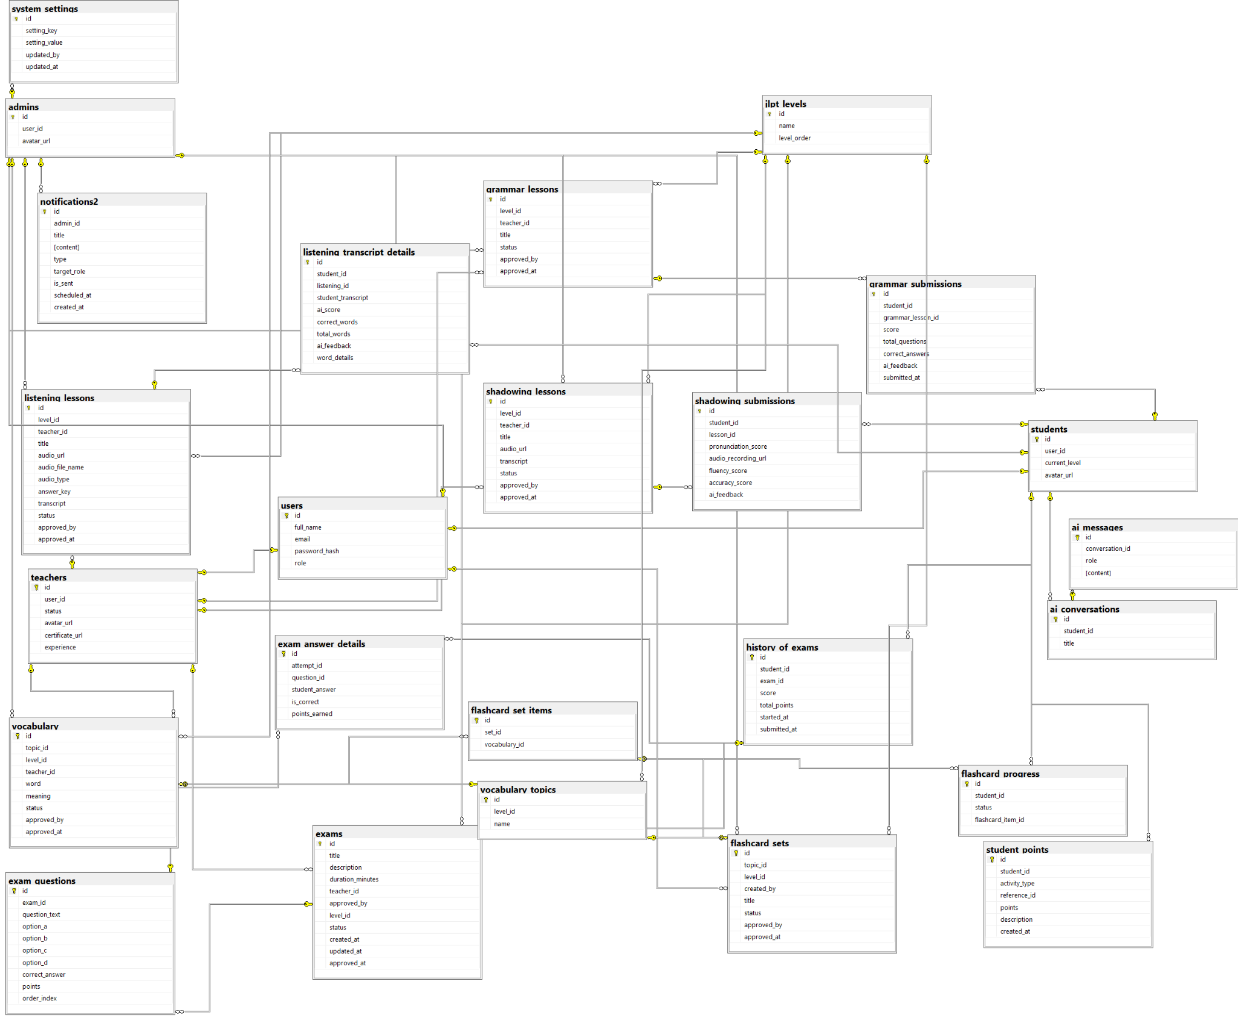

b. Table Descriptions
No | Table | Description
1 | users | Stores all user accounts used by the system, including students, teachers, and administrators  - Primary keys: id  - Foreign keys: None
2 | students | Stores student profile information, learning progress, and current JLPT level.  - Primary keys: id  - Foreign keys: user_id
3 | teachers | Stores teacher profile information, Certificates, Experience and teaching approval status.  - Primary keys: id  - Foreign keys: user_id, approved_by
4 | admins | Stores administrator profile information  - Primary keys: id  - Foreign keys: user_id
5 | jlpt_levels | Stores the proficiency levels of the JLPT learning program. These levels are used to classify learning content and assessments.  - Primary keys: id  - Foreign keys: None
6 | vocabulary_topics | Stores vocabulary topic categories associated with specific learning levels. Topics are used to organize vocabulary and flashcard content.  - Primary keys: id  - Foreign keys: level_id
7 | vocabulary | Stores vocabulary words, meanings, and related information created by teachers for each level and topic.  - Primary keys: id  - Foreign keys: topic_id, level_id, teacher_id
8 | flashcard_sets | Stores collections of flashcards grouped by topic and learning level. These sets are used for vocabulary practice activities.  - Primary keys: id  - Foreign keys: topic_id, level_id, created_by
9 | flashcard_set_items | Stores the relationship between flashcard sets and vocabulary items. Each record represents a vocabulary word included in a flashcard set.  - Primary keys: id  - Foreign keys: set_id, vocabulary_id
10 | flashcard_progress | Stores student learning progress for flashcard activities. It tracks completion status of individual flashcard items.  - Primary keys: id  - Foreign keys: student_id, flashcard_item_id
11 | listening_lessons | Stores listening lesson content, including audio files, transcripts, and answer keys for listening practice.  - Primary keys: id  - Foreign keys: level_id, teacher_id
12 | listening_transcript_details | Stores student listening practice results, including submitted transcripts, scores, and AI-generated feedback.  - Primary keys: id  - Foreign keys: student_id, listening_id
13 | shadowing_lessons | Stores shadowing practice lessons, including audio resources and transcripts used to improve pronunciation and speaking skills.  - Primary keys: id  - Foreign keys: level_id, teacher_id
14 | grammar_lessons | Stores grammar lesson materials created by teachers for specific proficiency levels.  - Primary keys: id  - Foreign keys: level_id, teacher_id
15 | exams | Stores examination information, including duration, level, approval status, and creator information.  - Primary keys: id  - Foreign keys: teacher_id, approved_by, level_id
16 | exam_questions | Stores questions belonging to an examination, including answer options, correct answers, and scoring information.  - Primary keys: id  - Foreign keys: exam_id
17 | listening_lessons | Stores listening lesson content, including audio files, transcripts, and answer keys for listening practice.  - Primary keys: id  - Foreign keys: level_id, teacher_id
18 | shadowing_submissions | Stores student submissions for shadowing exercises, including pronunciation evaluation, fluency score, accuracy score, and AI feedback.  - Primary keys: id  - Foreign keys: student_id, lesson_id
19 | grammar_submissions | Stores student grammar exercise results and AI-generated evaluations. It records scores, correct answers, and submission timestamps.  - Primary keys: id  - Foreign keys: student_id, grammar_lesson_id
20 | history_of_exams | Stores examination attempt history for students, including scores, total points, start time, and submission time.  - Primary keys: id  - Foreign keys: student_id, exam_id
21 | exam_answer_details | Stores detailed answers submitted by students for each exam question, including correctness and earned points.  - Primary keys: id  - Foreign keys: attempt_id, question_id
22 | student_points | Stores points earned by students through learning activities. The table supports reward, ranking, and gamification features.  - Primary keys: id  - Foreign keys: student_id, reference_id
23 | ai_conversations | Stores AI chat sessions created by students. Each conversation contains a collection of AI-generated and student-generated messages.  - Primary keys: id  - Foreign keys: student_id
24 | ai_messages | Stores individual messages exchanged within an AI conversation, including sender role and message content.  - Primary keys: id  - Foreign keys: conversation_id
25 | notifications2 | Stores notifications created by administrators and sent to specific user roles. The table supports scheduling, tracking delivery status, and managing system announcements.  - Primary keys: id  - Foreign keys: admin_id
26 | system_settings | Stores configurable system parameters and application settings. These settings can be maintained by administrators without modifying source code.  - Primary keys: id  - Foreign keys: updated_by

3.2 Code Packages

Package descriptions
No | Package | Description
01 | Member_authority | <Description of the package>
02 | registration | <Description of the package>
03 | …

II. Requirement Specifications

1. Authentication

1.1 UC-01_Register

a. Functionalities
Provide the functional description for the use cases using the template/guides below
Functional Description Template
UC ID and Name: | UC-1_Register
Created By: |  | Date Created:
Primary Actor: | Guest | Secondary Actors: | None
Trigger: | Guest clicks on the button “Login/Get started” pop-up form.
Description: | As a guest I want to register successfully so that I can use the system’s authenticated features.
Preconditions: | Gmail must be unique when they register for the first time.
Postconditions: | Guests can register successfully.
Normal Flow: | 1.0 Register system  - A guest user navigates to the platform and clicks on the "Login/Get started" button located in the header.  - The platform opens a pop-up registration form that asks for details such as email, password, and role ( Teacher, Student).  - The guest fills in the required information in the form fields (valid email, password, role selection).  - The guest clicks the "Get started" button to submit the form for validation.  - System validates the register details .  - System tracks guest’s success register to the Activity Log.  - System accesses the Home Page.
Alternative Flows: | None
Exceptions: | 1.0.E1 Guest entered the wrong format of the fields  - The Error Message screen is shown to the user.  - Guests did not fill in required fields.  - Guests fills in invalid information.  1.0.E2 Guest’s email was available in system  - The Error Message screen is shown to the user.
Priority: | Must have
Frequency of Use:
Business Rules: | BR-01,BR-02,BR-03,BR-08
Other Information:
Assumptions:

b. Business Rules
Provide the business rules those are applied only to the use case
ID | Business Rule | Business Rule Description
BR-01 | Wrong email rule | System will notify guest the message MSG01 if they don't fill invalid email address
BR-02 | Wrong password rule | System will notify User the MSG02 if they fill in invalid password ( < 8 regex)
BR-03 | Used email rule | System will notify guest the MSG03 if they had been used gmail for register
BR-08 | Wrong Re-entered Password rule | System will notify User the MSG11 if they fill in wrong re-entered password

1.2 UC-02_Login

a. Functionalities
UC ID and Name: | UC 2_Login
Created By: |  | Date Created:
Primary Actor: | Admin, Teacher, Student | Secondary Actors:
Trigger: | -·Users click on the button “Login/Get started” on header.  - Click on the ”Login”.
Description: | As a user, I want to be able to log into the system so that I can use the system’s authenticated features and access my personalized account.
Preconditions: | User has already has an account on the platform .
Postconditions: | Users can login successfully.
Normal Flow: | 2.0 Login system  - User accesses the User Login screen  - User types in the login details or choose other login options (see 2.1)  - User clicks the Login button  - System validates the login details  - System allows user to access  - System tracks user’s success login to the Activity Log  - System accesses the Home Page
Alternative Flows: | 2.1 Google Login  - User chooses to login system using Google account  - System redirects the user to the Google’s Login screen  - User types in the Google account details and chooses to login  - Google validates user’s login information successfully and redirect him/her back to the system  - Return to step 5 of normal flow.
Exceptions: | 2.0.E2 System can’t authenticate the user  - The Error Message screen is shown to the user  - User cancels the logging in => UC stops, change to Homepage  - User clicks “Forgot Password?” link => change to UC-06_Reset Password  - User clicks “Register” link => change to UC-01_Register User Account
Priority: | Must Have
Frequency of Use:
Business Rules: | BR-01,BR-02,BR-04,BR-09,BR-10
Other Information:
Assumptions:

b. Business Rule
ID | Business Rule | Business Rule Description
BR-01 | Wrong email rule | System will notify guest the message MSG01 if they dont fill invalid email address
BR-02 | Wrong password rule | System will notify User the MSG02 if they fill in invalid password ( < 8 regrex)
BR-04 | Notification about login information rule | -System will notify User the MSG04 and redirect to the guest homepage if they fill the wrong registered email and password.  -System will notify User the MSG05 and redirect to user homepage if they fill correct registered email and password
BR-09 | Role choosing Form Rule | -This form only appears for gmail when logging into the system for the first time (no role yet). The recommended role is Teacher/Student.  -This form does not apply to Admin accounts.
BR-10 | Login-gmail Rule | In case gmail has been successfully registered with password on the system registration form, when logging in using gmail login method, it still accesses that account.

1.3 UC-03_Logout

a. Functionalities
UC ID and Name: | UC-3_Logout
Created By: |  | Date Created:
Primary Actor: | Admin, Teacher, Student | Secondary Actors:
Trigger: | Admin, Teacher, Student click on “Logout”
Description: | As a user, I want to be able to log out of the system so that I can change other accounts.
Preconditions: | Users are logged in successfully as the actor above.
Postconditions: | - Users can log out successfully.  - End up the user's session.
Normal Flow: | 3.0 Logout  - User clicks on the avatar on the header.  - Users click on the button “Logout” on the header.
Alternative Flows: | None.
Exceptions: | None.
Priority: | Must have.
Frequency of Use:
Business Rules: | None.
Other Information:
Assumptions:

b. Business Rule
None

1.4 UC-04_View profile

a. Functionalities
UC ID and Name: | UC-4_View profile
Created By: |  | Date Created:
Primary Actor: | Admin, Teacher, Student | Secondary Actors:
Trigger: | Users click on the ”Profile”
Description: | As a user, I want to be able to view profile so that I can know exactly my specification
Preconditions: | Users logged in successfully as the actor above.
Postconditions: | Users can view detail information of their own accounts
Normal Flow: | 4.0 View profile system  - Users click on the avatar in the header.  - Users click on the ”Profile”
Alternative Flows: | None.
Exceptions: | None.
Priority: | High
Frequency of Use:
Business Rules: | None
Other Information:
Assumptions:

b. Business Rule
None

1.5 UC-05_Edit profile

a. Functionalities
UC ID and Name: | UC-05_Edit profile
Created By: |  | Date Created: | 30/Sep/2024
Primary Actor: | Admin, Teacher, Student | Secondary Actors:
Trigger: | Users has clicked on “Profile” on the platform
Description: | As a user, I want to be able to change my account so that I can change my avatar.
Preconditions: | Users logged in successfully as actor above.
Postconditions: | Users can update information successfully.
Normal Flow | 5.1 Edit profile system  - Users click on the avatar in the header.  - Users click on the ”Profile”  - Users click on the ”Settings”  - Users click on the ”Edit”
Alternative Flows: | 5.2 Edit profile system  - Users click on the “Profile” on the sidebar.  - Users click on the ”Settings”  - Users click on the ”Edit”
Exceptions:
Priority: | High
Frequency of Use:
Business Rules: | BR-11
Other Information:
Assumptions:

b. Business Rule
ID | Business Rule | Business Rule Description
BR-11 | Upload profile successfully rule | System will notify guest the MSG06 if they update new profile and database successfully

1.6 UC-06_Change password

a. Functionalities
UC ID and Name: | UC-06_Change password
Created By: |  | Date Created: | 30/Sep/2024
Primary Actor: | Admin, Teacher, Student | Secondary Actors:
Trigger: | Users click on “Update Password"
Description: | As a user, I want to be able to change my password so that I can update new password
Preconditions: | Users logged in successfully as the actor above.
Postconditions: | - Users can change passwords successfully.  - Users can use new password to login
Normal Flow: | 6.1 Change password system  - Users click on the avatar in the header.  - Users click on the ”Profile”  - Users click on the ”Settings”  - Users click on the ”Security”  - Users click on the ”Update Password”
Alternative Flows: | 6.2 Change password system  - Users click on the “Profile” on the sidebar.  - Users click on the ”Settings”  - Users click on the ”Security”  - Users click on the ”Update Password”
Exceptions:
Priority: | High
Frequency of Use:
Business Rules: | BR-02,BR-05,BR-08,BR-11
Other Information:
Assumptions:

b. Business Rule
ID | Business Rule | Business Rule Description
BR-02 | Wrong password rule | System will notify User the MSG02 if they fill in invalid password ( < 8 regex)
BR-05 | Wrong old password rule | System will notify users the message MSG06 if they don’t fill correct old password of account
BR-08 | Wrong re-enter password | System will notify users of the message MSG11 if the re-entered password is incorrect.
BR-11 | Wrong new password | System will notify users the message MSG12 if the re-entered password is the same as the old password.

1.7 UC-07_Forgot password

a. Functionalities
UC ID and Name: | UC-07_Forgot password
Created By: |  | Date Created:
Primary Actor: | Admin, Teacher, Student | Secondary Actors:
Trigger: | User click on “Forgot password” on form login
Description: | As a user, I want to be able to reset my password so that I can update new password
Preconditions: | User have already had account
Postconditions: | User is logged in successfully with new password
Normal Flow: | 7.0 Change password system  - Users click on”Login”in the header  - Users click on the ”Forgot password”
Alternative Flows: | None
Exceptions:
Priority: | High
Frequency of Use:
Business Rules: | BR-06,BR-07,BR-02,BR-08
Other Information:
Assumptions:

b.Business Rule
ID | Business Rule | Business Rule Description
BR-06 | Forgotten Account’s Gmail rule | If gmail has never registered before, the system will display message MSG07.
BR-07 | Wrong OTP rule | If OTP is wrong, the system will display message MSG09 and load the OTP form page again.  If OTP is correct, the system will display message MSG010 and redirect to the reset password page.
BR-02 | Wrong Password rule | System will notify User the MSG02 if they fill in invalid password ( < 8 regex)
BR-08 | Wrong Re-entered Password rule | System will notify User the MSG11 if they fill in wrong re-entered password

1.8 UC-08_View HomePage

a. Functionalities
UC ID and Name: | UC-08 View HomePage
Created By: |  | Date Created:
Primary Actor: | Guest,Admin, Teacher, Student | Secondary Actors:
Trigger: | Users access the platform.
Description: | As a guest or logged-in user, I want to view the Home Page and browse public content.
Preconditions: | None
Postconditions: | Home Page is displayed.
Normal Flow: | 8.0 View Home Page  - User accesses the website.  - System loads public content.  - System displays the Home Page.
Alternative Flows: | None
Exceptions: | Error message is displayed.
Priority: | High
Frequency of Use:
Business Rules: | BR- 13,BR-14,BR-
Other Information:
Assumptions:

b. Business Rule
ID | Business Rule | Business Rule Description
BR-13 | Public Home Page Access | Guests and authenticated users (Admin, Teacher, Student) are allowed to access and view the Home Page without any additional permissions.
BR-14 | Public Content Display | The system displays publicly available content on the Home Page when the page is loaded.
BR-15 | Home Page Loading Failure Notification | Notify users with MSG13 if the Home Page cannot be loaded successfully.

2. Admin

2.1 UC-09_Approve/Reject Exams

a. Functionalities
UC ID and Name: | UC-9_Approve/Reject Exams
Created By: |  | Date Created:
Primary Actor: | Admin | Secondary Actors: | Teacher
Trigger: | Admin selects a pending exam.
Description: | As an admin, I want to review exams created by teachers so that suitable exams are published and unsuitable exams are rejected.
Preconditions: | The exam status is Pending.
Postconditions: | The exam status becomes Approved or Rejected and the action is recorded.
Normal Flow: | 9.0 Approve/Reject Exams  - Admin opens the Pending Exams page.  - System displays a list of pending exams.  - Admin selects an exam.  - Admin reviews the exam content.  - Admin chooses one of the following actions:  - Approve  - Reject  - System validates the request.  - System changes the exam status to Approved/Rejected  - System publishes the exam if system changes the exam status to Approved.
Alternative Flows: | None
Exceptions: | Error message is displayed.
Priority: | High
Frequency of Use: | High
Business Rules: | BR-16, BR-17, BR-18, BR-19, BR-20
Other Information:
Assumptions:

b. Business Rule
ID | Business Rule | Business Rule Description
BR-16 | Admin Approval Authorization | Only Admin is allowed to approve or reject exams submitted by Teachers.
BR-17 | Pending Status Validation | Only exams with status Pending can be reviewed and processed.
BR-18 | Exam Status Update | After validation, the system changes the exam status to either Approved or Rejected and records the action history.
BR-19 | Automatic Publication | An exam is automatically published when its status becomes Approved.
BR-20 | Approval/Rejection Notification | Notify Admin with MSG14 when an exam is approved successfully and with MSG15 when an exam is rejected successfully.

2.2 UC-10_Approve/Reject Flashcard

a. Functionalities
UC ID and Name: | UC-10_Approve/Reject Flashcard
Created By: |  | Date Created:
Primary Actor: | Admin
Trigger: | Admin reviews pending flashcard sets.
Description: | As an admin, I want to approve or reject flashcard sets created by teachers so that only appropriate learning materials are available to students.
Preconditions: | The flashcard set status is Pending.
Postconditions: | The flashcard set status becomes Approved or Rejected.
Normal Flow: | 10. Approve/Reject Flashcard  - Admin opens the Flashcard Requests page.  - System displays a list of pending flashcard sets.  - Admin selects a flashcard set.  - System displays the flashcard details.  - Admin reviews the flashcard content.  - Admin chooses one of the following actions:  - Approve  - Reject.  - The system validates the request.  - System changes the flashcard set status to Approved/Reject.  - System publishes the flashcard sets if System changes this status to Approved.
Alternative Flows: | Cancel approval  - Admin cancels the operation.  - System returns to the Flashcard Requests page.
Exceptions: | The system displays an error message.
Priority: | High
Frequency of Use: | High
Business Rules: | BR-16, BR-17, BR-18,BR-19 BR-20
Other Information:
Assumptions:

b. Business Rule
ID | Business Rule | Business Rule Description
BR-16 | Admin Approval Authorization | Only Admin is allowed to approve or reject exams submitted by Teachers.
BR-17 | Pending Status Validation | Only exams with status Pending can be reviewed and processed.
BR-18 | Exam Status Update | After validation, the system changes the exam status to either Approved or Rejected and records the action history.
BR-19 | Automatic Publication | An exam is automatically published when its status becomes Approved.
BR-20 | Approval/Rejection Notification | Notify Admin with MSG14 when an exam is approved successfully and with MSG15 when an exam is rejected successfully.

2.3 UC-11_ Approve/Reject Grammar

a. Functionalities
UC ID and Name: | UC-11_ Approve/Reject Grammar
Created By: |  | Date Created:
Primary Actor: | Admin
Trigger: | Admin reviews pending grammar lessons.
Description: | As an admin, I want to approve or reject grammar lessons created by teachers so that only accurate and appropriate content is available to students.
Preconditions: | The grammar lesson status is Pending.
Postconditions: | The grammar lesson status becomes Approved or Rejected.
Normal Flow: | 11. Approve/Reject Grammar  - Admin opens the Grammar Requests page.  - The system displays a list of pending grammar lessons.  - Admin selects a grammar lesson.  - The system displays the grammar content and examples.  - Admin reviews the lesson.  - Admin chooses one of the following actions:  - Approve  - Reject.  - System validates the request.  - System changes the grammar lesson status to Approved/Reject.  - System publishes the grammar lesson if System changes the grammar lesson status to Approved.
Alternative Flows: | Cancel approval  - Admin cancels the operation.  - System returns to the Flashcard Requests page.
Exceptions: | System displays an error message.
Priority: | High
Frequency of Use: | High
Business Rules: | BR-16, BR-17, BR-18,BR-19 BR-20
Other Information:
Assumptions:

b. Business Rule
ID | Business Rule | Business Rule Description
BR-16 | Admin Approval Authorization | Only Admin is allowed to approve or reject exams submitted by Teachers.
BR-17 | Pending Status Validation | Only exams with status Pending can be reviewed and processed.
BR-18 | Exam Status Update | After validation, the system changes the exam status to either Approved or Rejected and records the action history.
BR-19 | Automatic Publication | An exam is automatically published when its status becomes Approved.
BR-20 | Approval/Rejection Notification | Notify Admin with MSG14 when an exam is approved successfully and with MSG15 when an exam is rejected successfully.

2.4 UC-12_Unlock/Lock User Account

a. Functionalities
UC ID and Name: | UC-12_Unlock/Lock User Account
Created By: |  | Date Created:
Primary Actor: | Admin | Secondary Actors: | Teacher, Student
Trigger: | Admin selects a user account.
Description: | As an admin, I want to lock or unlock user accounts so that I can enforce platform policies and restore account access when necessary.
Preconditions: | User accounts exists.
Postconditions: | Account status becomes Locked or Active.
Normal Flow: | 12.0 Unlock/Lock User Account  - Admin opens User Management.  - The system displays user accounts.  - Admin selects an account.  - Admin chooses one of the following actions:  - Lock account  - Unlock account  - The system validates the request.  - System changes the account status to Locked/Unlock.  - The system records the action in the Activity Log.
Alternative Flows: | None
Exceptions: | An error message is displayed.
Priority: | High
Frequency of Use: | Medium
Business Rules: | BR-21, BR-22, BR-23, BR-24, BR-25
Other Information:
Assumptions:

b. Business Rule
ID | Business Rule | Business Rule Description
BR-21 | Account Management Authorization | Only Admin is allowed to lock or unlock user accounts.
BR-22 | Existing Account Validation | The selected account must exist before any lock or unlock operation is performed.
BR-23 | Account Status Update | The system changes the account status to Locked or Active after validation.
BR-24 | Activity Logging | Every lock or unlock action must be recorded in the Activity Log.
BR-25 | Account Status Change Notification | Notify Admin when an account is locked or unlocked successfully.

2.5 UC-13_Approve/Reject Teacher Account

a. Functionalities
UC ID and Name: | UC-13_Approve/Reject Teacher Account
Created By: |  | Date Created:
Primary Actor: | Admin | Secondary Actors: | Teacher
Trigger: | Admin reviews pending teacher accounts.
Description: | As an admin, I want to review teachers' certificates and approve or reject teacher accounts so that only qualified teachers can access teacher functions
Preconditions: | The teacher account status is Pending.
Postconditions: | The teacher account status becomes Approved or Rejected.
Normal Flow: | 13.0 Review teacher account  - Admin opens the Teacher Approval page.  - System displays a list of pending teacher accounts.  - Admin selects a teacher account.  - System displays the teacher's information and uploaded certificate.  - Admin reviews the certificate and related information.  - Admin chooses one of the following actions:  - Approve  - Reject.  - System validates the request.  - System changes the teacher account status to Approved or Rejected.  - System records the action in the Activity Log.  - System displays a success message.
Alternative Flows: | None
Exceptions: | Error message is displayed.
Priority: | High
Frequency of Use: | Medium
Business Rules: | BR-16, BR-17, BR-18, BR-20, BR-24, BR-26
Other Information:
Assumptions:

b. Business Rule
ID | Business Rule | Business Rule Description
BR-16 | Admin Approval Authorization | Only Admin is allowed to approve or reject requests submitted by Teachers.
BR-17 | Pending Status Validation | Only items with status Pending can be reviewed and processed.
BR-18 | Status Update | After validation, the system changes the status to either Approved or Rejected and records the action history.
BR-20 | Approval/Rejection Notification | Notify Admin when the approval or rejection operation is completed successfully.
BR-24 | Activity Logging | Every approval or rejection action must be recorded in the Activity Log.
BR-26 | Teacher Certificate Validation | A teacher account can only be approved if the uploaded certificate and related information are available for review.

2.6 UC-14_View User Analytics

a. Functionalities
UC ID and Name: | UC-14_View User Analytics
Created By: |  | Date Created:
Primary Actor: | Admin | Secondary Actors:
Trigger: | Admin opens the Analytics page.
Description: | As an admin, I want to analyze user activities and platform statistics
Preconditions: | Admin is logged in.
Postconditions: | Statistical information is displayed.
Normal Flow: | 14.0 View analytics  - Admin opens Analytics page.  - System retrieves statistical data.  - System calculates user metrics.  - System displays charts and reports.  - Admin reviews the information.
Alternative Flows: | None
Exceptions: | System displays a message indicating no data found.
Priority: | Medium
Frequency of Use: | Medium
Business Rules: | BR-27, BR-28, BR-29, BR-30
Other Information:
Assumptions:

b. Business Rule
ID | Business Rule | Business Rule Description
BR-27 | Analytics Access Authorization | Only Admin is allowed to access user analytics and platform statistics.
BR-28 | Metrics Calculation | The system calculates statistical metrics based on available user activities and platform data.
BR-29 | Analytics Data Visualization | Statistical information must be presented in charts and reports.
BR-30 | Empty Data Notification | Notify Admin with MSG25 if no statistical data is available.

3. Teacher

3.1 UC-15_Add Vocabulary

a. Functionalities
UC ID and Name: | UC-15_Add Vocabulary
Created By: |  | Date Created:
Primary Actor: | Teacher | Secondary Actors:
Trigger: | Teacher clicks "Add Vocabulary".
Description: | As a teacher, I want to add new vocabulary so that students can learn new words.
Preconditions: | Teacher is logged in.
Postconditions: | New vocabulary is stored successfully.
Normal Flow: | - Teacher opens Vocabulary Management.  - Teacher clicks "Add Vocabulary".  - Teacher enters word information.  - Teacher clicks Save.  - System validates data.  - System stores the vocabulary.  - System displays a success message.
Alternative Flows: | None
Exceptions: | Error message is displayed.
Priority: | High
Frequency of Use:
Business Rules: | BR-31, BR-32, BR-33, BR-34
Other Information:
Assumptions:

b. Business Rule
ID | Business Rule | Business Rule Description
BR-31 | Teacher Authorization | Only approved Teacher accounts are allowed to add learning materials.
BR-32 | Required Field Validation | All mandatory vocabulary information must be provided before saving
BR-33 | Vocabulary Storage | The system stores the vocabulary information after successful validation.
BR-34 | Vocabulary Creation Notification | Notify Teacher when a vocabulary entry is created successfully.

3.2 UC-16_Edit Vocabulary

a. Functionalities
UC ID and Name: | UC-16_Edit Vocabulary
Created By: |  | Date Created:
Primary Actor: | Teacher | Secondary Actors:
Trigger: | Teacher clicks the Edit button on a vocabulary item.
Description: | As a teacher, I want to modify vocabulary information so that students can access updated content.
Preconditions: | Teacher is logged in and the vocabulary exists.
Postconditions: | Vocabulary information is updated successfully.
Normal Flow: | 16.0 Edit vocabulary  - Teacher opens Vocabulary Management.  - System displays the vocabulary list.  - Teacher selects a vocabulary item.  - Teacher clicks the Edit button.  - System displays current vocabulary information.  - Teacher updates the information.  - Teacher clicks Save.  - System validates the data.  - System updates the vocabulary.  - System displays a success message.
Alternative Flows: | Cancel editing  - Teacher clicks Cancel.  - System discards unsaved changes.  - System returns to the Vocabulary Management page.
Exceptions: | System displays an error message.
Priority: | High
Frequency of Use: | High
Business Rules: | BR-31, BR-32, BR-33, BR-34, BR-35
Other Information:
Assumptions:

b. Business Rule
ID | Business Rule | Business Rule Description
BR-31 | Teacher Authorization | Only approved Teacher accounts are allowed to add learning materials.
BR-32 | Required Field Validation | All mandatory vocabulary information must be provided before saving
BR-33 | Vocabulary Storage | The system stores the vocabulary information after successful validation.
BR-34 | Notification | Notify Teacher when a vocabulary entry is created successfully.
BR-35 | Existing Vocabulary Validation | A vocabulary item must exist before it can be edited.

3.3 UC-17_Delete Vocabulary

a. Functionalities
UC ID and Name: | UC-17_Delete Vocabulary
Created By: |  | Date Created:
Primary Actor: | Teacher | Secondary Actors:
Trigger: | Teacher clicks Delete on a vocabulary item.
Description: | As a teacher, I want to remove unnecessary vocabulary from the system.
Preconditions: | Teacher is logged in and the vocabulary exists.
Postconditions: | Vocabulary is deleted successfully.
Normal Flow: | 17.0 Delete vocabulary  - Teacher opens Vocabulary Management.  - Teacher selects a vocabulary item.  - Teacher clicks Delete.  - System asks for confirmation.  - Teacher confirms the action.  - System removes the vocabulary.  - System displays a success message.
Alternative Flows: | Cancel deletion  - Teacher cancels the operation.  - System returns to the Vocabulary Management page.
Exceptions: | Error message is displayed.
Priority: | High
Frequency of Use: | Medium
Business Rules: | BR-31, BR-34, BR-35, BR-36, BR-37
Other Information:
Assumptions:

b. Business Rule
ID | Business Rule | Business Rule Description
BR-31 | Teacher Authorization | Only approved Teacher accounts are allowed to manage learning materials.
BR-34 | Save Operation Notification | Notify Teacher with the corresponding success message when a learning material operation is completed successfully.
BR-35 | Existing Vocabulary Validation | A vocabulary item must exist before it can be deleted
BR-36 | Delete Confirmation | The system requires confirmation from the Teacher before deleting a vocabulary item.
BR-37 | Vocabulary Deletion | The system permanently removes the selected vocabulary after confirmation.

3.4 UC-18_Add Grammar Lessons

a. Functionalities
UC ID and Name: | UC-18_Add Grammar Lessons
Created By: |  | Date Created:
Primary Actor: | Teacher | Secondary Actors:
Trigger: | Teacher clicks Add Grammar Lesson.
Description: | As a teacher, I want to add grammar lessons so that students can learn grammar structures.
Preconditions: | Teacher is logged in.
Postconditions: | New grammar lesson is created successfully.
Normal Flow: | 18.0 Add grammar lesson  - Teacher opens Grammar Management.  - Teacher clicks Add.  - System displays the creation form.  - Teacher enters lesson information.  - Teacher clicks Save.  - System validates the information.  - System stores the lesson.  - System displays a success message.
Alternative Flows: | Cancel creation  - Teacher clicks Cancel.  - System returns to Grammar Management.
Exceptions: | Error message is displayed.
Priority: | High
Frequency of Use: | Medium
Business Rules: | BR-31, BR-32, BR-33, BR-34
Other Information:
Assumptions:

b. Business Rule
ID | Business Rule | Business Rule Description
BR-31 | Teacher Authorization | Only approved Teacher accounts are allowed to add learning materials.
BR-32 | Required Field Validation | All required fields must be provided before saving.
BR-33 | Learning Material Storage | The system stores the learning material after successful validation.
BR-34 | Operation Success Notification | Notify Teacher with the corresponding success message when a learning material operation is completed successfully.

3.5 UC-19_Edit Grammar Lessons

a. Functionalities
UC ID and Name: | UC-19 Edit Grammar Lessons
Created By: |  | Date Created:
Primary Actor: | Teacher | Secondary Actors:
Trigger: | Teacher clicks Edit on a grammar lesson.
Description: | As a teacher, I want to update grammar lessons so that students always receive accurate content.
Preconditions: | Teacher is logged in and the lesson exists.
Postconditions: | Grammar lesson is updated successfully.
Normal Flow: | 19.0 Edit grammar lesson  - Teacher opens Grammar Management.  - Teacher selects a lesson.  - Teacher clicks Edit.  - System displays lesson information.  - Teacher modifies the content.  - Teacher clicks Save.  - System updates the lesson.  - System displays a success message.
Alternative Flows: | Cancel editing  - Teacher cancels the operation.  - System returns to Grammar Management.
Exceptions: | Error message is displayed.
Priority: | High
Frequency of Use: | Medium
Business Rules: | BR-31, BR-32, BR-33, BR-34, BR-35
Other Information:
Assumptions:

b. Business Rule
ID | Business Rule | Business Rule Description
BR-31 | Teacher Authorization | Only approved Teacher accounts are allowed to manage learning materials.
BR-32 | Required Field Validation | All required fields must be provided before saving.
BR-33 | Learning Material Storage | The system stores updated learning material information after successful validation.
BR-34 | Operation Success Notification | Notify Teacher with the corresponding success message when a learning material operation is completed successfully.
BR-35 | Existing Learning Material Validation | The selected learning material must exist before it can be edited.

3.6 UC-20_Delete Grammar Lessons

a. Functionalities
UC ID and Name: | UC-20 Delete Grammar Lessons
Created By: |  | Date Created:
Primary Actor: | Teacher | Secondary Actors:
Trigger: | Teacher clicks Delete on a grammar lesson.
Description: | As a teacher, I want to remove outdated grammar lessons from the system.
Preconditions: | Teacher is logged in and the lesson exists.
Postconditions: | Grammar lesson is deleted successfully.
Normal Flow: | 20.0 Delete grammar lesson  - Teacher opens Grammar Management.  - Teacher selects a lesson.  - Teacher clicks Delete.  - System requests confirmation.  - Teacher confirms deletion.  - System removes the lesson.  - System displays a success message.
Alternative Flows: | Cancel deletion  - Teacher cancels the action.  - System returns to Grammar Management.
Exceptions: | Error message is displayed.
Priority: | High
Frequency of Use: | Medium
Business Rules: | BR-31, BR-34, BR-35, BR-36, BR-37
Other Information:
Assumptions:

b. Business Rule
ID | Business Rule | Business Rule Description
BR-31 | Teacher Authorization | Only approved Teacher accounts are allowed to manage learning materials.
BR-34 | Operation Success Notification | Notify Teacher with the corresponding success message when a learning material operation is completed successfully.
BR-35 | Existing Learning Material Validation | The selected learning material must exist before it can be deleted.
BR-36 | Delete Confirmation | The system requires confirmation from the Teacher before deleting a learning material.
BR-37 | Learning Material Deletion | The system removes the selected learning material after confirmation.

3.7 UC-21_Add Listening Lessons

a. Functionalities
UC ID and Name: | UC-21 Add Listening Lessons
Created By: |  | Date Created:
Primary Actor: | Teacher | Secondary Actors:
Trigger: | Teacher clicks Add Listening Lesson.
Description: | As a teacher, I want to create listening lessons so that students can practice listening comprehension.
Preconditions: | Teacher is logged in.
Postconditions: | Listening lesson is created successfully.
Normal Flow: | 21.0 Add listening lesson  - Teacher opens Listening Management.  - Teacher clicks Add.  - System displays the lesson creation form.  - Teacher uploads audio and enters lesson information.  - Teacher clicks Save.  - System validates the information.  - System stores the lesson.  - System displays a success message.
Alternative Flows: | None
Exceptions: | Error message is displayed.
Priority: | High
Frequency of Use: | Medium
Business Rules: | BR-31, BR-32, BR-33, BR-34, BR-38
Other Information:
Assumptions:

b. Business Rule
ID | Business Rule | Business Rule Description
BR-31 | Teacher Authorization | Only approved Teacher accounts are allowed to create and manage learning materials.
BR-32 | Required Field Validation | All required fields must be provided before saving.
BR-33 | Learning Material Storage | The system stores the learning material after successful validation.
BR-34 | Operation Success Notification | Notify Teacher with the corresponding success message when a learning material operation is completed successfully.
BR-38 | Audio File Validation | A listening lesson must contain a valid audio file before it can be saved.

3.8 UC-22_Edit Listening Lessons

a. Functionalities
UC ID and Name: | UC-22 Edit Listening Lessons
Created By: |  | Date Created:
Primary Actor: | Teacher | Secondary Actors:
Trigger: | Teacher clicks Edit on a listening lesson.
Description: | As a teacher, I want to update listening lessons so that students receive accurate content.
Preconditions: | Teacher is logged in and the lesson exists.
Postconditions: | Listening lesson is updated successfully.
Normal Flow: | 22.0 Edit listening lesson  - Teacher opens Listening Management.  - Teacher selects a lesson.  - Teacher clicks Edit.  - System displays lesson information.  - Teacher updates the information.  - Teacher clicks Save.  - System validates the data.  - System updates the lesson.  - System displays a success message
Alternative Flows: | None
Exceptions: | Error message is displayed.
Priority: | High
Frequency of Use: | Medium
Business Rules: | BR-31, BR-32, BR-33, BR-34, BR-35, BR-38
Other Information:
Assumptions:

b. Business Rule
ID | Business Rule | Business Rule Description
BR-31 | Teacher Authorization | Only approved Teacher accounts are allowed to manage learning materials.
BR-32 | Required Field Validation | All required fields must be provided before saving.
BR-33 | Learning Material Storage | The system stores updated learning material information after successful validation.
BR-34 | Operation Success Notification | Notify Teacher with the corresponding success message when a learning material operation is completed successfully.
BR-35 | Existing Learning Material Validation | The selected learning material must exist before it can be edited.
BR-38 | Audio File Validation | A listening lesson must contain a valid audio file before it can be saved.

3.9 UC-23_Delete Listening Lessons

a. Functionalities
UC ID and Name: | UC-23 Delete Listening Lessons
Created By: |  | Date Created:
Primary Actor: | Teacher | Secondary Actors:
Trigger: | Teacher clicks Delete on a listening lesson.
Description: | As a teacher, I want to remove obsolete listening lessons from the system.
Preconditions: | Teacher is logged in and the lesson exists.
Postconditions: | Listening lesson is deleted successfully.
Normal Flow: | 23.0 Delete listening lesson  - Teacher opens Listening Management.  - Teacher selects a lesson.  - Teacher clicks Delete.  - System asks for confirmation.  - Teacher confirms deletion.  - System removes the lesson.  - System displays a success message.
Alternative Flows: | Cancel deletion  - Teacher cancels the action.  - System returns to Listening Management
Exceptions: | Error message is displayed.
Priority: | High
Frequency of Use: | Medium
Business Rules: | BR-31, BR-34, BR-35, BR-36, BR-37
Other Information:
Assumptions:

b. Business Rule
ID | Business Rule | Business Rule Description
BR-31 | Teacher Authorization | Only approved Teacher accounts are allowed to manage learning materials.
BR-34 | Operation Success Notification | Notify Teacher with the corresponding success message when a learning material operation is completed successfully.
BR-35 | Existing Learning Material Validation | The selected learning material must exist before it can be deleted.
BR-36 | Delete Confirmation | The system requires confirmation from the Teacher before deleting a learning material.
BR-37 | Learning Material Deletion | The system removes the selected learning material after confirmation.

3.10 UC-24_Create Exams

a. Functionalities
UC ID and Name: | UC-24_Create Exams
Created By: |  | Date Created:
Primary Actor: | Teacher | Secondary Actors:
Trigger: | Teacher clicks Create Exam.
Description: | As a teacher, I want to create exams so that students can evaluate their knowledge
Preconditions: | Teacher is logged in.
Postconditions: | Exam is created and assigned Pending status.
Normal Flow: | 24.0 Create exam  - Teacher opens Exam Management.  - Teacher clicks Create Exam.  - System displays the exam creation form.  - Teacher update file PDF  - Teacher clicks Submit.  - System validates the exam.  - System stores exam information.  - System sets exam status to Pending.  - System displays a success message.
Alternative Flows: | None
Exceptions: | Error message is displayed.
Priority: | High
Frequency of Use: | Medium
Business Rules: | BR-31, BR-32, BR-33, BR-34, BR-39, BR-40
Other Information:
Assumptions:

b. Business Rule
ID | Business Rule | Business Rule Description
BR-31 | Teacher Authorization | Only approved Teacher accounts are allowed to manage learning materials.
BR-32 | Required Field Validation | All required fields must be provided before saving.
BR-33 | Learning Material Storage | The system stores updated learning material information after successful validation.
BR-34 | Operation Success Notification | Notify Teacher with the corresponding success message when a learning material operation is completed successfully.
BR-39 | PDF File Validation | An exam must contain a valid PDF file before submission.
BR-40 | Pending Status Assignment | Newly created exams are assigned the status Pending and require Admin approval before publication.

3.11 UC-25_Edit Exams

a. Functionalities
UC ID and Name: | UC-25_Edit Exams
Created By: |  | Date Created:
Primary Actor: | Teacher | Secondary Actors:
Trigger: | Teacher clicks Edit on an exam.
Description: | As a teacher, I want to modify exam content to improve quality.
Preconditions: | Teacher is logged in and the exam exists.
Postconditions: | Exam information is updated successfully.
Normal Flow: | 25.0 Edit exam  - Teacher opens Exam Management.  - Teacher selects an exam.  - Teacher clicks Edit.  - System displays exam information.  - Teacher updates questions or settings.  - Teacher clicks Save.  - System validates the information.  - System updates the exam.  - System displays a success message.
Alternative Flows: | None
Exceptions: | Error message is displayed.
Priority: | High
Frequency of Use: | Medium
Business Rules: | BR-31, BR-32, BR-33, BR-34, BR-35, BR-39, BR-40
Other Information:
Assumptions:

b. Business Rule
ID | Business Rule | Business Rule Description
BR-31 | Teacher Authorization | Only approved Teacher accounts are allowed to manage learning materials.
BR-32 | Required Field Validation | All required fields must be provided before saving.
BR-33 | Learning Material Storage | The system stores updated learning material information after successful validation.
BR-34 | Operation Success Notification | Notify Teacher with the corresponding success message when a learning material operation is completed successfully.
BR-35 | Existing Learning Material Validation | The selected learning material must exist before it can be edited.
BR-39 | PDF File Validation | An exam must contain a valid PDF file before submission.
BR-40 | Pending Status Assignment | Newly created exams are assigned the status Pending and require Admin approval before publication.

3.12 UC-26_Delete Exams

a. Functionalities
UC ID and Name: | UC-26_Delete Exams
Created By: |  | Date Created:
Primary Actor: | Teacher | Secondary Actors:
Trigger: | Teacher clicks Delete on an exam.
Description: | As a teacher, I want to remove outdated exams from the system.
Preconditions: | Teacher is logged in and the exam exists.
Postconditions: | Exam is deleted successfully.
Normal Flow: | 26.0 Delete exam  - Teacher opens Exam Management.  - Teacher selects an exam.  - Teacher clicks Delete.  - System asks for confirmation.  - Teacher confirms the action.  - System removes the exam.  - System displays a success message.
Alternative Flows: | None
Exceptions: | Error message is displayed.
Priority: | High
Frequency of Use: | Medium
Business Rules: | BR-31, BR-34, BR-35, BR-36, BR-37
Other Information:
Assumptions:

b. Business Rule
ID | Business Rule | Business Rule Description
BR-31 | Teacher Authorization | Only approved Teacher accounts are allowed to manage learning materials
BR-34 | Operation Success Notification | Notify Teacher with the corresponding success message when a learning material operation is completed successfully.
BR-35 | Existing Learning Material Validation | The selected learning material must exist before it can be deleted.
BR-36 | Delete Confirmation | The system requires confirmation from the Teacher before deleting a learning material.
BR-37 | Learning Material Deletion | The system removes the selected learning material after confirmation.

3.13 UC-27_Add Shadowing Lessons

a. Functionalities
UC ID and Name: | UC-27_Add Shadowing Lessons
Created By: |  | Date Created:
Primary Actor: | Teacher | Secondary Actors:
Trigger: | Teacher clicks Add Shadowing Lesson.
Description: | As a teacher, I want to create shadowing lessons so that students can improve their pronunciation and speaking skills.
Preconditions: | Teacher is logged in
Postconditions: | New shadowing lesson is created successfully.
Normal Flow: | 27.0 Add shadowing lesson  - Teacher opens Shadowing Management.  - Teacher clicks Add.  - System displays the lesson creation form.  - Teacher uploads audio and enters transcript information.  - Teacher clicks Save.  - System validates the information.  - System stores the lesson.  - System displays a success message.
Alternative Flows: | None
Exceptions: | Error message is displayed.
Priority: | High
Frequency of Use: | Medium
Business Rules: | BR-31, BR-32, BR-33, BR-34, BR-38, BR-41
Other Information:
Assumptions:

b. Business Rule
ID | Business Rule | Business Rule Description
BR-31 | Teacher Authorization | Only approved Teacher accounts are allowed to manage learning materials.
BR-32 | Required Field Validation | All required fields must be provided before saving.
BR-33 | Learning Material Storage | The system stores updated learning material information after successful validation.
BR-34 | Operation Success Notification | Notify Teacher with the corresponding success message when a learning material operation is completed successfully.
BR-38 | Audio File Validation | A shadowing lesson must contain a valid audio file before it can be saved.
BR-41 | Transcript Validation | A shadowing lesson must contain a transcript corresponding to the uploaded audio before it can be saved.

3.14 UC-28_Edit Shadowing Lessons

a. Functionalities
UC ID and Name: | UC-28_Edit Shadowing Lessons
Created By: |  | Date Created:
Primary Actor: | Teacher | Secondary Actors:
Trigger: | Teacher clicks Edit on a shadowing lesson.
Description: | As a teacher, I want to update shadowing lessons so that students can access accurate and up-to-date content.
Preconditions: | Teacher is logged in and the lesson exists.
Postconditions: | Shadowing lesson is updated successfully.
Normal Flow: | 28.0 Edit shadowing lesson  - Teacher opens Shadowing Management.  - System displays available lessons.  - Teacher selects a lesson.  - Teacher clicks Edit.  - System displays lesson details.  - Teacher modifies the information.  - Teacher clicks Save.  - System validates the input.  - System updates the lesson.  - System displays a success message.
Alternative Flows: | None
Exceptions: | Error message is displayed.
Priority: | High
Frequency of Use: | Medium
Business Rules: | BR-31, BR-32, BR-33, BR-34, BR-35, BR-38, BR-41
Other Information:
Assumptions:

b.Business Rule
ID | Business Rule | Business Rule Description
BR-31 | Teacher Authorization | Only approved Teacher accounts are allowed to manage learning materials.
BR-32 | Required Field Validation | All required fields must be provided before saving.
BR-33 | Learning Material Storage | The system stores updated learning material information after successful validation.
BR-34 | Operation Success Notification | Notify Teacher with the corresponding success message when a learning material operation is completed successfully.
BR-35 | Existing Learning Material Validation | The selected learning material must exist before it can be edited.
BR-38 | Audio File Validation | A shadowing lesson must contain a valid audio file before it can be saved.
BR-41 | Transcript Validation | A shadowing lesson must contain a transcript corresponding to the uploaded audio before it can be saved.

3.15 UC-29_Delete Shadowing Lessons

a. Functionalities
UC ID and Name: | UC-29_Delete Shadowing Lessons
Created By: |  | Date Created:
Primary Actor: | Teacher | Secondary Actors:
Trigger: | Teacher clicks Delete on a shadowing lesson.
Description: | As a teacher, I want to remove obsolete shadowing lessons so that students only access relevant materials.
Preconditions: | Teacher is logged in and the lesson exists.
Postconditions: | Shadowing lesson is deleted successfully.
Normal Flow: | 29.0 Delete shadowing lesson  - Teacher opens Shadowing Management.  - System displays available lessons.  - Teacher selects a lesson.  - Teacher clicks Delete.  - System asks for confirmation.  - Teacher confirms the deletion.  - System removes the lesson.  - System displays a success message.
Alternative Flows: | None
Exceptions: | Error message is displayed.
Priority: | High
Frequency of Use: | Medium
Business Rules: | BR-31, BR-34, BR-35, BR-36, BR-37
Other Information:
Assumptions:

b.Business Rule
ID | Business Rule | Business Rule Description
BR-31 | Teacher Authorization | Only approved Teacher accounts are allowed to manage learning materials.
BR-34 | Operation Success Notification | Notify Teacher with the corresponding success message when a learning material operation is completed successfully.
BR-35 | Existing Learning Material Validation | The selected learning material must exist before it can be deleted
BR-36 | Delete Confirmation | The system requires confirmation from the Teacher before deleting a learning material
BR-37 | Learning Material Deletion | The system removes the selected learning material after confirmation.

3.16 UC-30_Add Flashcard

a. Functionalities
UC ID and Name: | UC-30_Add Flashcard
Created By: |  | Date Created:
Primary Actor: | Teacher | Secondary Actors:
Trigger: | Teacher clicks Add Flashcard.
Description: | As a teacher, I want to add new flashcards to a deck so that students can study new vocabulary and terms.
Preconditions: | Teacher is logged in and the corresponding flashcard deck exists.
Postconditions: | New flashcard is created and added to the deck successfully.
Normal Flow: | 31.0 Add flashcard:  (1) Teacher opens Flashcard Management and selects a specific deck.  (2) Teacher clicks Add.  (3) System displays the flashcard creation form.  (4) Teacher enters flashcard details (Word, Type, Meaning, JLPT Level).  (5) Teacher clicks Save.  (6) System validates the information.  (7) System stores the flashcard.  (8) System displays a success message.
Alternative Flows: | None
Exceptions: | Error message is displayed if database connection fails or input format is wrong.
Priority: | High
Frequency of Use: | High
Business Rules: | BR-31, BR-34, BR-38, BR-39
Other Information:
Assumptions:

b.Business Rule
ID | Business Rule | Business Rule Description
BR-31 | Teacher Authorization | Only approved Teacher accounts are allowed to manage learning materials.
BR-34 | Operation Success Notification | Notify Teacher with the corresponding success message when a learning material operation is completed successfully.
BR-38 | Mandatory Fields Validation | The system ensures all mandatory inputs (Word, Meaning, Type, Level) are filled properly before executing creation.
BR-39 | Duplicate Flashcard Check | The system checks and prevents creating a flashcard if the exact word term already exists within the same active deck.

3.17 UC-31_Delete Flashcard

a. . Functionalities
UC ID and Name: | UC-31_Delete Flashcard
Created By: |  | Date Created:
Primary Actor: |  | Secondary Actors:
Trigger: | Teacher clicks Delete on a flashcard.
Description: | As a teacher, I want to remove obsolete or incorrect flashcards from a deck.
Preconditions:
Postconditions: | The selected flashcard is deleted successfully.
Normal Flow: | 31.0 Delete flashcard: (1) Teacher opens Flashcard Management and enters a specific deck. (2) System displays available flashcards. (3) Teacher selects a flashcard. (4) Teacher clicks Delete. (5) System asks for confirmation. (6) Teacher confirms the deletion. (7) System removes the flashcard. (8) System displays a success message.
Alternative Flows:
Exceptions:
Priority:
Frequency of Use:
Business Rules:
Other Information:
Assumptions:

b.Business Rule
ID | Business Rule | Business Rule Description

3.18 UC-32_Edit Flashcard

a. . Functionalities
UC ID and Name: | UC-32_Edit Flashcard
Created By: |  | Date Created:
Primary Actor: |  | Secondary Actors:
Trigger:
Description:
Preconditions:
Postconditions:
Normal Flow:
Alternative Flows:
Exceptions:
Priority:
Frequency of Use:
Business Rules:
Other Information:
Assumptions:

b.Business Rule
ID | Business Rule | Business Rule Description

4. Student

4.1 UC-33_Learn Vocabulary

a. Functionalities
UC ID and Name: | UC-33_Learn Vocabulary
Created By: |  | Date Created:
Primary Actor: | Student | Secondary Actors:
Trigger: | Student selects a vocabulary topic.
Description: | As a student, I want to learn vocabulary so that I can improve my Japanese language skills.
Preconditions: | Student is logged in and vocabulary lessons exist.
Postconditions: | Learning progress is updated.
Normal Flow: | 33.0 Learn vocabulary  - Student opens Vocabulary Learning.  - System displays available vocabulary topics.  - Student selects a topic.  - System displays vocabulary, pronunciation, meaning, and examples.  - Student studies the content.  - System records learning activity.  - System updates learning progress.
Alternative Flows: | Search vocabulary  - Student enters a keyword.  - System filters matching vocabulary.  - Student selects a word to study.
Exceptions: | System displays an error message.
Priority: | High
Frequency of Use: | High
Business Rules: | BR-42, BR-43, BR-44, BR-45
Other Information:
Assumptions:

b. Business Rule
ID | Business Rule | Business Rule Description
BR-42 | Student Authorization | Only logged-in Students are allowed to access learning materials and learning progress.
BR-43 | Learning Content Availability | Vocabulary lessons must be available and approved before Students can access them.
BR-44 | Learning Progress Tracking | The system records student learning activities and updates learning progress after studying a vocabulary lesson.
BR-45 | Vocabulary Search | The system allows Students to search vocabulary by keyword and displays matching results.

4.2 UC-34_Learn Grammar

a. Functionalities
UC ID and Name: | UC-34_Learn Grammar
Created By: |  | Date Created:
Primary Actor: | Student | Secondary Actors:
Trigger: | Student selects a grammar lesson.
Description: | As a student, I want to learn grammar structures so that I can improve my Japanese comprehension.
Preconditions: | Student is logged in and grammar lessons exist.
Postconditions: | Learning progress is updated.
Normal Flow: | 34.0 Learn grammar  - Student opens Grammar Learning.  - System displays available lessons.  - Student selects a lesson.  - System displays grammar explanations and examples.  - Student studies the lesson.  - System records learning activity.  - System updates learning progress
Alternative Flows: | Search grammar lessons  - Student enters a keyword.  - System displays matching lessons.  - Student selects a lesson.
Exceptions: | Error message is displayed.
Priority: | High
Frequency of Use: | High
Business Rules: | BR-42, BR-43, BR-44, BR-45
Other Information:
Assumptions:

b. Business Rule
ID | Business Rule | Business Rule Description
BR-42 | Student Authorization | Only logged-in Students are allowed to access learning materials and learning progress.
BR-43 | Learning Content Availability | Vocabulary lessons must be available and approved before Students can access them.
BR-44 | Learning Progress Tracking | The system records student learning activities and updates learning progress after studying a vocabulary lesson.
BR-45 | Vocabulary Search | The system allows Students to search vocabulary by keyword and displays matching results.

4.3 UC-35_Practice Shadowing

a. Functionalities
UC ID and Name: | UC-35_Practice Shadowing
Created By: |  | Date Created:
Primary Actor: | Student | Secondary Actors:
Trigger: | Student selects a shadowing lesson.
Description: | As a student, I want to practice shadowing so that I can improve pronunciation and speaking fluency.
Preconditions: | Student is logged in and shadowing lessons exist.
Postconditions: | AI returned points
Normal Flow: | 35.0 Practice shadowing  - Student opens Shadowing Practice.  - System displays available lessons.  - Student selects a lesson.  - System plays the audio.  - Student listens and repeats.  - Student continues practicing.  - System records practice history.  - System updates learning progress.
Alternative Flows: | Replay audio  - Student clicks Replay.  - System plays the audio again.
Exceptions: | Error message is displayed.
Priority: | High
Frequency of Use: | High
Business Rules: | BR-42, BR-43, BR-44, BR-46, BR-47, BR-48
Other Information:
Assumptions:

b. Business Rule
ID | Business Rule | Business Rule Description
BR-42 | Student Authorization | Only logged-in Students are allowed to access learning materials and learning progress.
BR-43 | Learning Content Availability | Vocabulary lessons must be available and approved before Students can access them.
BR-44 | Learning Progress Tracking | The system records student learning activities and updates learning progress after studying a vocabulary lesson.
BR-46 | Practice History Recording | The system records each shadowing practice session in the student's learning history.
BR-47 | AI Scoring | The system evaluates the student's pronunciation and speaking performance and returns a score.
BR-48 | Audio Replay Support | Students are allowed to replay the lesson audio multiple times during practice.

4.4 UC-36_Practice Flashcard

a. Functionalities
UC ID and Name: | UC-36 Practice Flashcard
Created By: |  | Date Created:
Primary Actor: | Student | Secondary Actors:
Trigger: | Student selects Flashcard Practice.
Description: | As a student, I want to review vocabulary using flashcards so that I can memorize words effectively.
Preconditions: | Student is logged in and flashcards are available.
Postconditions: | Review history is recorded.
Normal Flow: | 36.0 Practice flashcards  - Student opens Flashcard Practice.  - System displays flashcards.  - Student reviews the front side.  - Student flips the card.  - System displays the answer side.  - Student moves to the next card.  - System records review history.  - System updates learning progress.
Alternative Flows: | Shuffle flashcards  - Student selects Shuffle mode.  - System randomizes the card order.
Exceptions: | Error message is displayed.
Priority: | High
Frequency of Use: | High
Business Rules: | BR-42, BR-43, BR-44, BR-46, BR-49
Other Information:
Assumptions:

b. Business Rule
ID | Business Rule | Business Rule Description
BR-42 | Student Authorization | Only logged-in Students are allowed to access learning materials and learning progress.
BR-43 | Learning Content Availability | Vocabulary lessons must be available and approved before Students can access them.
BR-44 | Learning Progress Tracking | The system records student learning activities and updates learning progress after studying a vocabulary lesson.
BR-46 | Practice History Recording | The system records each shadowing practice session in the student's learning history.
BR-49 | Flashcard Shuffle | The system allows Students to randomize the display order of flashcards during practice.

4.5 UC-37_Practice Dictation

a. Functionalities
UC ID and Name: | UC-37_Practice Dictation
Created By: |  | Date Created:
Primary Actor: | Student | Secondary Actors:
Trigger: | Student selects a listening exercise.
Description: | As a student, I want to practice listening through dictation so that I can improve my listening comprehension and writing accuracy.
Preconditions: | Student is logged in and exercises are available.
Postconditions: | Dictation results and learning history are recorded.
Normal Flow: | 37.0 Practice listening dictation  - Student opens Listening Practice.  - System displays available dictation exercises.  - Student selects an exercise.  - System plays the audio.  - Student listens to the audio and types what they hear.  - Student submits the answer.  - System compares the answer with the transcript.  - System calculates the accuracy score.  - System highlights incorrect words.  - System records the result.  - System displays the score and correct transcript.
Alternative Flows: | 1.0.A1 Replay audio  - Student clicks Replay.  - System plays the audio again.  1.0.A2 Change playback speed  - Student selects a playback speed.  - System adjusts the audio speed.  - Student continues the exercise..
Exceptions: | Error message is displayed.
Priority: | High
Frequency of Use: | High
Business Rules: | BR-42, BR-43, BR-44, BR-46, BR-48, BR-50, BR-51, BR-52, BR-53
Other Information:
Assumptions:

b. Business Rule
ID | Business Rule | Business Rule Description
BR-42 | Student Authorization | Only logged-in Students are allowed to access learning materials and learning progress.
BR-43 | Learning Content Availability | Vocabulary lessons must be available and approved before Students can access them.
BR-44 | Learning Progress Tracking | The system records student learning activities and updates learning progress after studying a vocabulary lesson.
BR-46 | Practice History Recording | The system records each shadowing practice session in the student's learning history.
BR-48 | Audio Replay Support | Students are allowed to replay the lesson audio multiple times during practice.
BR-50 | Dictation Answer Evaluation | The system compares the student's answer with the correct transcript and evaluates accuracy.
BR-51 | Accuracy Score Calculation | The system calculates an accuracy score based on the comparison result.
BR-52 | Error Highlighting | The system highlights incorrect or missing words after submission.
BR-53 | Playback Speed Control | Students can adjust the playback speed of the audio during dictation practice.

4.6 UC-38_Practice Exam

a. Functionalities
UC ID and Name: | UC-38 Practice Exam
Created By: |  | Date Created:
Primary Actor: | Student | Secondary Actors:
Trigger: | Student selects an exam. .
Description: | As a student, I want to take practice exams so that I can assess my Japanese proficiency.
Preconditions: | Student is logged in and approved exams exist.
Postconditions: | Exam score and history are saved.
Normal Flow: | 38.0 Practice exam  - Student opens Exam Practice.  - System displays available exams.  - Student selects an exam.  - System displays exam questions.  - Student answers the questions.  - Student submits the exam.  - System evaluates the answers.  - System calculates the score.  - System stores exam history.  - System displays the result.
Alternative Flows:
Exceptions: | Error message is displayed.
Priority: | High
Frequency of Use: | High
Business Rules: | BR-42, BR-43, BR-44, BR-46, BR-50, BR-51, BR-54, BR-55
Other Information:
Assumptions:

b. Business Rule
ID | Business Rule | Business Rule Description
BR-42 | Student Authorization | Only logged-in Students are allowed to access learning materials and learning progress.
BR-43 | Learning Content Availability | Vocabulary lessons must be available and approved before Students can access them.
BR-44 | Learning Progress Tracking | The system records student learning activities and updates learning progress after studying a vocabulary lesson.
BR-46 | Practice History Recording | The system records each shadowing practice session in the student's learning history.
BR-50 | Answer Evaluation | The system evaluates the student's submitted answers.
BR-51 | Score Calculation | The system calculates the final score based on the evaluation result.
BR-54 | Exam Submission | An exam is evaluated only after the Student submits the completed exam.
BR-55 | Exam Result Storage | The system stores exam scores and attempt history after evaluation.

4.7 UC-39_View Learning Progress

a. Functionalities
UC ID and Name: | UC-39 View Learning Progress
Created By: |  | Date Created:
Primary Actor: | Student | Secondary Actors:
Trigger: | Student opens the Progress page.
Description: | As a student, I want to view my learning progress so that I can monitor my performance and achievements.
Preconditions: | Student is logged in.
Postconditions: | Learning statistics are displayed.
Normal Flow: | 39.0 View learning progress  - Student opens Progress Tracking.  - System retrieves learning records.  - System calculates statistics.  - System generates charts and reports.  - System displays learning progress information.  - Student reviews achievements and scores.
Alternative Flows:
Exceptions: | Error message is displayed.
Priority: | High
Frequency of Use: | High
Business Rules: | BR-42, BR-44, BR-56, BR-57, BR-58
Other Information:
Assumptions:

b. Business Rule
ID | Business Rule | Business Rule Description
BR-42 | Student Authorization | Only logged-in Students are allowed to access their learning progress information.
BR-44 | Learning Progress Tracking | The system records learning activities and updates learning progress data.
BR-56 | Progress Statistics Generation | The system calculates learning statistics based on the student's learning history, practice results, and exam scores.
BR-57 | Progress Report Display | The system displays learning progress information, charts, reports, achievements, and scores.
BR-58 | Personal Data Access Restriction | Students can view only their own learning progress and statistics.

4.8 UC-40_AI Sensei

a. Functionalities
UC ID and Name: | UC-40 AI Sensei
Created By: |  | Date Created:
Primary Actor: | Student | Secondary Actors: | AI Chatbot
Trigger: | Student sends a message to AI Sensei.
Description: | As a student, I want to interact with AI Sensei so that I can receive guidance, corrections, and conversational practice in real time.
Preconditions: | Student is logged in and AI service is available.
Postconditions: | AI responses are displayed and conversation history is saved
Normal Flow: | 40.0 Use AI Sensei  - Student opens the AI Sensei page.  - System displays the chat interface.  - Student enters a question or message.  - Student clicks Send.  - System forwards the request to the AI service.  - AI service processes the request.  - System receives the response.  - System displays the AI response.  - Student continues the conversation or exits.
Alternative Flows: | 40.1.1 Continue conversation  - Student enters another message.  - System repeats steps 5 to 8.  40.1.2 Delete chat history  - Student selects Delete.  - System removes previous conversation records.  - System displays an empty chat screen.
Exceptions: | Error message is displayed.
Priority: | High
Frequency of Use: | High
Business Rules: | BR-42, BR-58, BR-59, BR-60, BR-61, BR-62, BR-63
Other Information:
Assumptions:

b. Business Rule
ID | Business Rule | Business Rule Description
BR-42 | Student Authorization | Only logged-in Students are allowed to access AI Sensei.
BR-58 | Personal Data Access Restriction | Students can access only their own conversation history and AI interactions.
BR-59 | AI Service Availability | AI Sensei can only process requests when the AI service is available.
BR-60 | Message Processing | The system forwards the student's message to the AI service and returns the generated response.
BR-61 | Conversation History Storage | The system stores conversation history after each successful interaction.
BR-62 | Continuous Conversation Support | The system maintains conversation context during the same chat session.
BR-63 | Chat History Deletion | Students can delete their conversation history, and the system permanently removes the selected chat records.

4.9 UC-41_View Rankings

a. Functionalities
UC ID and Name: | UC-41_View Rankings
Created By: |  | Date Created:
Primary Actor: | Student | Secondary Actors:
Trigger: | Student accesses the Leaderboard page.
Description: | As a student, I want to view rankings so that I can compare my learning performance with other students.
Preconditions: | Student is logged in and ranking data exists.
Postconditions: | Leaderboard information is displayed.
Normal Flow: | 41.0 View rankings  - Student opens the Leaderboard page.  - System displays the ranking list.  - Student views their own position and other students' rankings
Alternative Flows:
Exceptions: | Error message is displayed.
Priority: | High
Frequency of Use: | High
Business Rules: | BR-42, BR-64, BR-65, BR-66, BR-67
Other Information:
Assumptions:

b. Business Rule
ID | Business Rule | Business Rule Description
BR-42 | Student Authorization | Only logged-in Students are allowed to access ranking information.
BR-64 | Ranking Data Availability | The leaderboard can be displayed only when ranking data exists.
BR-65 | Ranking Calculation | The system calculates rankings based on student learning achievements, scores, and activities.
BR-66 | Leaderboard Display | The system displays ranking positions, student information, and scores in descending order.
BR-67 | Personal Ranking Highlight | The system highlights the current student's ranking position in the leaderboard.

III. Design Specifications

1. Authentication

1.1 Register
This screen allows registered users to access system screens/functions.
Related use cases: UC01_Registration

UI Design
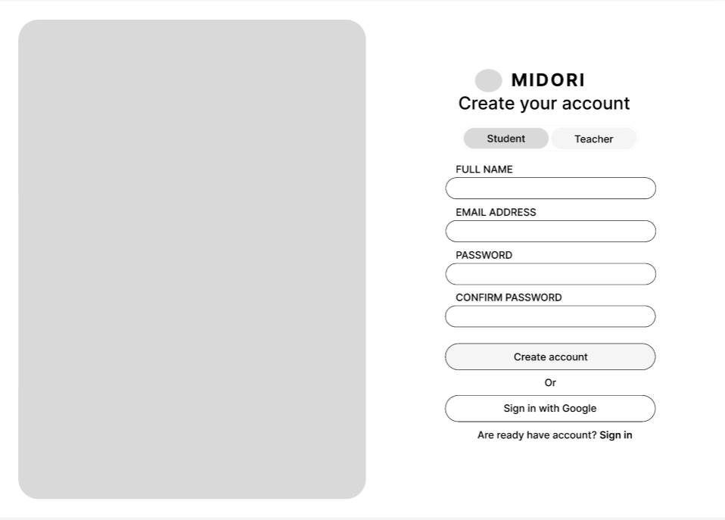
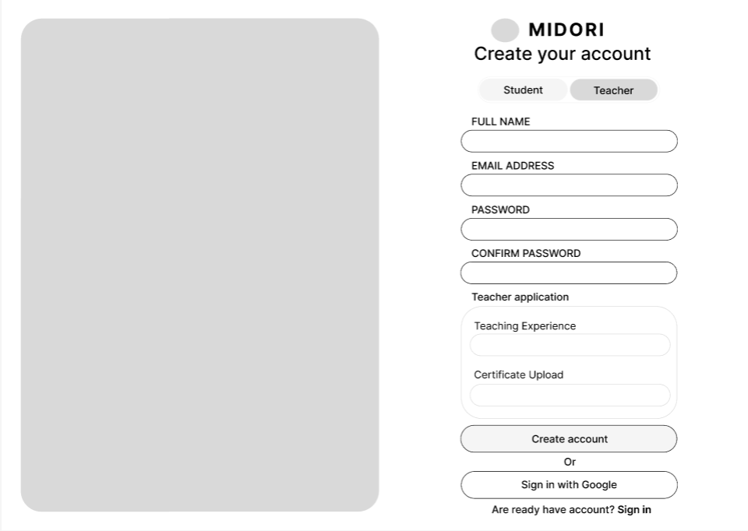
Field Name | Field Type | Description
Field Group Name
Role Toggle (Student / Teacher) | Segmented Control / Tab | Allows the user to select their role.  - Default: Student  - When a Teacher is selected the Teacher application section is revealed.
Full name | Text input | Enter the user's full name.
Email Address | Email Input | Enter your registered email address (The system will automatically check for valid email format).
Password | Password Input | Enter your account password (Characters will be displayed in hidden form).
Confirm Password | Password Input. | Re-enter your password to verify. It must match the PASSWORD field exactly.
Teaching Experience | Text/Number Input | Enter the number of years or a brief description of your teaching experience.
Certificate Upload | File Upload | component allows you to click/drag and drop to upload certificate files in PDF, PNG, JPG, and other formats.
Create account | Primary Button | This button confirms that the registration information has been submitted to the system.
Sign in with | Google Secondary Button | A quick sign-up button that integrates and verifies your Google account
Sign in | Text Link | Quick Navigation Button: Clicking this button will take you to the Sign In screen.

Database Access
Table | CRUD | Description
Users | R | Query to check if the registered email already exists in the system.
Users | C | Create a new user account with the following information: Name, Email, Password (encrypted hash), Role (Student/Teacher).
Teacher_Profiles | C | Create a new teacher application profile containing: user_id, teaching experience, and the path to save the certificate file. (Only applies when selecting the Teacher role)

SQL Commands

Check for duplicate emails:
SELECT COUNT(*) FROM Users WHERE email = :email_address;

Create new User account information:
INSERT INTO Users (full_name, email, password_hash, role, created_at, status)
VALUES (:full_name, :email_address, :password_hash, :role, NOW(), 'Active');

Create new Teacher profile information (If Role = Teacher):
INSERT INTO Teacher_Profiles (user_id, teaching_experience, certificate_url, application_status, updated_at)
VALUES (:user_id, :teaching_experience, :certificate_url, 'Pending', NOW());

1.2 Login
This screen allows user to be authenticated to the system screens/functionalities.
Related use cases:
- UC02_Login System

UI Design
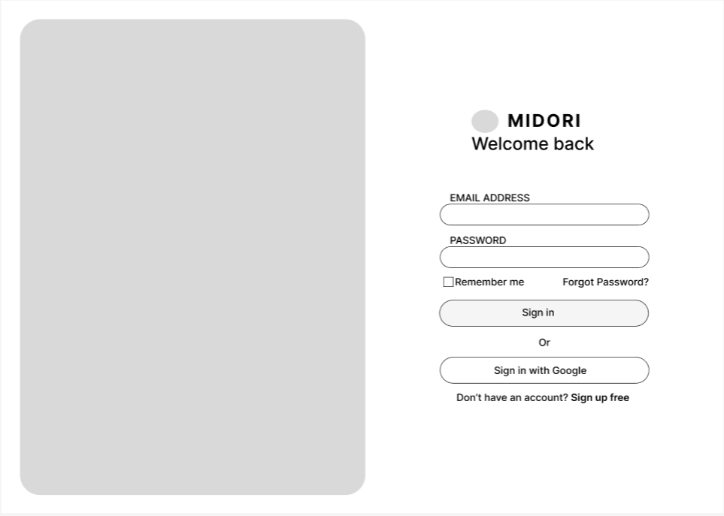

Field Name | Field Type | Description
Email Address | Email Input | Enter your registered email address (The system will automatically check for valid email format).
Password | Password Input | Enter your account password (Characters will be displayed in hidden form).
Sign in | Text Link | Quick Navigation Button: Clicking this button will take you to the Sign In screen.
Remember me | Checkbox | Allows users to optionally save their login status (maintains the session/token permanently so they don't have to log in again next time).
Forgot Password | Text Link | Quick navigation button: Clicking it will take you to the Password Recovery screen.
Sign in with Google: | Secondary Button | A quick login button using third-party authentication (Google OAuth).
Sign up free (Link) | Text Link. | Quick navigation button: Clicking this will take the user back to the Account Registration screen.
Sign in | Text Link | Quick Navigation Button: Clicking this button will take you to the Sign In screen.

Database Access
Table | CRUD | Description
Users | R | Verify the existence of the email address, retrieve password_hash, role, and account status.
Users | U | Update the last login time (last_login_at) after successful authentication.

SQL Commands:
Verify information and obtain authentication data:
SELECT id, password_hash, role, status
FROM Users
WHERE email = :email_address;

Update the last login time:
UPDATE Users
SET last_login_at = NOW()
WHERE id = :user_id;

1.3 Logout
The home screen requires data to be read when the page loads and handles session deletion when the user logs out.
- UC03_Logout

UI Design
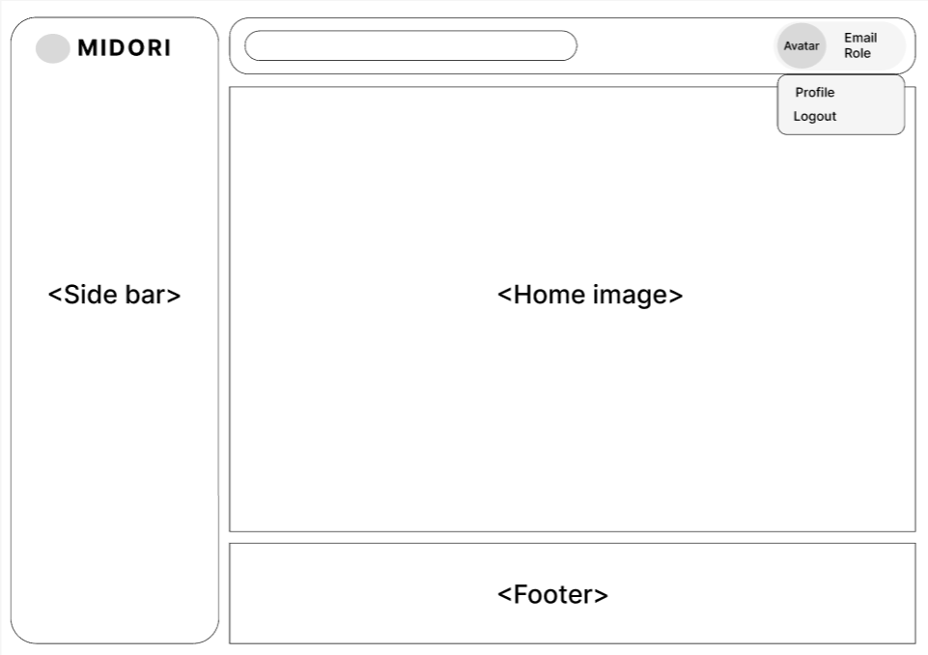

Field Name | Field Type | Description
Profile (Dropdown Option) | Text Link / Button | : This option is located in the dropdown menu. Clicking it will redirect the user to the personal information management page.
Logout (Dropdown Option) | Text Link / Button | This option is located in the dropdown menu. Clicking it will log out of the account and cancel the session.
The User Info Widget | Container block | displays the current user's information in the upper right corner, including Avatar, Email, and Role (Student/Teacher). Clicking on this area will activate the dropdown menu.
Search Bar | Text Input | The search bar is located in the header and allows users to quickly enter keywords for searching.

Database Access
Table | CRUD | Description
Users | R | Query basic information (email, role, avatar_url) of the current user via user_id to display in the Header.
User_Sessions / Tokens | D | Delete the session record or revoke the user's refresh token from the database when they select "Logout".

SQL Commands:
Upload user information to Header:
SELECT email, role, avatar_url
FROM Users
WHERE id = :current_user_id AND status = 'Active';

Delete/Revoke Session or Token when Logout:
DELETE FROM User_Sessions
WHERE user_id = :current_user_id AND session_token = :current_session_token;

1.4 View Profile
This display requires two-way data interaction to display and store information:
- UC04_ViewProfile

UI Design
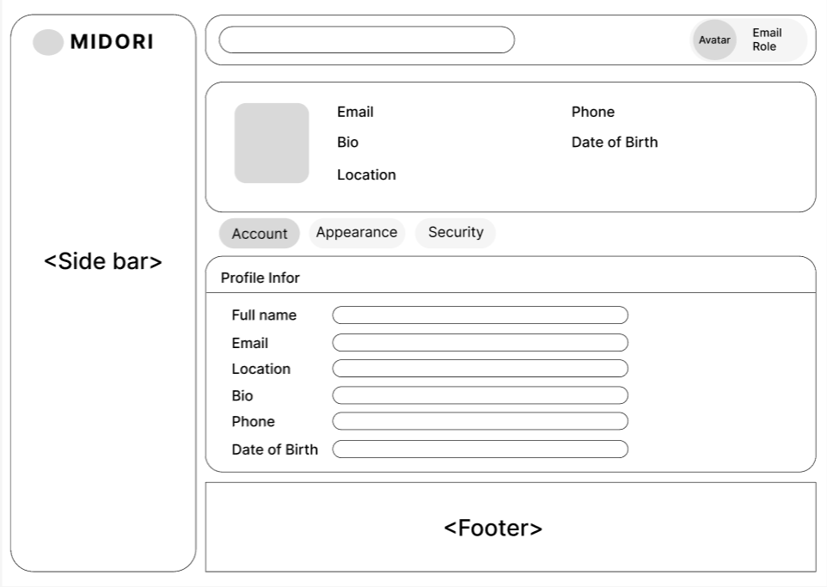

Field Name | Field Type | Description
Profile Summary Card | Container Display Block | This is the overview area at the top, quickly displaying the user's current information in read-only mode, including: Avatar, Email, Bio, Location, Phone, and Date of Birth.
Settings Tabs (Account / Appearance / Security) | Tab Control | Switching bar for settings subsystem. - Account: Current screen, used to edit personal information. - Appearance: Interface settings. - Security: Password/security settings.
Full name | Text Input: | Input field to update the user's full name.
Email | Text Input (Disabled/Read-only) | Displays the account's email address. This field is usually locked for security purposes, or requires a separate verification process to change.
Bio | Textarea / Text Input | Input field for a brief self-introduction or biography.
Phone | Phone/Number Input | An input field to update the contact phone number.
Date of Birth | Date Picker/Text Input | A field to select or enter the user's date of birth (day/month/year).

Database Access
Table | CRUD | Description
User_Profiles | R | Reads all details (full_name, location, bio, phone, date_of_birth, avatar_url) to display on the interface.
User_Profile |  | Updates the new changes from the form into the database according to user_id.

SQL Commands:
Query to get user profile information:
SELECT full_name, email, location, bio, phone, date_of_birth, avatar_url
FROM User_Profiles
WHERE user_id = :current_user_id;

Update and change profile information:
UPDATE User_Profiles
SET full_name = :full_name,
location = :location,
bio = :bio,
phone = :phone,
date_of_birth = :date_of_birth,
updated_at = NOW()
WHERE user_id = :current_user_id;

1.5 Edit Profile
This screen allows user to be authenticated to the system screens/functionalities.
Related use cases:
- UC05_EditProfile

UI Design
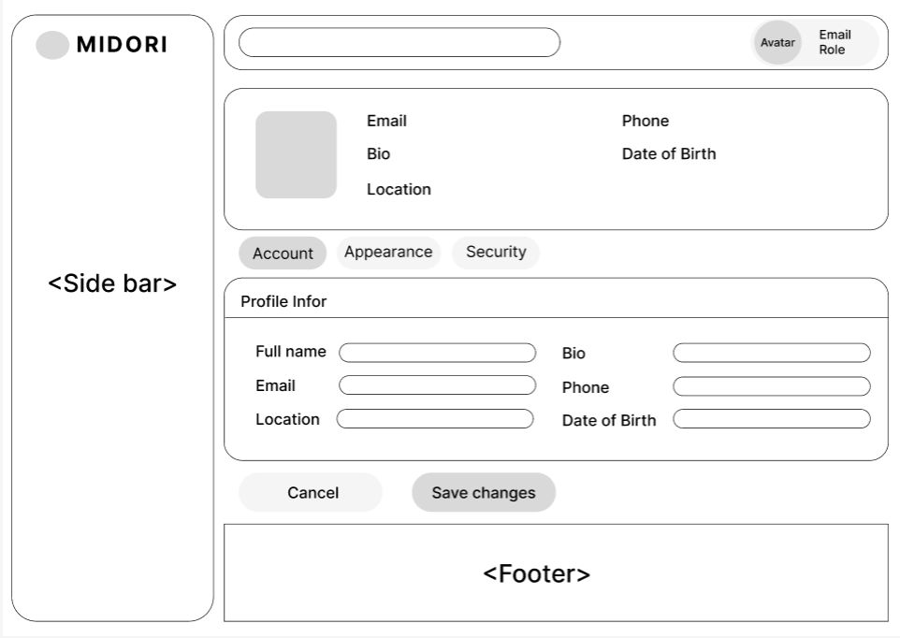

Field Name | Field Type | Description
Full name | Text Input: | Input field to update the user's full name.
Email | Text Input (Disabled/Read-only) | Displays the account's email address. This field is usually locked for security purposes, or requires a separate verification process to change.
Bio | Textarea / Text Input | Input field for a brief self-introduction or biography.
Location | Text Input | Editable input field for country/city details (Positioned in the left column).
Phone | Phone/Number Input | An input field to update the contact phone number.
Password | Password Input | Enter your account password (Characters will be displayed in hidden form).
Comfirm Password | Password Input. | Re-enter your password to verify. It must match the PASSWORD field exactly.
Profile Summary Card | Container Block | Top read-only widget showing active user values: Avatar, Email, Bio, Location, Phone, Date of Birth.
Settings Tabs | Tab Control | Switches configuration panels: Account (Active view), Appearance, and Security.
Cancel | Secondary Button | Discards any unsaved text changes in the form fields and reverts to original database values.

Database Access
Table | CRUD | Description
User_Profiles | R | Retrieves specific profile records to display on both the Summary Card and Form fields.
User_Profiles | U | Overwrites the existing profile details in the database once "Save changes" is pressed.

SQL Commands:
1. Fetch current profile values on page initialization
SELECT full_name, email, location, bio, phone, date_of_birth FROM User_Profiles WHERE user_id = :current_user_id;

2. Update modified profile details on "Save changes" action
UPDATE User_Profiles
SET full_name = :full_name,
location = :location,
bio = :bio,
phone = :phone,
date_of_birth = :date_of_birth,
updated_at = NOW()
WHERE user_id = :current_user_id;

1.6 Change password
When the user fills out the form and clicks the "Update Password" button, the application executes the following transaction logic
- UC02_Change password

UI Design
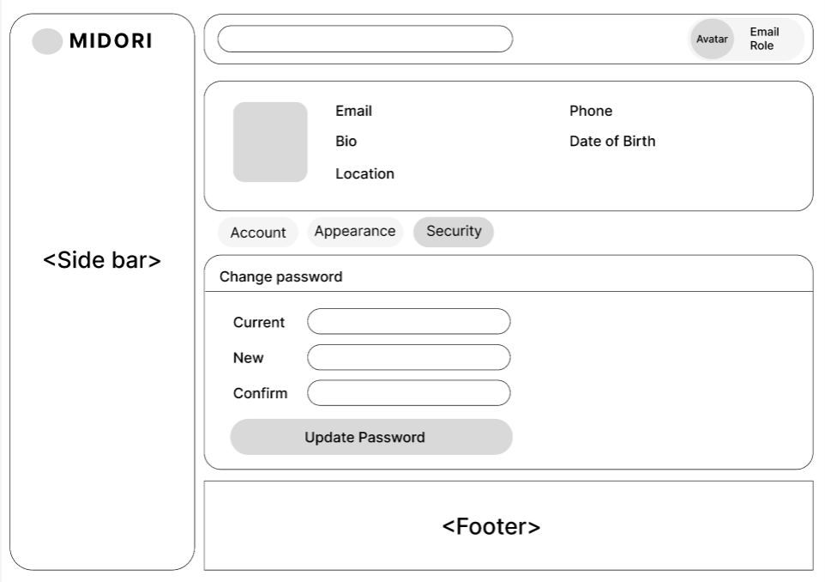
Field Name | Field Type | Description
Profile Summary Card | Container Block | Top read-only widget displaying a snapshot of user status, synchronized across all profile tabs.
Settings Tabs | Tab Control | Navigation tabs to toggle sub-panels: Account, Appearance, and Security (Currently active tab).
Current | Password Input | Input field to capture the user's existing password for identity verification (Masked with ).
New | Password Input | Input field to capture the new desired password string (Masked with ).
Confirm | Password Input | Re-entry field to confirm the new password. It must strictly match the value in the New field (Masked with ).
Update Password | Primary Button | Form submission button to validate inputs and persist the new credentials into the database.

Database Access
Table | CRUD | Description
Users | R | Fetches the current active password_hash to authenticate the user's input in the Current field.
Users | U | Commits and updates the newly hashed password string mapped securely by the authenticated user_id.

SQL Commands:
1. Retrieve current hashed password for verification
SELECT password_hash FROM Users WHERE id = :current_user_id;

-- 2. Update to the new hashed password upon successful validation
UPDATE Users
SET password_hash = :new_password_hash,
updated_at = NOW()
WHERE id = :current_user_id;

1.7 Forgot Password
This screen allows user to be authenticated to the system screens/functionalities.
Related use cases:
- UC02_Login System

UI Design
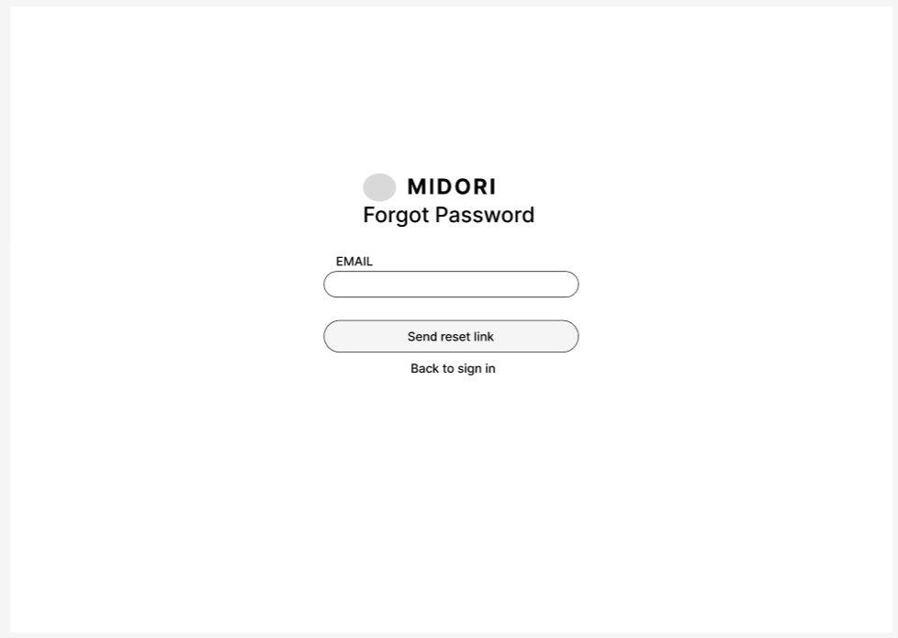
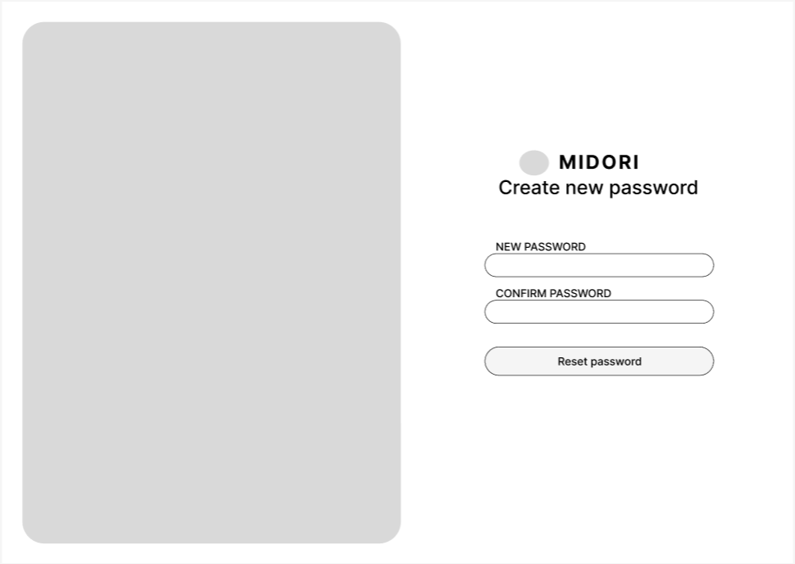
Field Name | Field Type | Description
EMAIL | Email Input | Captures the registered user's email address to initiate the recovery process.
Send reset link | Primary Button | Form submission button to generate and dispatch a password reset token/link to the inputted email.
Back to sign in (Link) | Text Link | Navigation shortcut redirecting users back to the standard Sign In/Login interface.
NEW PASSWORD | Password Input | Captures the new desired password string (Masked with • characters).
CONFIRM PASSWORD | Password Input | Re-entry field to confirm the new password. It must match the NEW PASSWORD value exactly (Masked with •).
Reset password | Primary Button | Final confirmation button to commit and persist the newly set password credentials to the database.

Database Access
Table | CRUD | Description
Users | R | Queries user identification utilizing the provided email address to verify account existence.
Password_Resets | C | Inserts the generated password reset metadata including the token, user link, and expiration timestamp.
Password_Resets | R | Validates the token's authenticity and status when the user loads the password modification view.
Users | U | Commits and overwrites the user's password_hash column with the newly encrypted data string.
Password_Resets | U | Modifies the token record status to used, preventing malicious replay attacks or token reuse.

SQL Commands:
1. Validate user email address existence
SELECT id, status FROM Users WHERE email = :email;

2. Store newly generated secure reset token
INSERT INTO Password_Resets (user_id, token, expires_at, created_at, is_used)
VALUES (:user_id, :reset_token, :expires_at, NOW(), 0);

3. Verify reset token validity and expiry window
SELECT user_id, expires_at FROM Password_Resets
WHERE token = :reset_token AND is_used = 0;

4. Update password record upon successful token verification
UPDATE Users
SET password_hash = :new_password_hash, updated_at = NOW()
WHERE id = :user_id;

5. Invalidate token after password change completion
UPDATE Password_Resets
SET is_used = 1
WHERE token = :reset_token;

1.8 Forgot Password
This screen allows user to be authenticated to the system screens/functionalities.
Related use cases:
- UC08_Forgot Password

UI Design


Field Name | Field Type | Description
Email* | Text Box | This is for user to input valid email address for logging in
Password* | Password Box | This is for user to input password for logging in
Sign in | Button | User clicks to authenticate him/herself into the system with provided email & password
Sign in free | Button | User clicks to redirect to the User Register page for registering new user account to access the system
Forgot Password? | Hyperlink | User clicks to redirect to the Password Reset page for resetting his/her forgot password
Login with Google | Hyperlink | Allow user to login with his/her Google account

Database Access
Table | CRUD | Description
User | R | Verify UserName & Password information
Setting, User | R | Specify the authorizations of the logged-in user

SQL Commands:
1/ Verify UserName & Password information

2/ Specify the authorizations of the logged-in user

2. Admin

2.1 Approve/Reject Exams
This screen allows user to be authenticated to the system screens/functionalities.
Related use cases:
- UC09_Approve/Reject_Exams

UI Design
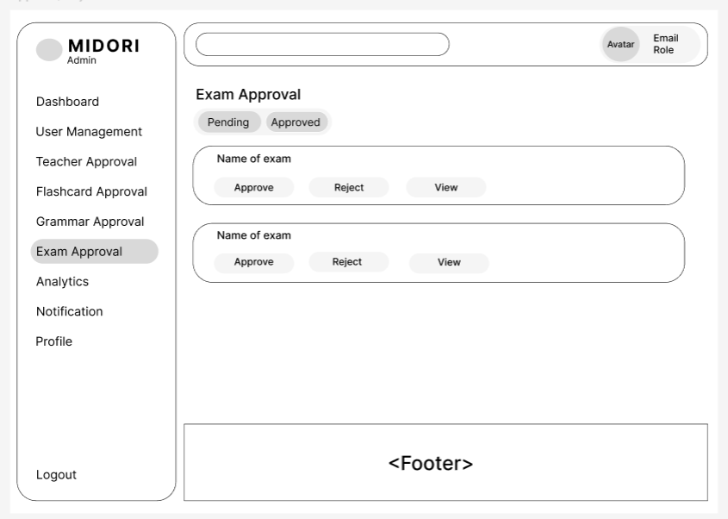
Field Name | Field Type | Description
<Side bar> (Admin) | Navigation Layout | Left-hand navigation dedicated to administration capabilities: Dashboard, User Management, Teacher Approval, Flashcard Approval, Grammar Approval, Exam Approval (Currently active), Analytics, Notification, Profile, and Logout.
Approval Status Tabs (Pending / Approved) | Tab Control | Status filter controls:- Pending: Lists all newly submitted exams awaiting moderation (Current View).- Approved: Views past certified exam histories.
Name of exam | Text Display | Renders the text title or identifier of the submitted test module.
Approve | Action Button | Certification verification trigger. Clicking this publishes the exam package globally for student access.
Reject | Action Button | Declines the submission. Can prompt for moderation notes or reason entries.
View | Action Button | Inspection tool to audit granular question items before making an approval decision.

Database Access
Table | CRUD | Description
Exams | R | Queries lists of submitted testing layouts based on selected active moderation tabs.
Exams | U | Alters target examination rows updating status tags (status = 'Approved' or 'Rejected') bound by action selections.

SQL Commands:
1/ Verify UserName & Password information

2/ Specify the authorizations of the logged-in user

2.2 Approve/Reject Flashcard
This screen allows user to be authenticated to the system screens/functionalities.
Related use cases:
- UC10_Login System

UI Design
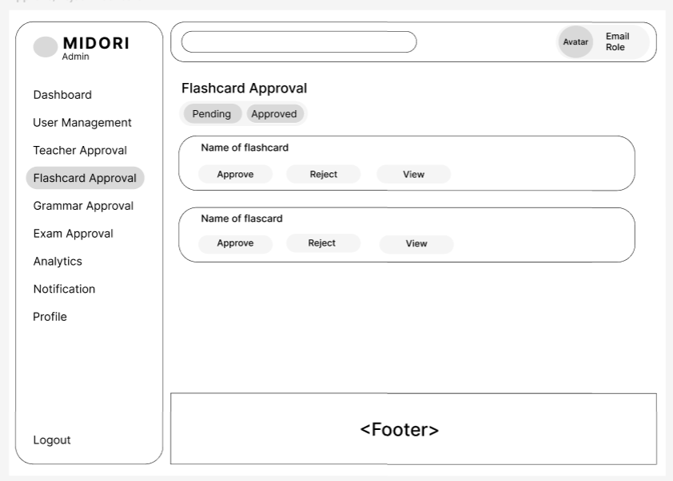
Field Name | Field Type | Description
Flashcard Approval (Active Menu) | Sidebar Item | Highlights the specific admin control node inside the sidebar suite upon interaction.
Approval Status Tabs (Pending / Approved) | Tab Control | State condition filters for grouping entries:  - Pending: Displays freshly drafted collections awaiting moderation (Default)  .- Approved: Inspects items already deployed into the library.
Name of flashcard | Text Display | Renders the text name header identifying the deck package currently selected for review.
Approve | Action Button | Confirms compliance, releasing the targeted study set into public learning streams.
Reject | Action Button | Denies the dataset and blocks public library index entries.
View | Action Button | Details explorer link allowing moderators to check individual card contents before deciding statuses.

Database Access
Table | CRUD | Description
Flashcard_Sets | R | Pulls rows representing student or instructor decks requiring platform processing.
Flashcard_Sets | U | Edits state indicators inside target card entries based on selected admin commands.

SQL Commands:
-- 1. Fetch unreviewed card packages (Pending Tab)
SELECT id, title, creator_id, created_at
FROM Flashcard_Sets
WHERE status = 'Pending'
ORDER BY created_at DESC;

-- 2. Commit deployment clearance parameters (Approve Button)
UPDATE Flashcard_Sets
SET status = 'Approved',
approved_by = :admin_id,
approved_at = NOW()
WHERE id = :flashcard_set_id;

-- 3. Reject target submitted deck items (Reject Button)
UPDATE Flashcard_Sets
SET status = 'Rejected',
approved_by = :admin_id,
approved_at = NOW()
WHERE id = :flashcard_set_id;

2.3 Approve/Reject Grammar
This screen allows user to be authenticated to the system screens/functionalities.
Related use cases:
- UC11_Approve/Reject Grammar

UI Design
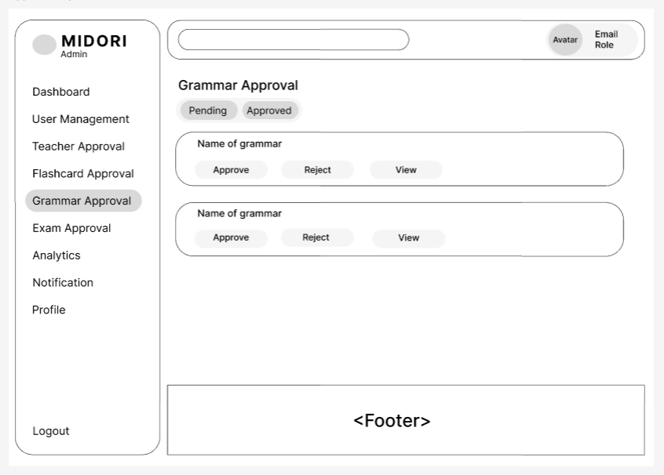
Field Name | Field Type | Description
Grammar Approval (Active Menu) | Sidebar Item | Indicates active sub-navigation positioning within the control core sidebar suite.
Approval Status Tabs (Pending / Approved) | Tab Control | Condition sorting filters to toggle view models:- Pending: Lists unreviewed lessons proposed by instructors (Default).- Approved: Lists validated grammatical content sets published in the learning index.
Name of grammar | Text Display | Renders the primary text topic title identifying the grammatical draft element undergoing examination.
Approve | Action Button | Validates submission compliance, shifting visibility indexes to make the lesson available to public learning channels.
Reject | Action Button | Dismisses the lesson request, blocking publication due to structural or contextual flaws.
View | Action Button | Modal inspector link allowing the reviewing moderator to audit specific item examples and explanations before saving changes.

Database Access
Table | CRUD | Description
Grammar_Lessons | R | Reviews system records to populate the target grid based on filtered lesson status parameters.
Grammar_Lessons | U | Alters target data fields changing tracking parameters (status = 'Approved' or 'Rejected') along with auditing admin identification signatures.

SQL Commands:
-- 1. Gather pending grammar structures submitted for curation
SELECT id, title, teacher_id, created_at
FROM Grammar_Lessons
WHERE status = 'Pending'
ORDER BY created_at DESC;

-- 2. Authorize grammar lesson deployment parameters (Approve Button)
UPDATE Grammar_Lessons
SET status = 'Approved',
approved_by = :admin_id,
approved_at = NOW()
WHERE id = :grammar_lesson_id;

-- 3. Decline submitted lesson structural layouts (Reject Button)
UPDATE Grammar_Lessons
SET status = 'Rejected',
approved_by = :admin_id,
approved_at = NOW()
WHERE id = :grammar_lesson_id;

2.4 Unlock/Lock User Account

- 2_Unlock/Lock User Account

UI Design
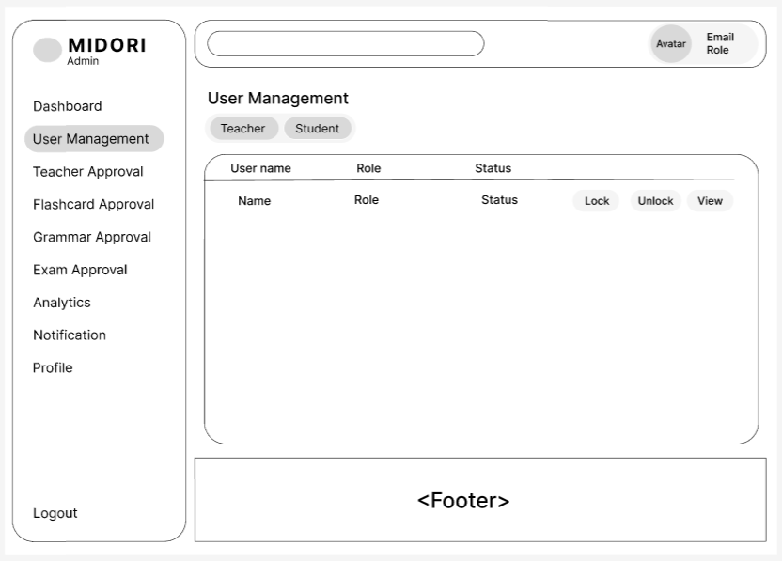
Field Name | Field Type | Description
User Management | Sidebar Item | Highlights the central account directory path node inside the primary administrative sidebar menu layout.
User Role Tabs | Tab Control | System profile filters to isolate view logs: Toggle the "Teacher" tab to manage instructor accounts or select "Student" to display registered learners.
Users Data Table | Data Grid | Structured data presentation component tracking system entities through clean metadata metrics: User name, account Role, and operational Status.
Lock | Action Button | Suspension tool. Freezes account execution by modifying tracking status parameters to "Locked" to block interface authentication.
Unlock | Action Button | Restoration command. Reactivates a suspended user row by resetting status parameters to "Active" to enable normal application access.
View | Action Button | Structural navigation hyperlink routing moderators directly to complete registration records, usage parameters, and active profile logs.

Database Access
Table | CRUD | Description
Users | R | Scans accounts from the backend database to populate monitoring tables tracking names, role indicators, and status tags.
Users | U | Alters specific account visibility variables (status) based on active administrative operational restriction inputs.

SQL Commands:
-- 1. Extract accounts filtered by assigned system Roles
SELECT id, full_name AS user_name, role, status FROM Users WHERE role = :selected_role ORDER BY full_name ASC;

-- 2. Modify account operational access status (Lock or Unlock)
UPDATE Users SET status = :new_status WHERE id = :target_user_id;
```</Side></Side>

2.5 Approve/Reject Teacher Account

- UC13_Approve/Reject Teacher Account

UI Design
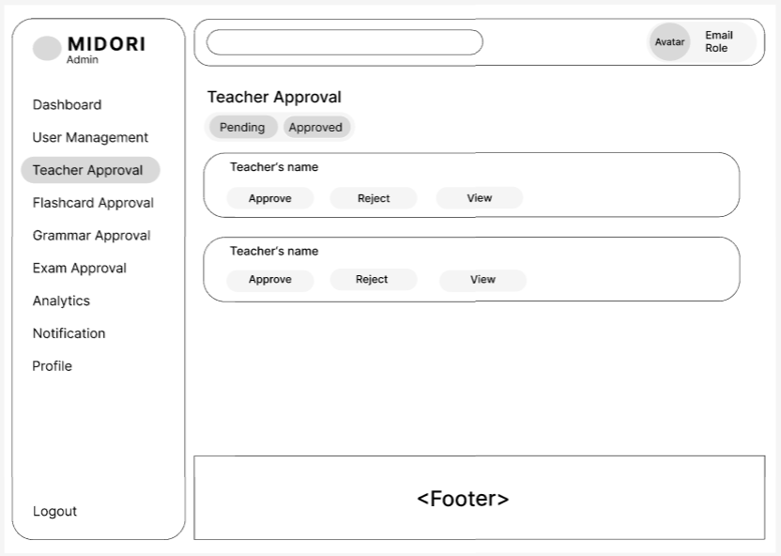
Field Name | Field Type | Description
Teacher Approval | Sidebar Item | Indicates active sub-navigation workspace positioning within the main administrator interface shell for registration verification workflows.
Approval Status Tabs | Tab Control | Categorized control filters separating requests into "Pending" for incoming educator sign-ups (Default) and "Approved" for certified teacher rows.
Teacher's name | Text Display | Renders the primary legal full name string identifying the educator applicant undergoing credentials checking.
Approve | Action Button | Administrative clearance trigger that sets user row variables to 'Active' status and updates pedagogical access roles.
Reject | Action Button | Dismisses the registration request, leaving account parameters disabled and preventing application system entry.
View | Action Button | Modal layout explorer link enabling the moderator to audit descriptive professional experience history and attached file certificate links.

Database Access
Table | CRUD | Description
Teacher_Applications | R | Collects active educator application logs matching chosen status filters to dynamically populate the moderation list component.
Users | Teacher_Apps | U | Modifies baseline identity conditions setting state trackers ('Active' or 'Approved') following authorization events.

SQL Commands:
-- Extract unreviewed registration rows
SELECT ta.id, u.full_name AS teacher_name, ta.teaching_experience, ta.created_at FROM Teacher_Applications ta JOIN Users u ON ta.user_id = u.id WHERE ta.status = 'Pending' ORDER BY ta.created_at DESC;

-- Authorize educator status properties
UPDATE Users SET status = 'Active' WHERE id = :target_user_id;
UPDATE Teacher_Applications SET status = 'Approved', reviewed_by = :admin_id, reviewed_at = NOW() WHERE user_id = :target_user_id;

2.6 View User Analytics

- UC14_View User Analytics

UI Design
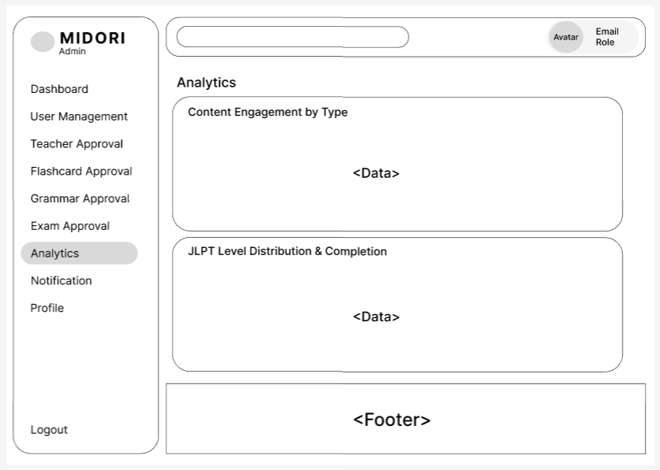
Field Name | Field Type | Description
Analytics (Active Menu) | Sidebar Item | Features highlighted navigation formatting on the main control core sidebar menu layout when viewing metrics data.
Content Engagement by Type | Chart/Data Card | Renders visual analytical chart layouts detailing aggregate platform interaction metrics segmented by core feature scopes like Flashcards, Grammar, or Exams.
JLPT Level Distribution & Completion | Chart/Data Card | Provides statistical breakdowns mapping universal student enrollment volumes across JLPT bands alongside average course progression percentage tracking.

Database Access
Table | CRUD | Description
User_Activities | R | Aggregates user operational telemetry logs tracking page interactions and submittals to construct specific content distribution trends.
User_Progress | R | Collects platform completion milestones and account configuration values to model average system learning progress charts.

SQL Commands:
-- Query interaction summary group counts by type
SELECT content_type, COUNT(*) AS total_interactions FROM User_Activities GROUP BY content_type;

-- Gather student volume and progress values per JLPT band
SELECT jlpt_level, COUNT(user_id) AS student_count, AVG(completion_rate) AS avg_completion FROM User_Progress GROUP BY jlpt_level;

3. Teacher

3.1 Add Vocabulary

- UC15_ Add Vocabulary

UI Design
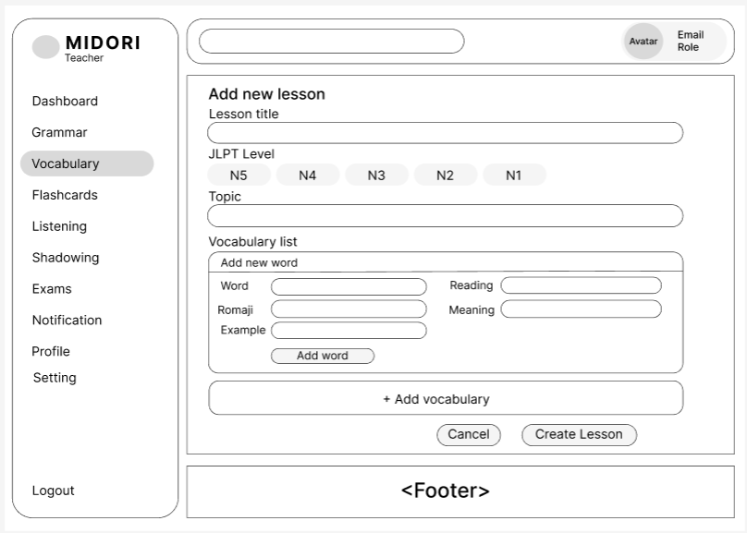

Field Name | Field Type | Description
Vocabulary (Active Menu) | Sidebar Item | Displays highlighted navigation formatting within the primary Teacher dashboard sidebar, indicating that the user is currently working inside the Vocabulary module.
Lesson title | Text Input | Structured plain text data entry field enabling the instructor to specify the official core title or name designation for the new vocabulary lesson.
JLPT Level | Radio Button Group | Single-selection element group used to classify the overall difficulty level of the material under standardized Japanese proficiency marks from N5 down to N1.
Topic | Text Input | Specialized text interface element to configure the specific contextual theme or conceptual classification of the words clustered within the lesson layout.
Word | Text Input | Input container targeted to capture the primary Japanese term spelled out in standardized characters including Kanji, Hiragana, or Katakana fields.
Reading | Text Input | Dedicated text entry field used to document the pure kana reading of the corresponding term to establish clear phonetic structures for users.
Romaji | Text Input | Text field to input the Latin alphabet transliteration of the Japanese term, ensuring users can accurately pronounce vocabulary elements.
Meaning | Text Input | Form entry layout designed to capture the semantic explanation or literal language translations for the corresponding Japanese word row.
Example | Text Input | Practical context text block allocated for documenting comprehensive sample sentences showcasing the active deployment of the vocabulary item.
Add word | Action Button | In-line workflow action trigger that saves the currently configured word data parameters into the lesson's temporary volatile compilation list view.
+ Add vocabulary | Action Button | Layout expansion control button designed to instantly append a clean new word registration sub-form block inside the current creation workspace.
Cancel | Action Button | Operational exit switch that completely terminates the active vocabulary session without persisting data records and re-routes back to lists.
Create Lesson | Action Button | Final transactional action trigger validating input field criteria and performing the backend insertion to permanently publish or stage the new lesson.

Database Access

Table | CRUD | Description
Vocabulary_Lessons | C | Inserts a new base log containing fundamental lesson attributes like title string, target level indicator, theme, and authoring account information.
Vocabulary_Items | C | Executes transactional relational record insertions storing item definitions linked directly to the newly established primary key identifier.

SQL Commands:
-- Store the fundamental configuration parameters of the new lesson unit
INSERT INTO Vocabulary_Lessons (title, jlpt_level, topic, teacher_id, status, created_at)
VALUES (:title, :jlpt_level, :topic, :teacher_id, 'Pending', NOW());

-- Populate the word collection records tied to the generated parent entity
INSERT INTO Vocabulary_Items (lesson_id, word, reading, romaji, meaning, example)
VALUES (:inserted_lesson_id, :word, :reading, :romaji, :meaning, :example);

3.2 Edit Vocabulary

- UC16_ Edit Vocabulary

UI Design

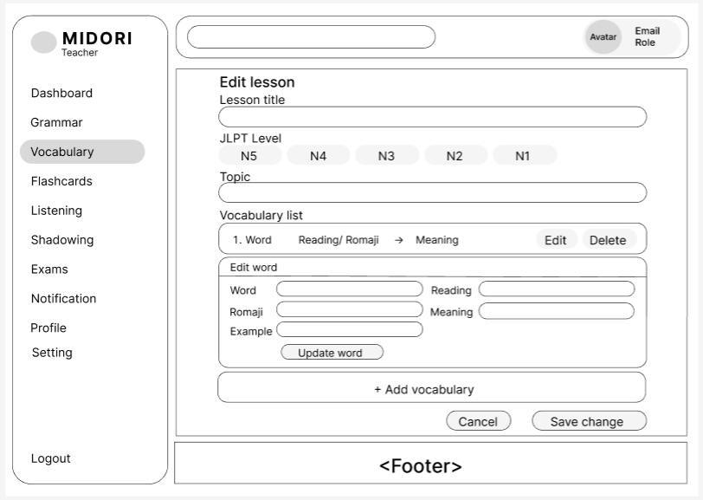
Field Name | Field Type | Description
Vocabulary (Active Menu) | Sidebar Item | Highlights navigation positioning within the primary Teacher sidebar layout, signaling that the user is manipulating entities in the Vocabulary core module.
Lesson title | Text Input | Populates the existing title text configuration of the vocabulary lesson, allowing instructors to input alphanumeric edits to modify the header name.
JLPT Level | Radio Button Group | Segmented radio selectors used to reclassify the structural Japanese proficiency target rank (N5 down to N1) assigned to the current data entity.
Topic | Text Input | Interface text block holding the active lesson theme value, enabling educators to update classification keywords for better grouping.
Vocabulary list row | Data Row | Formatted log entry rendering summary strings of a saved word model using a structured format: Serial Number, Japanese Word, Reading/Romaji -> Translation.
Edit (Row Action) | Action Button | In-line record control trigger that copies the row's metadata variables down into the "Edit word" detail workspace panel for direct value modification.
Delete (Row Action) | Action Button | Contextual operational command button that immediately purges the selected vocabulary row out of the active staging catalog matrix.
Edit word panel | Form Container | Dynamic nested form layout container displaying detailed input controls dedicated to updating an individual word instance chosen from the repository queue.
Word | Text Input | Text field displaying the target native Japanese character string (Kanji or Kana) allocated for character structure modifications.
Reading | Text Input | Form entry container configured to update or correct the exact phonetic kana representation string of the targeted item.
Romaji | Text Input | Alphabetical character text field allocated to adjust the standardized Latin alphabet transliteration profile mapping for learners.
Meaning | Text Input | Form data field used to modify the target language text explanations or localized semantic definitions of the Japanese entity.
Example | Text Input | Contextual plain text area designated to change or enrich accompanying sample sentence parameters detailing structural language use.
Update word | Action Button | Intermediate local action command that persists row variable modifications temporarily back up into the visual data table display grid.
+ Add vocabulary | Action Button | Layout expansion control used to append a clean blank vocabulary entry sub-form at the bottom of the current workspace array.
Cancel | Action Button | Operational exit command discarding all session text adjustments and safely returning the interface back to previous dashboard indexes.
Save change | Action Button | Main transactional execution button validating text field conditions and permanently flushing the multi-row structural updates to the database records.

Database Access
Table | CRUD | Description
Vocabulary_Lessons | R | Queries high-level baseline details (title, level indicator, topic metadata) corresponding to the unique lesson tracking ID parameter.
Vocabulary_Items | R | Extracts all individual lexical definitions associated with the parent lesson reference key to render the operational view rows.
Vocabulary_Lessons | U | Overwrites base configuration rows with modified values inside persistent storage arrays when the instructor confirms the transaction.
Vocabulary_Items | C/U/D | Executes bulk pipeline mutations (inserts, updates, deletes) synchronizing relational records with the modified UI item collection states.

SQL Commands:
-- Read lesson and individual items metadata for form initialization
SELECT id, title, jlpt_level, topic FROM Vocabulary_Lessons WHERE id = :lesson_id;
SELECT id, word, reading, romaji, meaning, example FROM Vocabulary_Items WHERE lesson_id = :lesson_id ORDER BY id ASC;

-- Update lesson parameters upon clicking Save change
UPDATE Vocabulary_Lessons SET title = :title, jlpt_level = :jlpt_level, topic = :topic, updated_at = NOW() WHERE id = :lesson_id;

-- Persist individual word item data modifications
UPDATE Vocabulary_Items SET word = :word, reading = :reading, romaji = :romaji, meaning = :meaning, example = :example WHERE id = :item_id;

3.3 Delete Vocabulary

- UC16_Delete Vocabulary

UI Design
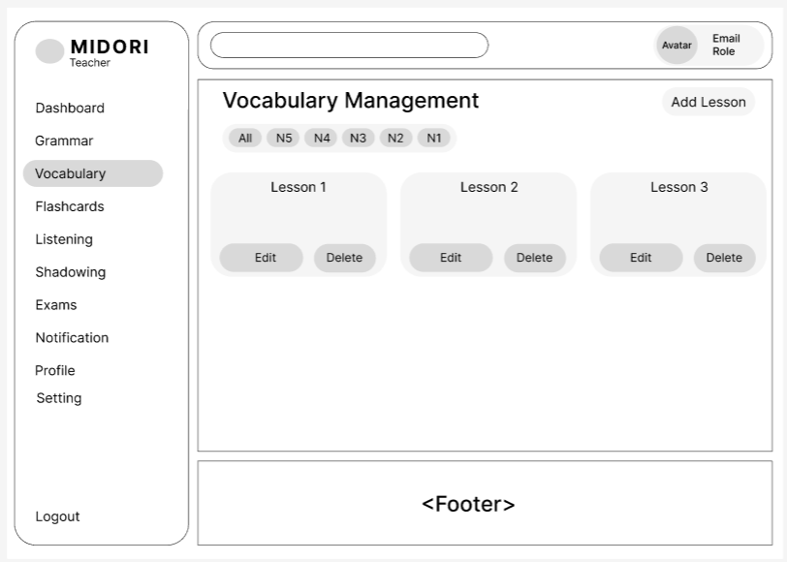
Field Name | Field Type | Description
Vocabulary (Active Menu) | Sidebar Item | Maintains highlighted formatting layouts on the primary Teacher sidebar core menu to indicate the active focus remains on the dashboard directory for vocabulary content.
Add Lesson | Action Button | Top-level shortcut action command button routing the instructor immediately into the blank vocabulary lesson creation form wizard workspace.
JLPT Level Filters | Tab Control | Horizontal segmented selection tabs allowing the user to seamlessly isolate or change displayed lesson rosters using standardized JLPT tags ranging from All to N1.
Lesson Card | Container/Card | Grid layout container element rendering a concise summary view block for a single lesson entity, displaying its core title text alongside modification action buttons.
Edit (Card Action) | Action Button | Contextual operational command switch mapped inside the card component to redirect the instructor to the dedicated multi-row lesson editing module view.
Delete (Card Action) | Action Button | Destructive processing trigger allowing teachers to completely purge the designated lesson metadata record from the main application datastore grid.

Database Access
Table | CRUD | Description
Vocabulary_Lessons | R | Scans and pulls all vocabulary index records associated with the logged-in teacher account, applying conditional clauses to respect active tab difficulty selections.
Vocabulary_Lessons | D | Permanently expunges selected parent lesson records and cascades relational cleanup operations down matching individual lexical word database definitions.

SQL Commands:
-- Query vocabulary lesson groups matching the selected proficiency tab filter
SELECT id, title, jlpt_level, topic, created_at FROM Vocabulary_Lessons WHERE teacher_id = :teacher_id AND (:selected_level = 'All' OR jlpt_level = :selected_level) ORDER BY created_at DESC;

-- Remove an existing lesson from the persistence data layer
DELETE FROM Vocabulary_Lessons WHERE id = :lesson_id AND teacher_id = :teacher_id;

3.4 Add Grammar Lessons
This screen allows user to be authenticated to the system screens/functionalities.
Related use cases:
- UC18_Add Grammar Lessons

UI Design
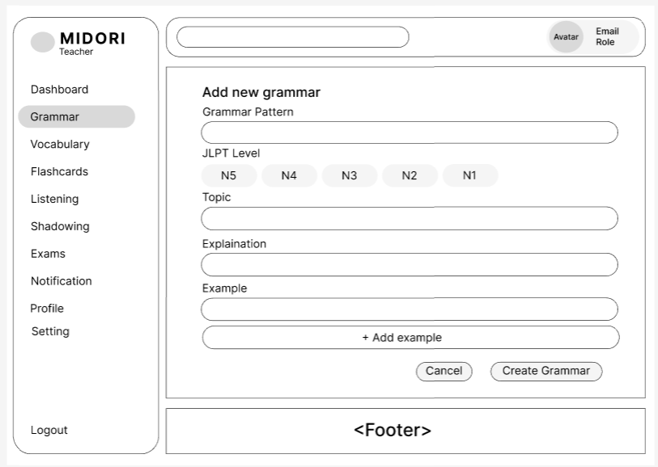
Field Name | Field Type | Description
Grammar (Active Menu) | Sidebar Item | Displays highlighted navigation formatting within the primary Teacher sidebar, confirming that the current workspace focus sits inside the Grammar module.
Grammar Pattern | Text Input | Structured plain text entry field enabling the instructor to specify the official core Japanese grammar formula or structural pattern.
JLPT Level | Radio Button Group | Single-selection option group used to classify the overall technical difficulty under standardized Japanese proficiency benchmarks from N5 down to N1.
Topic | Text Input | Text input block allocated for configuring the specific theme, metadata keywords, or conceptual category tags for the corresponding grammar item.
Explanation | Text Input | Dedicated input field designed to host comprehensive semantic meanings, contextual deployment parameters, and precise syntactic rules for the user.
Example | Text Input | Text form entry designed to log practical full-sentence usage instances that demonstrate the active structural implementation of the grammar pattern.
+ Add example | Action Button | Workspace layout control used to dynamically append a clean new specimen sentence input sub-row container within the active screen grid.
Cancel | Action Button | Operational workflow cancellation switch discarding all active configuration inputs and returning the user context back to previous summary indexes.
Create Grammar | Action Button | Final transactional processing trigger validating all input rules and executing backend database procedures to safely insert the completed record.

Database Access
Table | CRUD | Description
Grammar_Lessons | C | Performs persistent record generation storing high-level formula attributes including pattern strings, difficulty rankings, text descriptions, and creator accounts.
Grammar_Examples | C | Populates dependent database relational logs storing text string examples tied directly back to the primary key tracking reference of the parent item.

SQL Commands:
-- Create a new baseline grammar record profile
INSERT INTO Grammar_Lessons (grammar_pattern, jlpt_level, topic, explanation, teacher_id, status, created_at)
VALUES (:grammar_pattern, :jlpt_level, :topic, :explanation, :teacher_id, 'Pending', NOW());

-- Append corresponding demonstration items bound to the primary entity reference
INSERT INTO Grammar_Examples (grammar_id, example_content)
VALUES (:inserted_grammar_id, :example_content);

3.5 Edit Grammar Lessons

- UC19_ Edit Grammar Lessons

UI Design
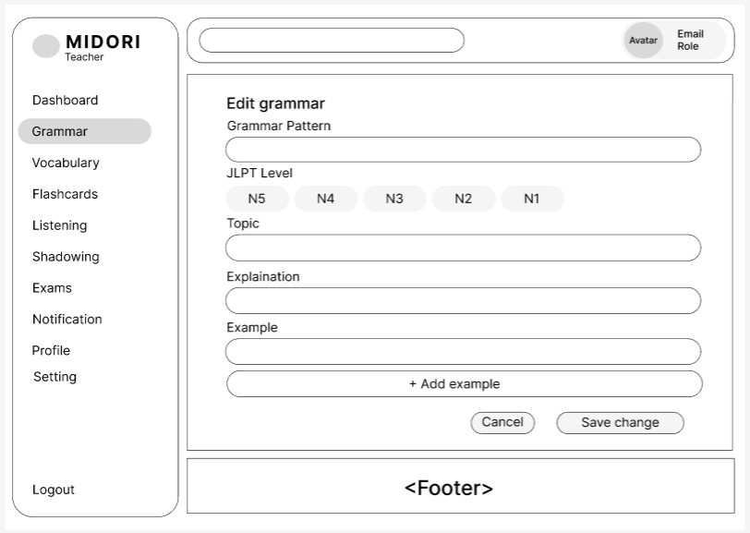
Field Name | Field Type | Description
Grammar (Active Menu) | Sidebar Item | Displays highlighted navigation formatting within the primary Teacher sidebar layout, signaling that the user is actively updating an existing entry inside the Grammar module.
Grammar Pattern | Text Input | Form entry layout displaying the current Japanese grammar formula string, enabling the instructor to perform text modifications to the structural pattern.
JLPT Level | Radio Button Group | Segmented option switches allowing the teacher to reclassify the structural Japanese proficiency tier benchmark ranging from N5 down to N1.
Topic | Text Input | Alphanumeric text interface element displaying the existing lesson category, allowing instructors to adjust or overwrite the theme metadata keywords.
Explaination | Text Input | Content entry area holding the detailed rule explanations and context descriptions, allocated for modifying pedagogical breakdowns and usage conditions.
Example | Text Input | Text input block populated with existing sample sentences, enabling the author to edit individual demonstration statements and text instances.
+ Add example | Action Button | Layout configuration switch designed to dynamically append an additional blank sample sentence input sub-row container onto the screen grid.
Cancel | Action Button | Operational exit command discarding all current text field adjustments and safely returning the workflow state back to previous directory indexes.
Save change | Action Button | Core transactional execution button validating form input rules and permanently flushing the updated grammar row variables to the persistent datastore.

Database Access
Table | CRUD | Description
Grammar_Lessons | R | Queries high-level pattern properties, difficulty ranks, and explanation metadata corresponding to the targeted unique grammar record ID parameter.
Grammar_Examples | R | Pulls dependent demonstration sentence rows linked directly to the parent grammar record reference key to initialize the editing workspace views.
Grammar_Lessons | U | Overwrites specific configuration rows inside persistent storage tables with modified attribute values when the instructor commits changes.
Grammar_Examples | C/U/D | Executes bulk relational pipeline data operations to insert, update, or remove dependent example strings matching the finalized interface collection states.

SQL Commands:
-- Read primary grammar and relational example entries for form data initialization
SELECT id, grammar_pattern, jlpt_level, topic, explanation FROM Grammar_Lessons WHERE id = :grammar_id;
SELECT id, example_content FROM Grammar_Examples WHERE grammar_id = :grammar_id ORDER BY id ASC;

-- Overwrite core grammar properties upon clicking Save change
UPDATE Grammar_Lessons SET grammar_pattern = :grammar_pattern, jlpt_level = :jlpt_level, topic = :topic, explanation = :explanation, updated_at = NOW() WHERE id = :grammar_id;

3.6 Delete Grammar Lessons

- UC20_Delete Grammar Lessons

UI Design
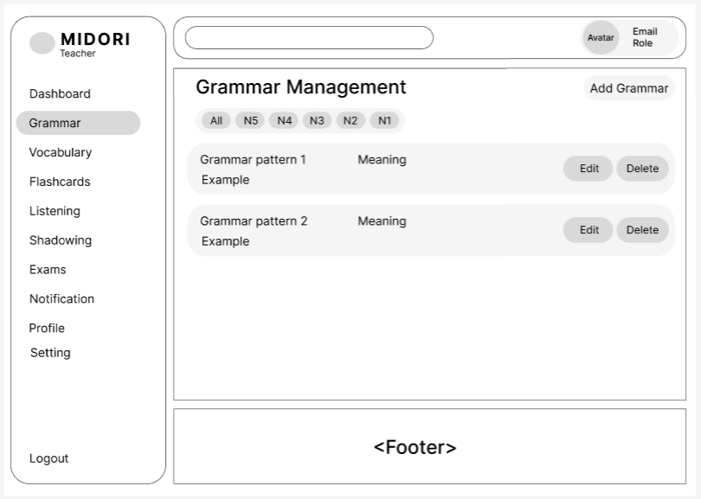
Field Name | Field Type | Description
Grammar (Active Menu) | Sidebar Item | Main shadow navigation item within the Teacher side menu layout, highlighted to confirm the active workspace focus rests inside the Grammar module directory.
Add Grammar | Action Button | Global operational command button routing the instructor directly to the blank grammar lesson creation form view wizard.
JLPT Level Filters | Tab Control | Horizontal tab control controls allowing the user to filter displayed grammar items using standardized JLPT tags ranging from All to N1.
Grammar Row/Card | Container/Card | Visual block component rendering concise summaries of an active grammar rule entity, detailing its pattern name, core meaning translation, and illustrative example string.
Edit (Row Action) | Action Button | Contextual operational item command switch mapped inside the listing row to redirect teachers to the dedicated grammar lesson modification workspace view.
Delete (Row Action) | Action Button | Destructive action trigger allowing instructors to completely purge the designated grammar metadata profile log from the persistent database application grid.

Database Access
Table | CRUD | Description
Grammar_Lessons | R | Scans and pulls grammar formula index logs associated with the logged-in teacher account, applying conditional clauses to respect active tab difficulty selections.
Grammar_Lessons | D | Permanently expunges selected grammar lesson profiles and cascades relational cleanup operations down matching dependent demonstration statements.

SQL Commands:
-- Query grammar lessons matching the selected proficiency tab filter
SELECT gl.id, gl.grammar_pattern, gl.explanation AS meaning, (SELECT ge.example_content FROM Grammar_Examples ge WHERE ge.grammar_id = gl.id LIMIT 1) AS example FROM Grammar_Lessons gl WHERE gl.teacher_id = :teacher_id AND (:selected_level = 'All' OR gl.jlpt_level = :selected_level) ORDER BY gl.created_at DESC;

-- Remove an existing grammar lesson profile from the persistence data layer
DELETE FROM Grammar_Lessons WHERE id = :grammar_id AND teacher_id = :teacher_id;

3.7 Add Listening Lessons
- UC21_Add Listening Lessons

UI Design
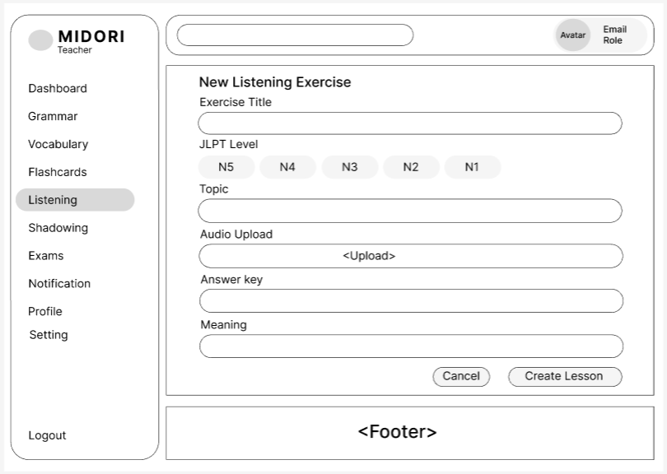
Field Name | Field Type | Description
Listening (Active Menu) | Sidebar Item | Displays highlighted navigation formatting within the primary Teacher sidebar, confirming that the current workspace focus sits inside the Listening exercise module.
Exercise Title | Text Input | Structured plain text entry field enabling the instructor to specify the official core title or name designation for the new listening exercise.
JLPT Level | Radio Button Group | Single-selection option group used to classify the target Japanese proficiency difficulty benchmark ranging from N5 down to N1.
Topic | Text Input | Text input block allocated for configuring the specific theme, metadata keywords, or conceptual category tags for the corresponding listening item.
Audio Upload | File Upload Component | Interactive drag-and-drop or click zone enabling the instructor to browse, select, and upload the core lesson audio file (.mp3, .wav) into the platform data repository.
Answer key | Text Input | Text field allowing the teacher to specify the correct answer options, solution grading parameters, or official verbatim audio transcriptions.
Meaning | Text Input | Form input area allocated to record comprehensive translation descriptions or detailed contextual semantic breakdowns of the audio material.
Cancel | Action Button | Operational workflow cancellation switch discarding all active configuration inputs and safely returning the user context back to previous directory indexes.
Create Lesson | Action Button | Final transactional processing trigger validating form input criteria and executing backend database procedures to safely insert the completed record.

Database Access
Table | CRUD | Description
Listening_Exercises | C | Performs persistent record generation storing high-level audio attributes including title string, difficulty ranking, theme keywords, multimedia asset URL, grading solutions, and creator account references.

SQL Commands:
-- Create a new baseline listening exercise record profile
INSERT INTO Listening_Exercises (title, jlpt_level, topic, audio_url, answer_key, meaning, teacher_id, status, created_at)
VALUES (:title, :jlpt_level, :topic, :audio_url, :answer_key, :meaning, :teacher_id, 'Pending', NOW());

3.8 Edit Listening Lessons

- UC22_ Edit Listening Lessons

UI Design
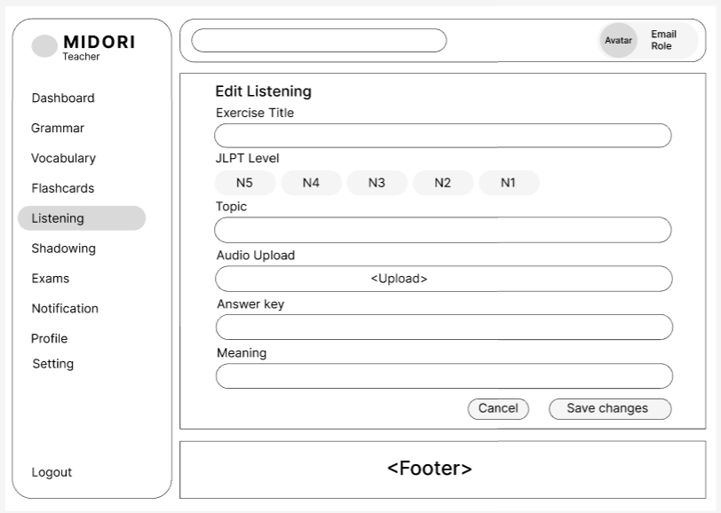

Field Name | Field Type | Description
Listening (Active Menu) | Sidebar Item | Displays highlighted navigation formatting within the primary Teacher sidebar layout, signaling that the user is actively modifying an existing record inside the Listening exercise module.
Exercise Title | Text Input | Populates the existing title string configuration of the listening task, allowing the instructor to input alphanumeric changes to modify the heading description.
JLPT Level | Radio Button Group | Segmented option switches enabling the teacher to reclassify the structural Japanese proficiency tier benchmark ranging from N5 down to N1.
Topic | Text Input | Alphanumeric text interface element displaying the active exercise category, allowing instructors to adjust or overwrite the theme metadata keywords.
Audio Upload | File Upload Component | Dedicated media uploader rendering active audio file parameters and supporting the upload of alternative auditory tracks (.mp3, .wav) to refresh the core lesson asset.
Answer key | Text Input | Text form field holding active grading solution options, response templates, or dialogue transcripts, enabling the author to edit validation attributes.
Meaning | Text Input | Form input container presenting current context translations or detailed semantic breakdowns of the audio material, allocated for modifying target-language references.
Cancel | Action Button | Operational exit switch discarding all unsubmitted session modifications and safely returning the workflow interface context back to the primary directory index.
Save changes | Action Button | Main transactional execution trigger validating text field criteria and permanently flushing the multi-field structural mutations to the backend database tables.

Database Access
Table | CRUD | Description
Listening_Exercises | R | Queries precise audio profile fields corresponding to the target record identification key to systematically populate the administrative form component.
Listening_Exercises | U | Modifies specific parameters inside target storage rows to overwrite database properties with verified changes upon authorization input.

SQL Commands:
-- Get detailed listening exercise information to display on the editing form
SELECT id, title, jlpt_level, topic, audio_url, answer_key, meaning FROM Listening_Exercises WHERE id = :exercise_id;

-- Update the changes to the listening exercise (Save changes button)
UPDATE Listening_Exercises SET title = :title, jlpt_level = :jlpt_level, topic = :topic, audio_url = :audio_url, answer_key = :answer_key, meaning = :meaning, updated_at = NOW() WHERE id = :exercise_id;

3.9 Delete Listening Lessons

- UC23_Delete Listening Lessons

UI Design
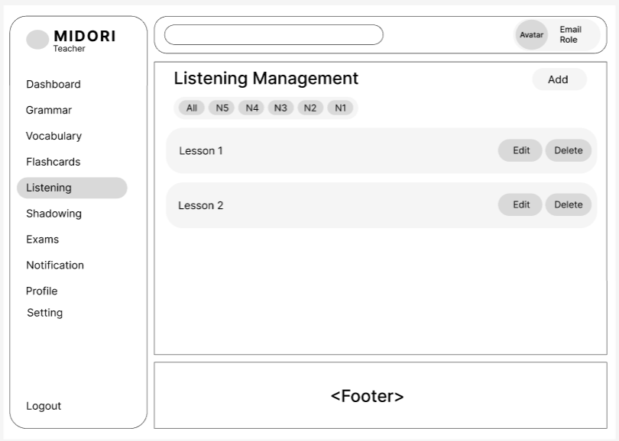

Field Name | Field Type | Description
Listening (Active Menu) | Sidebar Item | Maintains highlighted formatting layouts on the primary Teacher sidebar core menu to indicate the active focus remains on the dashboard directory for listening content.
Add | Action Button | Top-level shortcut action command button routing the instructor immediately into the blank listening exercise creation form wizard workspace.
JLPT Level Filters | Tab Control | Horizontal segmented selection tabs allowing the user to seamlessly isolate or filter displayed listening exercises using standardized JLPT tags ranging from All to N1.
Lesson Row/Card | Container/Card | Grid layout container element rendering a concise summary view block for a single listening exercise entity, displaying its core lesson title text alongside modification action buttons.
Edit (Row Action) | Action Button | Contextual operational command switch mapped inside the listing row to redirect the instructor to the dedicated listening exercise modification module view.
Delete (Row Action) | Action Button | Destructive processing trigger allowing teachers to completely purge the designated listening exercise metadata record from the main application datastore grid.

Database Access
Table | CRUD | Description
Listening_Exercises | R | Scans and pulls all listening exercise records associated with the logged-in teacher account, applying conditional clauses to respect active tab difficulty selections.
Listening_Exercises | D | Permanently expunges selected listening exercise parent records and clears corresponding metadata profiles from the persistent database application grid.

SQL Commands:
-- Query listening exercise groups matching the selected proficiency tab filter
SELECT id, title, jlpt_level, topic, created_at FROM Listening_Exercises WHERE teacher_id = :teacher_id AND (:selected_level = 'All' OR jlpt_level = :selected_level) ORDER BY created_at DESC;

-- Remove an existing listening exercise profile from the persistence data layer
DELETE FROM Listening_Exercises WHERE id = :exercise_id AND teacher_id = :teacher_id;

3.10 Create Exams

- UC24_Create Exams

UI Design
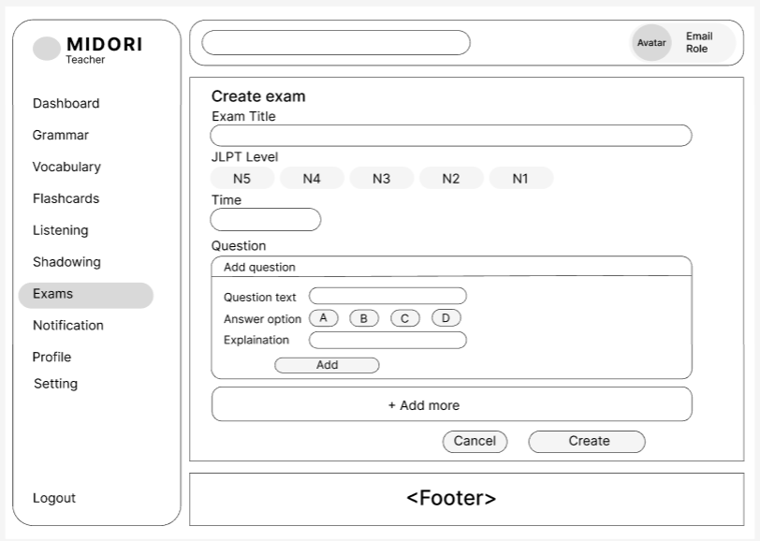

Field Name | Field Type | Description
Exams (Active Menu) | Sidebar Item | Displays highlighted navigation formatting within the primary Teacher sidebar, confirming that the current workspace focus sits inside the Exams module.
Exam Title | Text Input | Structured plain text entry field enabling the instructor to specify the official core title or designatory name for the new exam template.
JLPT Level | Radio Button Group | Single-selection option group used to classify the target Japanese proficiency difficulty benchmark ranging from N5 down to N1.
Time | Text Input | Form data field designated to configure the precise countdown duration constraints (measured in minutes) allocated for the online examination session.
Question text | Text Input | Specialized input field inside the nested form module designated to hold the verbatim textual question statement for the current grid item.
Answer option | Radio Button Group | Segmented multiple-choice selector buttons (A, B, C, D) used to establish the exact correct solution key used by the automatic grading engine.
Explanation | Text Input | Form container allocated to input semantic translations, breakdown commentary, or logical feedback context regarding the structural design of the question.
Add (Question Action) | Action Button | Sub-form commit switch that staging-saves the current question configuration block temporarily up into the temporary local compilation array.
+ Add more | Action Button | Workspace layout control used to dynamically append a clean new question skeleton container block array onto the active configuration screen.
Cancel | Action Button | Operational workflow cancellation switch discarding all active configuration inputs and safely returning the user context back to previous summary indexes.
Create | Action Button | Final transactional processing trigger validating all field logic constraints and triggering system database write pipelines to persist the unified test.

Database Access
Table | CRUD | Description
Exams | C | Performs persistent record generation storing structural test layout header info including exam title, level ranking values, duration limiters, visibility states, and teacher key references.
Exam_Questions | C | Populates dependent table rows storing individual choice items, question details, solution indicators, and advice notes mapped directly to the parent test tracking ID.

SQL Commands:
1-- Insert primary structural test parameters into database records
INSERT INTO Exams (title, jlpt_level, duration_minutes, teacher_id, status, created_at)
VALUES (:title, :jlpt_level, :duration_minutes, :teacher_id, 'Active', NOW());

2 Append dependent multiple-choice item logs to the newly created parent id reference
INSERT INTO Exam_Questions (exam_id, question_text, correct_option, explanation)
VALUES (:inserted_exam_id, :question_text, :correct_option, :explanation);

3.11 Edit Exams
- UC25_Edit Exams

UI Design
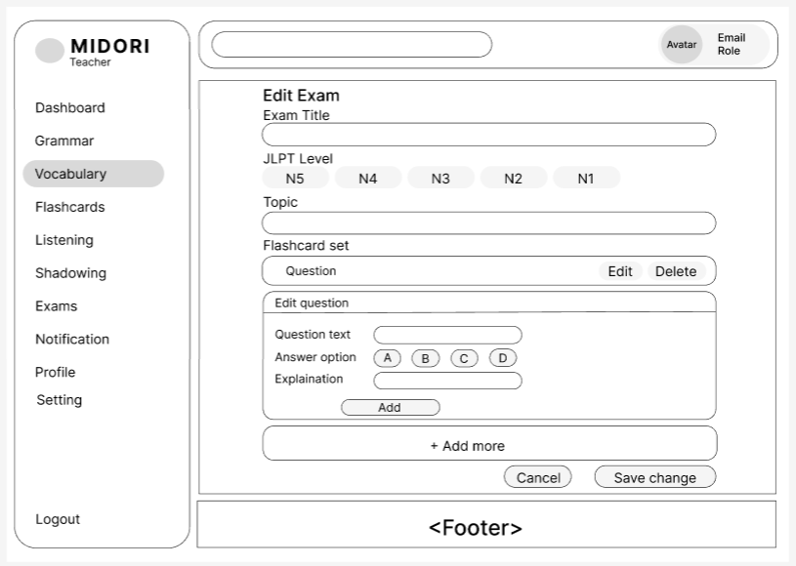

Field Name | Field Type | Description
Vocabulary (Active Menu) | Sidebar Item | Maintains highlighted formatting layouts on the primary Teacher sidebar menu to confirm that this examination entity belongs to or is bound within the Vocabulary module framework.
Exam Title | Text Input | Form entry layout displaying the current test title string, enabling the instructor to perform text modifications to the examination's official name.
JLPT Level | Radio Button Group | Segmented option switches allowing the teacher to reclassify the exam proficiency difficulty tier benchmark ranging from N5 down to N1.
Topic | Text Input | Alphanumeric text interface element displaying the existing test category, allowing instructors to adjust or update the theme metadata keywords.
Flashcard set (Question Row) | Container/Row | Dynamic summary list row rendering a previously added quiz item, fitted with dedicated quick-access Edit and Delete action commands for row item management.
Question text | Text Input | Specialized text field inside the nested "Edit question" component group designed to edit the primary multi-choice statement text.
Answer option | Radio Button Group | Segmented choice buttons (A, B, C, D) allowing the instructor to adjust or update the designated correct solution reference used by the scoring engine.
Explaination | Text Input | Input section hosting active translation annotations or diagnostic feedback notes, allocated for adjusting question resolution details.
Add (Question Button) | Action Button | Contextual operational commit control staging the current sub-form question updates back into the active screen collection overview.
+ Add more | Action Button | Grid modification switch used to dynamically append a clean question configuration skeleton container row into the workspace area.
Cancel | Action Button | Operational exit switch discarding all active form field modifications and safely returning the interface view context back to previous directory lists.
Save change | Action Button | Core transactional execution button validating complete form variables and permanently writing multi-table mutations to the database.

Database Access
Table | CRUD | Description
Exams | R | Queries high-level metadata properties including title, proficiency tier, and category tags corresponding to the active unique examination reference key.
Exam_Questions | R | Pulls individual multi-choice records, correction keys, and annotation fields matching the parent test identification attribute to render list containers.
Exams | U | Overwrites specific configuration parameters within the core examination table rows to permanently commit administrative metadata changes.
Exam_Questions | C/U/D | Drives cascade transactional pipeline logic to create, modify, or eliminate child multiple-choice text entities matching the definitive interface schema collection.

SQL Commands:
1/ -- Read baseline exam fields and corresponding quiz row records for view initialization
SELECT id, title, jlpt_level, topic FROM Exams WHERE id = :exam_id;
SELECT id, question_text, correct_option, explanation FROM Exam_Questions WHERE exam_id = :exam_id ORDER BY id ASC;

-- Update top-level master test attributes upon committing changes
UPDATE Exams SET title = :title, jlpt_level = :jlpt_level, topic = :topic, updated_at = NOW() WHERE id = :exam_id;

3.12 Delete Exams
- UC26_Delete Exams

UI Design
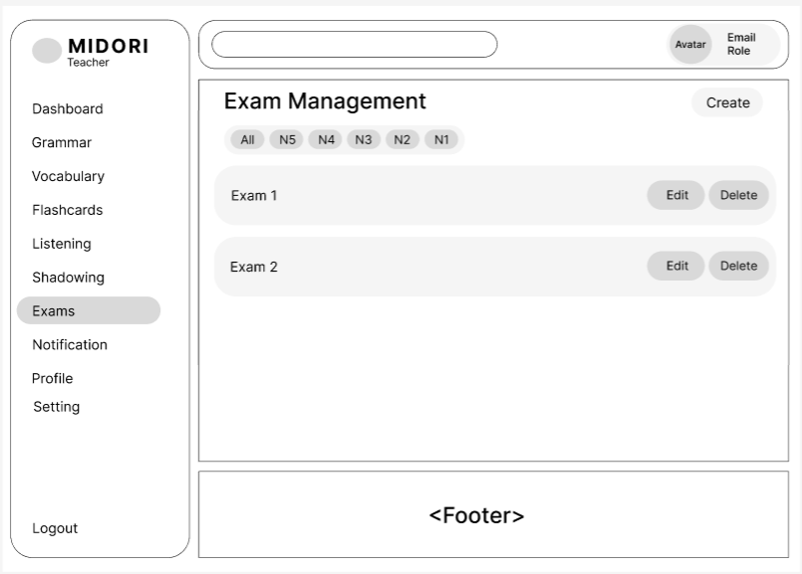

Field Name | Field Type | Description
Exams (Active Menu) | Sidebar Item | Highlights the active navigation focus within the primary Teacher side menu panel to indicate the user is currently managing the comprehensive Exams directory.
Create | Action Button | Top-level shortcut action command button routing the instructor immediately into the blank exam creation form wizard workspace.
JLPT Level Filters | Tab Control | Horizontal tab control controls allowing the instructor to seamlessly filter the active list of displayed exams using standardized JLPT difficulty tags ranging from All to N1.
Exam Row/Card | Container/Card | Grid layout box element rendering a concise summary view for an individual examination record, detailing its title string alongside contextual operation switches.
Edit (Row Action) | Action Button | Contextual operational command button mapped inside the listing row to redirect the teacher to the dedicated examination modification wizard view.
Delete (Row Action) | Action Button | Destructive processing action item allowing teachers to completely purge the designated test profile entity from the persistent application datastore.

Database Access
Table | CRUD | Description
Exams | R | Scans and extracts complete exam indexing records belonging to the authenticated teacher account, adding conditional criteria to respect active JLPT tab selections.
Exams | D | Executes a database deletion command to permanently clean up the targeted test master profile and clear out cascading relational child query blocks.

SQL Commands:
1/-- Query exam groups matching the selected proficiency tab filter
SELECT id, title, jlpt_level, duration_minutes, created_at FROM Exams WHERE teacher_id = :teacher_id AND (:selected_level = 'All' OR jlpt_level = :selected_level) ORDER BY created_at DESC;

-- Remove an existing exam profile from the persistence data layer
DELETE FROM Exams WHERE id = :exam_id AND teacher_id = :teacher_id;

3.13 Add Shadowing Lessons

- UC27_Add Shadowing Lessons

UI Design
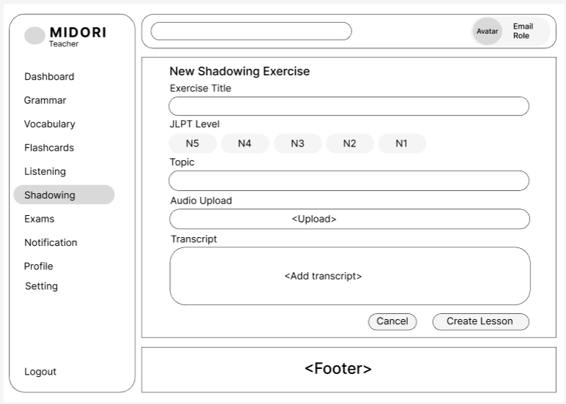

Field Name | Field Type | Description
Shadowing (Active Menu) | Sidebar Item | Displays highlighted navigation formatting within the primary Teacher sidebar, confirming that the current workspace focus sits inside the Shadowing exercise module.
Exercise Title | Text Input | Structured plain text entry field enabling the instructor to specify the official core title or designatory name for the new shadowing exercise.
JLPT Level | Radio Button Group | Single-selection option group used to classify the target Japanese proficiency difficulty benchmark ranging from N5 down to N1.
Topic | Text Input | Text input block allocated for configuring the specific theme, metadata keywords, or conceptual category tags for the corresponding shadowing item.
Audio Upload | File Upload Component | Interactive drag-and-drop or click zone enabling the instructor to browse, select, and upload the core lesson audio file (.mp3, .wav) into the platform data repository.
Transcript | Text Area Input | Multi-line large text entry area allowing the instructor to type or paste the verbatim textual script accompanying the uploaded audio tracks for student visual guidance.
Cancel | Action Button | Operational workflow cancellation switch discarding all active configuration inputs and safely returning the user context back to previous directory indexes.
Create Lesson | Action Button | Final transactional processing trigger validating form input criteria and executing backend database procedures to safely insert the completed record.

Database Access
Table | CRUD | Description
Shadowing_Exercises | C | Performs persistent record generation storing high-level audio and text script attributes including title string, difficulty ranking, theme keywords, multimedia asset URL, transcript text, and creator account references.

SQL Commands:
-- Create a new baseline shadowing exercise record profile
INSERT INTO Shadowing_Exercises (title, jlpt_level, topic, audio_url, transcript, teacher_id, status, created_at)
VALUES (:title, :jlpt_level, :topic, :audio_url, :transcript, :teacher_id, 'Pending', NOW());

3.14 Edit Shadowing Lessons

- UC-28_Edit Shadowing Lessons

UI Design
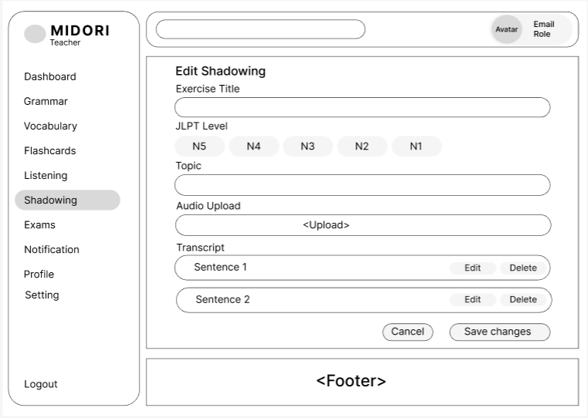
Field Name | Field Type | Description
Field Name | Field Type | Description
Shadowing (Active Menu) | Sidebar Item | Displays highlighted navigation formatting within the primary Teacher sidebar layout, signaling that the user is actively modifying an existing record inside the Shadowing exercise module.
Exercise Title | Text Input | Populates the existing title string configuration of the shadowing task, allowing the instructor to input alphanumeric changes to modify the heading description.
JLPT Level | Radio Button Group | Segmented option switches enabling the teacher to reclassify the structural Japanese proficiency tier benchmark ranging from N5 down to N1.
Topic | Text Input | Alphanumeric text interface element displaying the active exercise category, allowing instructors to adjust or overwrite the theme metadata keywords.
Audio Upload | File Upload Component | Dedicated media uploader rendering active audio file parameters and supporting the upload of alternative auditory tracks (.mp3, .wav) to refresh the core lesson asset.
Transcript Row (Sentence 1, Sentence 2) | Container/Row | Row layout component rendering a single sentence entry from the parsed audio transcript database layout, fitted with contextual modification switches.
Edit (Row Action) | Action Button | Contextual sub-command trigger within the transcript row allowing the instructor to modify the specific dialogue sentence string text.
Delete (Row Action) | Action Button | Immediate row destructive command button removing the specific sentence row line item from the local transcript compilation array.
Cancel | Action Button | Operational exit switch discarding all unsubmitted session modifications and safely returning the workflow interface context back to the primary directory index.
Save changes | Action Button | Main transactional execution trigger validating text field criteria and permanently flushing the multi-field structural mutations to the backend database tables.

Database Access
Table | CRUD | Description
Shadowing_Exercises | R | Queries precise audio profile fields corresponding to the target record identification key to systematically populate the administrative form component.
Shadowing_Transcripts | R | Pulls individual sentence row logs and breakdown text matching the parent shadowing exercise reference attribute to build out the sequence grid arrays.
Shadowing_Exercises | U | Modifies specific parameters inside target storage rows to overwrite core configuration metadata details once the form transaction is authorized.
Shadowing_Transcripts | C/U/D | Executes bulk relational pipeline data operations to insert, update, or remove sequence list items based on the finalized user interface interface collection matrix state.

SQL Commands:
- Read baseline shadowing parameters and sequence log records for administrative workspace view initialization
SELECT id, title, jlpt_level, topic, audio_url FROM Shadowing_Exercises WHERE id = :exercise_id;
SELECT id, sentence_text FROM Shadowing_Transcripts WHERE exercise_id = :exercise_id ORDER BY sequence_order ASC;

-- Commit multi-field master attribute mutations to storage tables upon validation
UPDATE Shadowing_Exercises SET title = :title, jlpt_level = :jlpt_level, topic = :topic, audio_url = :audio_url, updated_at = NOW() WHERE id = :exercise_id;

3.15 Delete Shadowing Lessons
This screen allows user to be authenticated to the system screens/functionalities.
Related use cases:
- UC-29_Delete Shadowing Lessons

UI Design
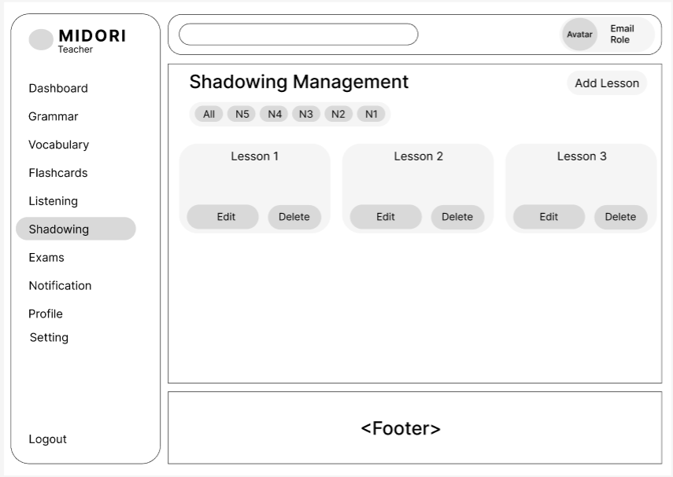
Field Name | Field Type | Description
Shadowing (Active Menu) | Sidebar Item | Maintains highlighted formatting layouts on the primary Teacher sidebar core menu to indicate the active focus remains on the main workspace directory for shadowing lessons.
Add Lesson | Action Button | Top-level shortcut action command button routing the instructor immediately into the blank shadowing exercise creation form wizard workspace layout.
JLPT Level Filters | Tab Control | Horizontal segmented selection tabs allowing the user to seamlessly isolate or filter displayed shadowing exercises using standardized JLPT tags ranging from All to N1.
Lesson Card (Lesson 1, 2, 3) | Container/Card | Grid layout card component rendering a concise summary view block for a single shadowing exercise entity, displaying its core lesson title text alongside modification action buttons.
Edit (Card Action) | Action Button | Contextual operational command switch mapped inside the lesson card block to redirect the instructor to the dedicated shadowing exercise modification module view.
Delete (Card Action) | Action Button | Destructive processing trigger allowing teachers to completely purge the designated shadowing exercise metadata record from the main application datastore grid.

Database Access
Table | CRUD | Description
Shadowing_Exercises | R | Scans and pulls all shadowing exercise records associated with the logged-in teacher account, applying conditional clauses to respect active tab difficulty selections.
Shadowing_Exercises | D | Permanently expunges selected shadowing exercise parent records and clears corresponding metadata profiles from the persistent database application grid.

SQL Commands:
-- Query shadowing exercise groups matching the selected proficiency tab filter
SELECT id, title, jlpt_level, topic, created_at FROM Shadowing_Exercises WHERE teacher_id = :teacher_id AND (:selected_level = 'All' OR jlpt_level = :selected_level) ORDER BY created_at DESC;

-- Remove an existing shadowing exercise profile from the persistence data layer
DELETE FROM Shadowing_Exercises WHERE id = :exercise_id AND teacher_id = :teacher_id;

3.16 Add Flashcard

- UC30_Add Flashcard

UI Design
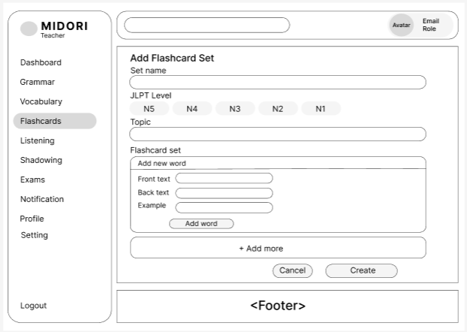

Field Name | Field Type | Description
Flashcards (Active Menu) | Sidebar Item | Displays highlighted navigation formatting within the primary Teacher sidebar menu panel, confirming the active workspace context is within the Flashcards module.
Set name | Text Input | Structured plain text entry field enabling the instructor to specify the official core title or designation name for the new flashcard set.
JLPT Level | Radio Button Group | Single-selection option group used to classify the target Japanese proficiency difficulty benchmark ranging from N5 down to N1.
Topic | Text Input | Text input block allocated for configuring the specific theme, metadata keywords, or conceptual category tags for the corresponding flashcard group.
Front text | Text Input | Specific text entry box within the nested "Add new word" sub-form container used to define the primary Japanese term or Kanji written on the front face of the card.
Back text | Text Input | Input container allocated to write down matching translations, semantic breakdown annotations, or phonetic readings shown on the reverse face of the card.
Example | Text Input | Supplemental input field allowing instructors to provide a functional context sentence utilizing the active target term for practical student training.
Add word (Sub-action) | Action Button | Sub-form commit switch that staging-saves the current card configuration block temporarily into the local compilation array list view.
+ Add more | Action Button | Dynamic layout switch used to append a clean new card structural entry component array onto the active configuration screen.
Cancel | Action Button | Operational workflow cancellation switch discarding all active configuration inputs and safely returning the user context back to previous directory lists.
Create | Action Button | Final transactional processing trigger validating multi-field input variables and permanently flushing the unified card array metadata records to the backend storage tables.

Database Access
Table | CRUD | Description
Flashcard_Sets | C | Performs persistent record generation storing structural flashcard set header definitions including group name, proficiency tier ranking, topic parameters, and teacher references.
Flashcard_Items | C | Populates dependent sub-table records storing front text strings, back definitions, and contextual example phrases mapped directly to the parent group identification code.

SQL Commands:
-- Insert primary structural flashcard set parameters into database records
INSERT INTO Flashcard_Sets (set_name, jlpt_level, topic, teacher_id, created_at)
VALUES (:set_name, :jlpt_level, :topic, :teacher_id, NOW());

-- Append dependent flashcard item records to the newly created parent set reference ID
INSERT INTO Flashcard_Items (set_id, front_text, back_text, example_text)
VALUES (:inserted_set_id, :front_text, :back_text, :example_text);

3.17 Edit Flashcard
- UC31_Edit Flashcard

UI Design
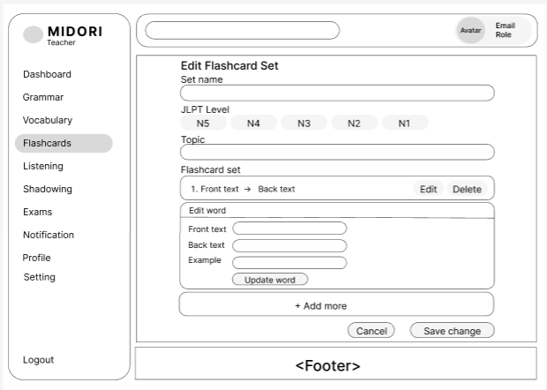

Field Name | Field Type | Description
Flashcards (Active Menu) | Sidebar Item | Displays highlighted navigation formatting within the primary Teacher sidebar menu panel, confirming the active workspace context is within the Flashcards module.
Set name | Text Input | Form entry layout displaying the current flashcard set name string, enabling the instructor to perform text modifications to the group's official title.
JLPT Level | Radio Button Group | Segmented option switches allowing the teacher to reclassify the structural Japanese proficiency tier benchmark ranging from N5 down to N1.
Topic | Text Input | Alphanumeric text interface element displaying the active flashcard set category, allowing instructors to adjust or update the theme metadata keywords.
Flashcard set (Item Row) | Container/Row | Dynamic summary list row rendering a single vocabulary entry line (Front text $\rightarrow$ Back text), fitted with dedicated quick-access Edit and Delete action commands.
Edit (Row Action) | Action Button | Contextual sub-command trigger within the card listing row that pulls the target word configurations down into the bottom "Edit word" active workspace.
Delete (Row Action) | Action Button | Immediate row destructive command button removing the specific vocabulary line item from the local flashcard collection compilation array.
Front text | Text Input | Specific text entry box within the nested "Edit word" sub-form container used to modify the primary Japanese term or Kanji written on the front face of the card.
Back text | Text Input | Input container allocated to adjust matching translations, semantic definitions, or phonetic readings shown on the reverse face of the target card.
Example | Text Input | Supplemental input field displaying the existing context phrase, allowing instructors to provide edited practical training sentences utilizing the target term.
Update word | Action Button | Contextual operational commit control staging the active text modifications of the selected vocabulary word back into the main collection array template.
+ Add more | Action Button | Grid modification switch used to dynamically append a clean, blank card structural entry component array onto the active configuration screen area.
Cancel | Action Button | Operational exit switch discarding all unsubmitted session modifications and safely returning the workflow interface context back to the primary directory index.
Save change | Action Button | Core transactional execution button validating complete form variables and permanently writing multi-table persistence mutations to the database tables.

Database Access
Table | CRUD | Description
Flashcard_Sets | R | Queries precise structural group parameters corresponding to the target record identification key to systematically populate the master administrative form component.
Flashcard_Items | R | Pulls individual vocabulary word logs and breakdown definitions matching the parent flashcard set reference attribute to build out the listing sequence rows.
Flashcard_Sets | U | Modifies specific configuration parameters inside the core flashcard table rows to permanently commit master metadata updates once authorized by the user.
Flashcard_Items | C/U/D | Drives bulk relational transactional logic pipelines to insert new items, update modified lines, or expunge child rows based on the final UI collection state.

SQL Commands:
-- Read baseline flashcard parameters and item rows for administrative workspace view initialization
SELECT id, set_name, jlpt_level, topic FROM Flashcard_Sets WHERE id = :set_id;
SELECT id, front_text, back_text, example_text FROM Flashcard_Items WHERE set_id = :set_id ORDER BY id ASC;

-- Commit multi-field master attribute mutations to storage tables upon validation
UPDATE Flashcard_Sets SET set_name = :set_name, jlpt_level = :jlpt_level, topic = :topic, updated_at = NOW() WHERE id = :set_id;

3.18 Delete Flashcard

- UC-32_Delete Flashcard

UI Design
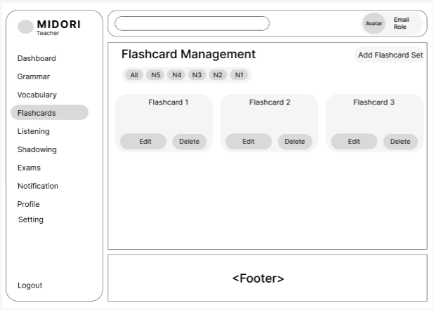

Field Name | Field Type | Description
Flashcards (Active Menu) | Sidebar Item | Maintains highlighted formatting layouts on the primary Teacher sidebar core menu to indicate the active focus remains on the main workspace directory for flashcard sets.
Add Flashcard Set | Action Button | Top-level shortcut action command button routing the instructor immediately into the blank flashcard set creation form wizard workspace layout.
JLPT Level Filters | Tab Control | Horizontal segmented selection tabs allowing the user to seamlessly isolate or filter displayed flashcard sets using standardized JLPT tags ranging from All to N1.
Flashcard Card (Flashcard 1, 2, 3) | Container/Card | Grid layout card component rendering a concise summary view block for a single flashcard set entity, displaying its core set title text alongside modification action buttons.
Edit (Card Action) | Action Button | Contextual operational command switch mapped inside the flashcard card block to redirect the instructor to the dedicated flashcard set modification module view.
Delete (Card Action) | Action Button | Destructive processing trigger allowing teachers to completely purge the designated flashcard set metadata record from the main application datastore grid.

Database Access
Table | CRUD | Description
Flashcard_Sets | R | Scans and pulls all flashcard set records associated with the logged-in teacher account, applying conditional clauses to respect active tab difficulty selections.
Flashcard_Sets | D | Permanently expunges selected flashcard set parent records and clears corresponding metadata profiles from the persistent database application grid.

SQL Commands:
-- Query flashcard set groups matching the selected proficiency tab filter
SELECT id, set_name, jlpt_level, topic, created_at FROM Flashcard_Sets WHERE teacher_id = :teacher_id AND (:selected_level = 'All' OR jlpt_level = :selected_level) ORDER BY created_at DESC;

-- Remove an existing flashcard set profile from the persistence data layer
DELETE FROM Flashcard_Sets WHERE id = :set_id AND teacher_id = :teacher_id;

4. Student

4.1 Learn Vocabulary
- UC-33_ Learn Vocabularye

UI Design
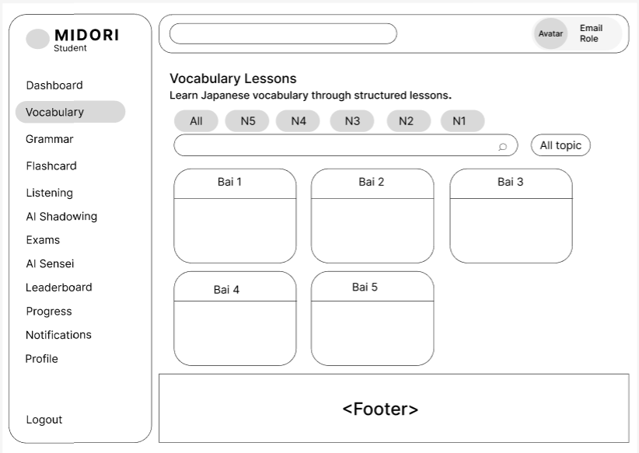
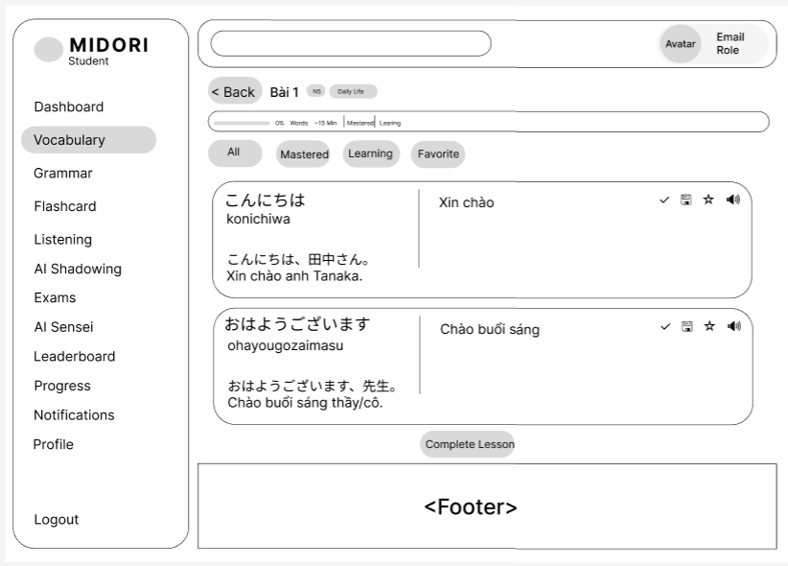

Field Name | Field Type | Description
Field Name | Field Type | Description
Vocabulary (Active Menu) | Sidebar Item | Highlights the primary item on the Student navigation sidebar, indicating the user's current workspace location is inside the Vocabulary feature module.
JLPT Level Filters | Tab Control | Provides segmented tab selectors (All, N5, N4, N3, N2, N1) to enable dynamic filtering of the lesson grid based on Japanese proficiency difficulty.
Search Bar | Text Input | Plain text input layout with an embedded magnifying glass icon, allowing students to filter lessons via character string keyword matching.
All topic | Dropdown Control | Dropdown selection component used to dynamically filter vocabulary lessons by specific thematic groups or conceptual category tags.
Lesson Card (Bai 1 -> Bai 5) | Container/Card | Grid layout card rendering individual vocabulary lessons, functioning as a clickable component that routes the student into the specific lesson workspace view.
< Back | Action Button | Navigation command button that exits the active vocabulary workspace and directs the user context back to the primary lesson overview catalog screen.
Lesson Meta Header | Label/Badge Group | Structural header layer rendering the current lesson name (B脿i 1) alongside metadata parameter tags such as JLPT tier (N5) and topic keyword (Daily Life).
Progress Metrics Bar | Progress Indicator | Horizontal visual metric tracker displaying completion percentage (0% Words), estimated study duration (~15 Min), and numerical counts for word learning states.
Status Filter Tabs | Tab Control | Sectional selection switches (All, Mastered, Learning, Favorite) used to isolate displayed items based on their individual student acquisition metrics.
Vocabulary Card Block | Container Layer | Isolated layout row enclosing target entry parameters including original character string text, definition rows, translation blocks, and contextual option switches.
Word Text & Romaji | Text Label | Text container displaying the primary Japanese script (Kanji/Kana) paired with its corresponding Latin character spelling (Romaji) to assist correct pronunciation.
Meaning Text | Text Label | Dedicated text layout block displaying the corresponding translated meaning strings in the native target language (Vietnamese).
Example Sentence Pair | Text Label | Structured sentence block outputting dual-language contextual patterns consisting of raw Japanese phrases and accompanying translated sentence rows.
Mark as Mastered (Check icon) | Toggle Button | Binary toggle switch that allows the student to flag the specific vocabulary item row as fully acquired ("Mastered") or revert it back to active training status.
Save State (Floppy icon) | Action Button | Instant execution button committing current structural configuration states and learning progress indicators for the isolated item to the backend datastore.
Favorite Toggle (Star icon) | Toggle Button | Star icon toggle switch enabling the user to append the target vocabulary word straight into their personal bookmark index or drop it from the favorite list.
Audio Pronunciation (Speaker) | Action Button | Media control trigger initiating synthetic text-to-speech rendering or pre-recorded audio stream playbacks to facilitate student auditory reinforcement.
Complete Lesson | Action Button | Final operational command switch setting the master lesson learning progress metric to 100% and recording the official block completion flag.

Database Access
Table | CRUD | Description
Vocabulary_Lessons | R | Scans and returns active vocabulary lesson records matching conditional queries based on targeted JLPT level tabs, typed search words, and category dropdown states.
Vocabulary_Words | R | Pulls complete sequential sets of vocabulary words (Kanji text, romaji, definition, example strings) assigned to the current parent lesson identifier.
Student_Word_Interactions | R/C/U | Reads and registers isolated student-specific item behaviors including mastery status changes, persistent transaction states, and favorite flag conditions.
Student_Lessons_Progress | U | Modifies or appends student progress database entries to record the milestone completion flag and set percentage fields to maximum value once authorized.

SQL Commands:
-- Query vocabulary lesson groups matching current user interface filter configurations
SELECT id, lesson_title, jlpt_level, topic FROM Vocabulary_Lessons WHERE status = 'Active' AND (:selected_level = 'All' OR jlpt_level = :selected_level) AND (:search_keyword = '' OR lesson_title LIKE CONCAT('%', :search_keyword, '%')) AND (:selected_topic = 'All' OR topic = :selected_topic) ORDER BY id ASC;
-- Read vocabulary terms accompanied by individual interaction logs for the active student profile
SELECT w.id, w.word, w.reading, w.romaji, w.meaning, w.example_text, i.is_mastered, i.is_favorite FROM Vocabulary_Words w LEFT JOIN Student_Word_Interactions i ON w.id = i.word_id AND i.student_id = :student_id WHERE w.lesson_id = :lesson_id ORDER BY w.id ASC;

-- Commit lesson completion status updates to persistence tables (Complete Lesson button action)
INSERT INTO Student_Lessons_Progress (student_id, lesson_id, progress_percentage, is_completed, updated_at) VALUES (:student_id, :lesson_id, 100, TRUE, NOW()) ON DUPLICATE KEY UPDATE progress_percentage = 100, is_completed = TRUE, updated_at = NOW();

4.2 Learn Grammar
- UC-34_Learn Grammar

UI Design
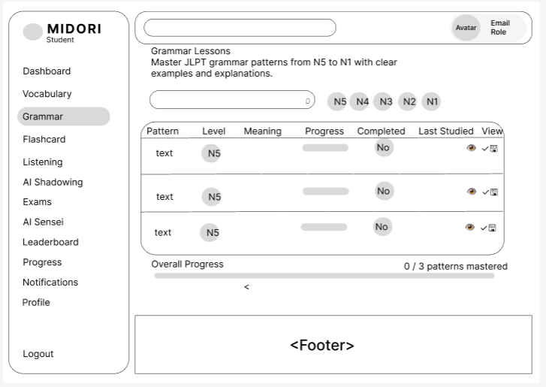

Field Name | Field Type | Description
Search Bar | Text Input | Integrated search input box with an embedded magnifying glass icon layout enabling students to query and filter specific grammar forms dynamically via text entry.
JLPT Level Filters | Button Group / Tab | Standardized filter option shortcuts (N5 down to N1) allowing students to filter out and display grammar patterns matching a designated difficulty tier.
Grammar Patterns Table | Data Grid / Table | Structured data grid component plotting individual grammar pattern metrics and relational progress attributes across predefined columns.
Pattern | Text Column | Data row cell displaying the primary character string representation or structural text formulation of the target Japanese grammar form.
Level | Badge Column | Visual metadata category badge rendering the specific level classification (e.g., N5) assigned to the corresponding row item.
Meaning | Text Column | Text field rendering a concise semantic translation or breakdown description of the active row grammar rule in the target language.
Progress | Progress Indicator | Contextual linear progress indicator displaying the individual student learning metric or familiarity ratio for that specific row entry.
Completed | Label / Badge | Text label tracking whether the student has met the mastery criteria for the active pattern, rendering values like "No" or "Yes".
Last Studied | Text Column | Timestamps display cell indicating the exact calendar date or relative time of the user's latest learning interaction with the grammar asset.
View Details (Eye icon) | Action Button | Operational command trigger inside the View section that redirects the student context directly into the granular explanation and example sentence view for the pattern.
Mark Completed (Check icon) | Toggle Button | Binary inline switch allowing students to directly toggle the pattern's completion flag state without navigating away from the grid overview table list.
Save State (Floppy icon) | Action Button | Data push command execution icon persisting row-level session learning modifications and progress metrics securely back to user datastore logs.
Overall Progress | Progress Indicator | Macro status bar tracking comprehensive module completion, displaying both a horizontal progress bar fill and a text metric summary like "0 / 3 patterns mastered".

Database Access
Table | CRUD | Description
Grammar_Patterns | R | Scans and pulls core structural grammar rule rows from datastore matching selected user interface criteria such as JLPT level nodes and text keywords.
Student_Grammar_Progress | R/C/U | Reads and alters granular tracking parameters per student reference to render inline completion flags, relative timestamps, and aggregate overall master metrics.

SQL Commands:
-- Read comprehensive grammar rule collections joined with user tracking metrics
SELECT g.id, g.pattern_text, g.jlpt_level, g.meaning_summary, p.progress_percentage, p.is_completed, p.last_studied_at FROM Grammar_Patterns g LEFT JOIN Student_Grammar_Progress p ON g.id = p.pattern_id AND p.student_id = :student_id WHERE (:selected_level = '' OR g.jlpt_level = :selected_level) AND (:search_keyword = '' OR g.pattern_text LIKE CONCAT('%', :search_keyword, '%')) ORDER BY g.id ASC;

-- Commit on-the-fly execution changes to the progress tracking schema tables
INSERT INTO Student_Grammar_Progress (student_id, pattern_id, progress_percentage, is_completed, last_studied_at) VALUES (:student_id, :pattern_id, :progress, :is_completed, NOW()) ON DUPLICATE KEY UPDATE progress_percentage = :progress, is_completed = :is_completed, last_studied_at = NOW();

4.3 Practice Shadowing
This screen allows user to be authenticated to the system screens/functionalities.
Related use cases:
- UC35-Practice Shadowing

UI Design
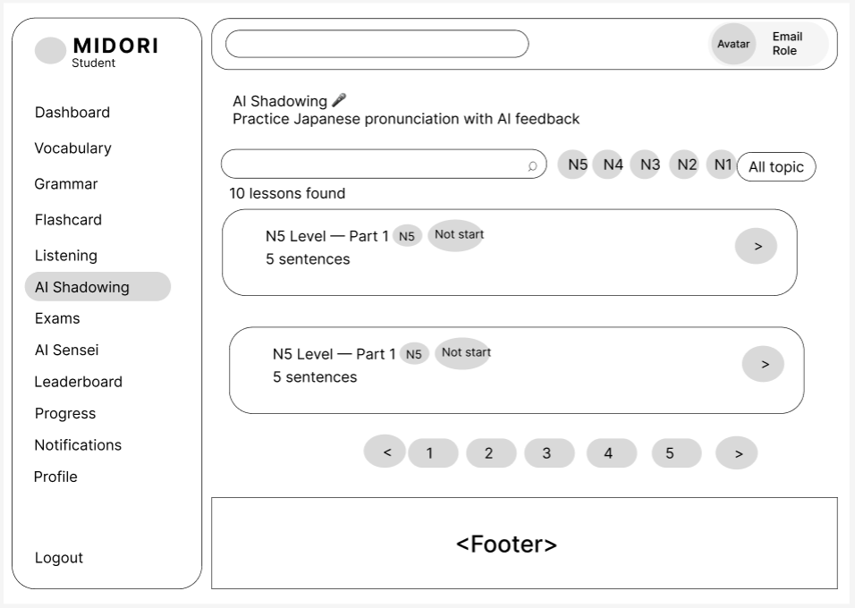
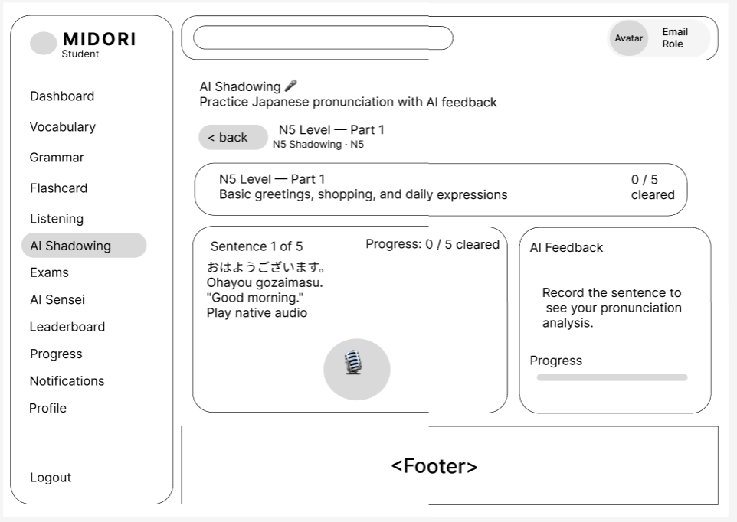

Field Name | Field Type | Description
< back | Action Button | Navigation command button that terminates the active speech tracking interface and returns the user to the master shadowing catalog listing grid screen.
Breadcrumb Path | Text Label | Relational orientation indicator text rendering structural node hierarchy details for the loaded item (e.g., "N5 Shadowing - N5") situated under the main feature header block.
Lesson Summary Banner | Container Block | Top banner compartment aggregating parent variables for the session including title "N5 Level — Part 1", content focus "Basic greetings, shopping, and daily expressions", and progress state "0 / 5 cleared".
Sentence Index Indicator | Text Label | Positional tracking text outputting the precise sequence index of the phrase currently undergoing speech evaluation relative to total layout count (e.g., "Sentence 1 of 5").
Workspace Progress Text | Text Label | Inline monitor text string reflecting the tally of sentence nodes successfully validated and checked off by the neural scoring engine in the current pass (e.g., "Progress: 0 / 5 cleared").
Japanese Script Text | Text Label | Central layout textbox displaying the target Japanese phrase formulation string utilizing proper native typography characters including Kanji, Hiragana, and punctuation (e.g., "おはようございます。").
Romaji Pronunciation | Text Label | Secondary pronunciation guide layout rendering phonetic transliterations of the primary Japanese phrase using standard Latin alphabet naming parameters (e.g., "Ohayou gozaimasu.").
English Translation Text | Text Label | Dedicated definition text layout outputting the target phrase's contextual meaning translated into the target language wrapped in quotation marks to aid understanding (e.g., "Good morning.").
Play native audio | Action Button | Link button component triggering instantaneous audio streaming playback of native-speaker master vocal recordings to deliver optimal phonetic reference for speech training.
Record Button (Microphone) | Voice Button | Primary interactive round audio trigger enclosing a microphone element icon designed to manage system record hardware states on long-press or toggle events.
AI Feedback Panel | Container Block | Modular auxiliary display panel situated on the right side of the screen designated to parse and display real-time machine learning grading evaluations once audio blocks are captured.
Feedback Placeholder | Text Label | Fallback instructional messaging displayed inside the feedback panel prior to any audio stream injection events occurring (e.g., "Record the sentence to see your pronunciation analysis.").
AI Evaluation Progress | Progress Bar | Horizontal status tracking bar matched with a "Progress" descriptor string to mirror data parsing loops or reflect visual scoring milestones after processing voice packets.

Database Access
Table | CRUD | Description
Shadowing_Sentences | R | Extracts all child sentence data structures (Kanji text arrays, phonetic romaji strings, translation definitions, reference audio URIs) keyed to the parent lesson ID.
Student_Sentence_Attempts | C/R | Logs and structures unique student voice sample transactions, tracking individual AI confidence metric points, recording parameters, and validation check states.
Student_Shadowing_Progress | U | Performs cell state updates on student master milestone sheets to record cleared count variables and transition master assignment indicators upon workspace completion.

SQL Commands:
-- Extract comprehensive sentence variables for the active AI Shadowing training module configuration
SELECT id, sentence_order, japanese_text, romaji_text, meaning_text, audio_url FROM Shadowing_Sentences WHERE lesson_id = :lesson_id ORDER BY sentence_order ASC;

-- Insert a granular pronunciation evaluation entry detailing AI scoring metrics per attempt
INSERT INTO Student_Sentence_Attempts (student_id, sentence_id, score, is_cleared, audio_recorded_url, created_at) VALUES (:student_id, :sentence_id, :ai_score, :is_cleared, :audio_url, NOW());

4.4 Practice Flashcard
\
- UC-36_practice flashcard

UI Design
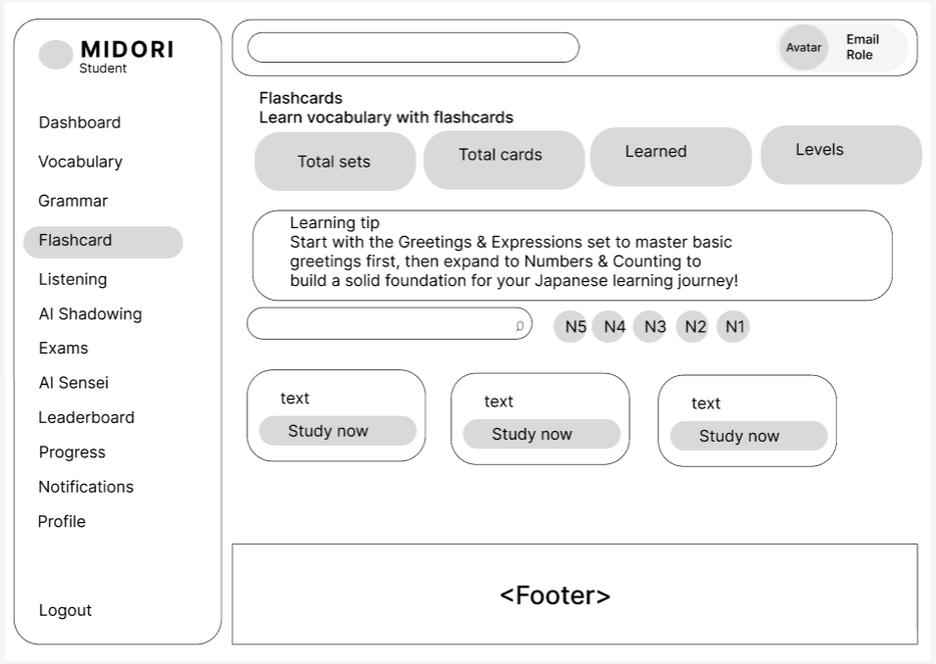
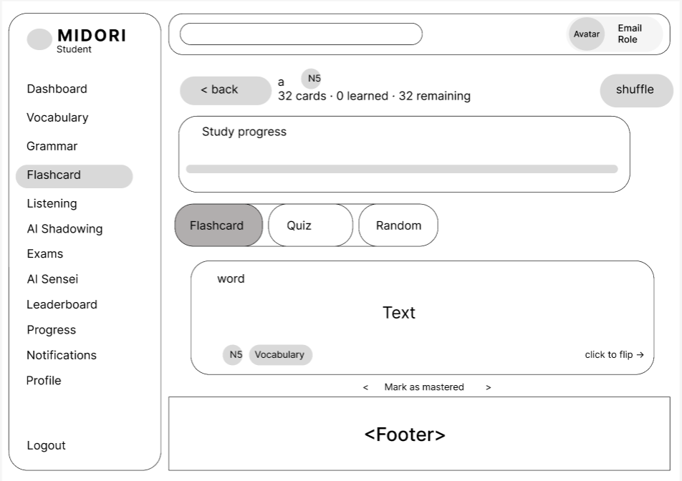

Field Name | Field Type | Description
Flashcard (Active Menu) | Sidebar Item | Highlights the primary item on the Student left navigation sidebar panel, confirming that the user's active view is located inside the Flashcards feature module.
< back | Action Button | Operational command button that closes the current active flashcard workspace and routes the student back to the master deck repository catalog screen.
Deck Title & Level Badge | Text & Badge | Layout field rendering the active flashcard deck name string (e.g., "a") paired directly with a graphical badge tracking its standardized JLPT tier classification (e.g., "N5").
Card Metrics Summary | Text Label | Status summary text layout displaying historical calculation tallies for the active study session, outputting values including total volume, completed nodes, and left nodes (e.g., "32 cards 路 0 learned 路 32 remaining").
shuffle | Action Button | Instant execution button allowing the student to randomize the sequential queue order of the flashcard entities inside the current active folder list.
Study progress Bar | Progress Indicator | Horizontal visual progress bar situated inside the Study progress block compartment, showing the acquisition ratio based on cards marked as mastered relative to the complete deck count.
Mode Selection Tabs | Tab Control | Segmented control selectors permitting students to fluidly shift training modalities among active study views including Flashcard (Familiarity pass), Quiz (Testing review), and Random (Arbitrary draw).
Flashcard Container Layer | Container Block | Interactive layout container mimicking a dual-sided physical study card, capturing click or tap triggers to toggle the 3D card flip animation sequence.
Inner Card Label | Text Label | Secondary categorical descriptor indicator text placed at the top-left edge inside the card box to denote the active parameter attribute (e.g., "word").
Main Content Text | Text Label | Central layout textbox displaying the target phrase script parameters (Front face exhibits native Japanese Kanji/Kana strings, while the reverse face renders phonetic Romaji and translation strings).
Metadata Badges | Badge Group | Contextual metadata label group situated on the bottom-left inner margin of the card representing target information including difficulty tier (e.g., "N5") and content classification (e.g., "Vocabulary").
Flip Hint Indicator | Text Label | Instructional navigation hint layout arranged on the bottom-right inner corner of the container reminding the student to hit or press the asset to reveal the alternative side (e.g., "click to flip ->").
Previous Card Button (<) | Action Button | Boundary control button housing a left-pointing chevron symbol that swaps the active view grid row backward onto the previous adjacent card element face.
Mark as mastered | Action Button | Central action hyperlink positioned within the lower workflow toolbar, allowing the user to mark the active item as acquired, updating user milestones and dropping it from active rotations.
Next Card Button (>) | Action Button | Boundary control button housing a right-pointing chevron symbol that advances the active view layer onto the next item index queue slot inside the session.

Database Access
Table | CRUD | Description
Flashcard_Decks | R | Scans foundational parent properties of the target vocabulary dataset folder including naming arrays, tier attributes, and cumulative child quantities.
Flashcard_Items | R | Pulls full item parameter sequences (original scripts, definition strings, structural word classes, difficulty classes) bound to the parent flashcard deck ID.
Student_Flashcard_Progress | R/C/U | Processes and updates transactional study progress logs per student reference to persist item mastery flags and update workflow retention records.

SQL Commands:
-- Fetch complete flashcard item configurations accompanied by individual student acquisition status flags
SELECT i.id, i.word_text, i.meaning_text, i.word_type, i.jlpt_level, COALESCE(p.is_mastered, FALSE) AS mastered_flag FROM Flashcard_Items i LEFT JOIN Student_Flashcard_Progress p ON i.id = p.item_id AND p.student_id = :student_id WHERE i.deck_id = :deck_id ORDER BY i.id ASC;

-- Persist master milestone acquisition parameters when the student authorizes the Mark as mastered event
INSERT INTO Student_Flashcard_Progress (student_id, item_id, is_mastered, updated_at) VALUES (:student_id, :item_id, TRUE, NOW()) ON DUPLICATE KEY UPDATE is_mastered = TRUE, updated_at = NOW();

4.5 Practice Dictation
- UC-37_ Practice Dictation

UI Design

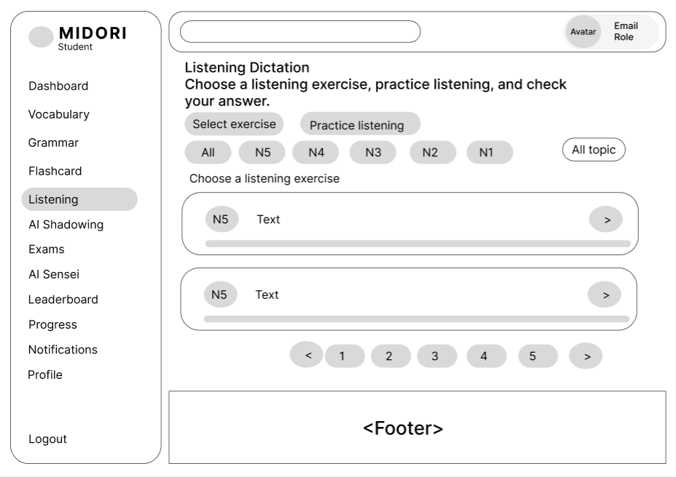
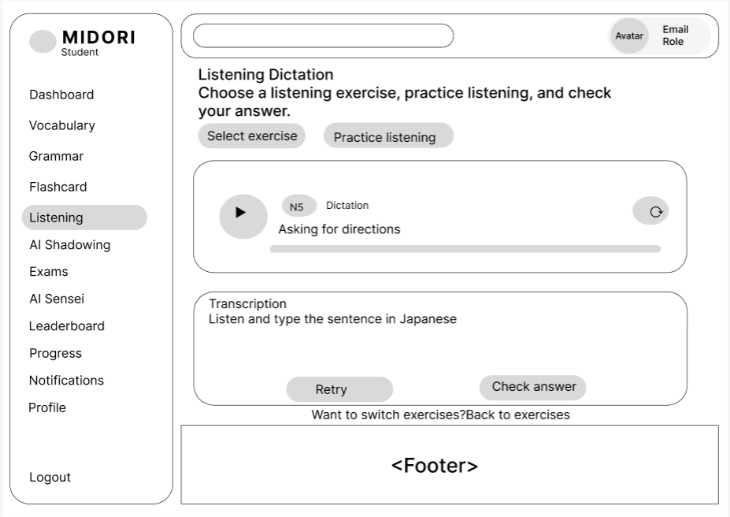

Field Name | Field Type | Description
Practice listening Tab | Button Item | Active view state button indicating that the user focus is currently nested inside a loaded live training session for a specific listening track.
Audio Player Container | Container Block | Structured multimedia interface layout housing interactive audio components tailored for standard stream execution and progress tracking loops.
Play/Pause Button | Media Button | Circular control button displaying a right-facing triangle icon that handles media states to trigger or pause the master native speaker vocal recording stream.
Audio Metadata Labels | Label Group | Visual text strings compiling the asset difficulty classification badge ("N5"), activity model label ("Dictation"), and situational topic title (e.g., "Asking for directions").
Replay / Loop Icon | Action Button | Circular command icon containing a loop arrow placed on the right margin enabling students to toggle automated recurring playback loops for speech checking.
Audio Seeker Bar | Progress Bar | Horizontal seeker bar mapping out real-time audio playback progression metrics across the master audio tracking sequence length.
Transcription Box | Text Area Card | Bounded interaction field framing prompt texts ("Transcription - Listen and type...") above a multi-line Textarea canvas where students capture Japanese characters.
Retry Button | Action Button | Functional workflow button allowing users to immediately wipe the text canvas clean to initiate a fresh playback transcription draft session.
Check answer Button | Action Button | Primary submission action layout routing the compiled student plain text input back into the evaluation controller for string verification.
Back to exercises Link | Hyperlink Text | Auxiliary navigation anchor phrase ("Want to switch exercises? Back to exercises") built to easily redirect the user back to the primary directory index view.

Database Access
Table | CRUD | Description
Listening_Exercises | R | Resolves structural master properties for the targeted task unit item including file repository endpoints (audio_url) and verification answer keys.
Student_Listening_Attempts | C/R | Creates unique validation transaction entries log blocks documenting typed text parameters, validation responses, and creation metadata.

SQL Commands:
-- Pull core multimedia stream references and validation metadata for the selected listening item
SELECT id, title_text, audio_url, correct_transcript_script FROM Listening_Exercises WHERE id = :exercise_id AND is_active = TRUE;

-- Record a granular student submission instance detailing typed characters and evaluation output states
INSERT INTO Student_Listening_Attempts (student_id, exercise_id, student_typed_text, is_correct, submitted_at) VALUES (:student_id, :exercise_id, :typed_text, :is_correct, NOW());

4.6 Practice Exam
- UC-38_Practice Exam

UI Design
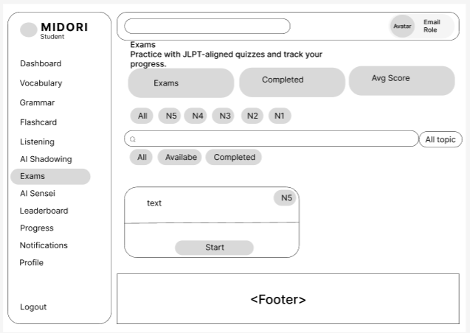
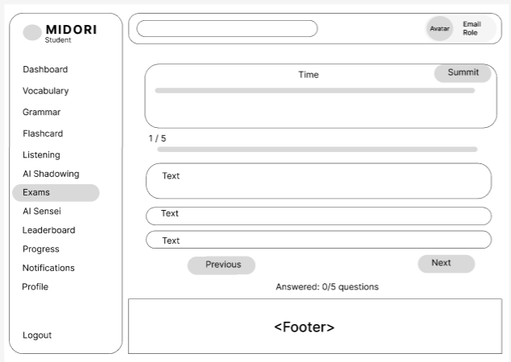
Field Name | Field Type | Description
Exams (Active Menu) | Sidebar Item | Highlights the primary item layout block on the Student left navigation sidebar grid, confirming the active user workflow is within the Exams examination section.
Time Container & Bar | Container Block | Top workspace panel grouping the "Time" header text alongside a horizontal visualization bar tracking active countdown session duration metrics.
Summit Button | Action Button | Action execution control rendering the specific string "Summit" (verbatim UI submit asset) designed to permanently forward selected option sequences to the scoring engine.
Question Index Indicator | Text Label | Text layout mapping out the current active question index sequence placement relative to the total quiz node pool limits (e.g., "1 / 5").
Question Progress Bar | Progress Bar | Linear horizontal milestone bar rendering a visual structural layout of the student's overall position within the test sequence.
Question Context Card | Container / Text | Large flat container block displaying the main question text body segment ("Text") containing targeted Japanese vocabulary, grammar, or reading comprehension prompts.
Answer Option Cards | Selectable Card | Row stack of elongated container options showing alternative answer choices ("Text"), capturing click states to toggle selected parameters.
Previous Button | Action Button | Boundary command element enabling the student to shift their operational workspace backward to inspect or revise the previous test question response.
Next Button | Action Button | Boundary command element enabling the student to advance their operational workspace forward to load the subsequent test question card.
Answered Counter Metrics | Text Label | Real-time analytical monitor text showing the accurate summation of populated student response entries against total test items (e.g., "Answered: 0/5 questions").

Database Access
Table | CRUD | Description
Exam_Questions | R | Scans and pulls all relational exam questions and multi-choice parameter arrays mapped to the corresponding parent test layout ID.
Student_Exam_Attempts | C/U | Instantiates new session tracking states and pushes structured JSON answer strings along with final grading values to DB when the "Summit" block fires.

SQL Commands:
-- Load structural question items and matching answer variations for active exam runtime components
SELECT q.id, q.question_text, q.options_json, q.correct_answer FROM Exam_Questions q WHERE q.exam_id = :exam_id ORDER BY q.sort_order ASC;

-- Commit final examination results vectors when the student authorizes the "Summit" action event
INSERT INTO Student_Exam_Attempts (student_id, exam_id, selected_answers_json, final_score, completed_at) VALUES (:student_id, :exam_id, :answers_json, :score, NOW());

4.7 View Learning Progress
This screen allows user to be authenticated to the system screens/functionalities.
Related use cases:
- UC-39_View Learning Progress

UI Design
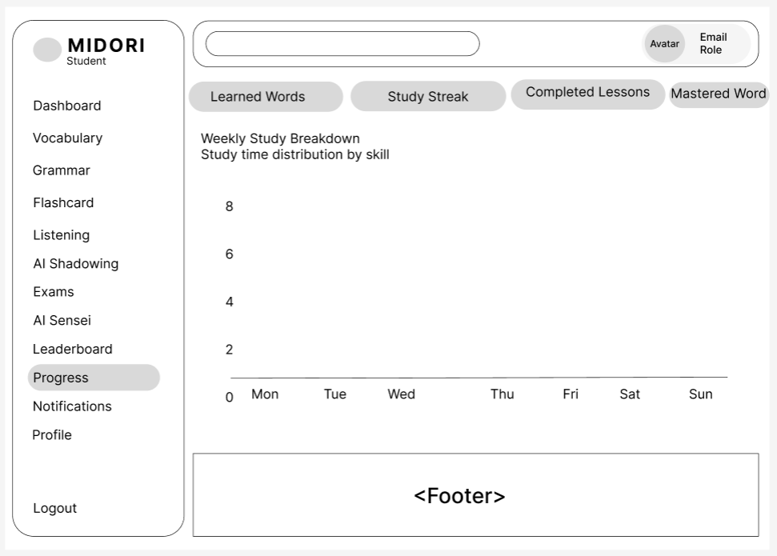
Field Name | Field Type | Description
Progress (Active Menu) | Sidebar Item | Highlights the targeted menu item on the Student left navigation sidebar block array, confirming the active dashboard view layout is centered inside the Progress analytics tracker interface.
Metric Switcher Pills | Tab Control / Button Group | Row of horizontal pill button options containing Learned Words, Study Streak, Completed Lessons, and Mastered Word configurations to dynamically switch dataset properties mapped on the lower visualization area.
Section Header & Subtitle | Label Group | Structural typography block outputting the primary section statement "Weekly Study Breakdown" backed by a descriptive workflow label "Study time distribution by skill".
Analytics Chart Canvas | Chart Component | Central visual analytical grid segment mapping data streams regarding the student's historical workload throughout the active week, supporting structural bar or line plot rendering loops.
Y-Axis Time Metric Labels | Axis Label | Linear scaling parameters placed along the vertical ordinate vector spanning from 0 up to 8 bounds, representing the quantitative hour logs spent inside system modules.
X-Axis Timeline Labels | Axis Label | Sequential temporal interval markers placed along the horizontal abscissa row tracking discrete week intervals including Mon, Tue, Wed, Thu, Fri, Sat, and Sun respectively.

Database Access
Table | CRUD | Description
Student_Daily_Metrics | R | Aggregates and calculates timestamp durations completed across individual week bounds for the authenticated student node to render standard visual coordinate chart matrix items.
Student_Learning_Profiles | R | Fetches historical totals including absolute streak count values and overall vocabulary unit weights to synchronize status totals on corresponding tab control blocks.

SQL Commands:
-- Aggregate accumulated student runtime metrics across skills for active weekly chart plotting loops
SELECT log_date, DAYNAME(log_date) AS day_of_week, SUM(vocabulary_minutes) AS vocab_time, SUM(grammar_minutes) AS grammar_time, SUM(listening_minutes) AS listening_time, SUM(shadowing_minutes) AS shadowing_time FROM Student_Daily_Metrics WHERE student_id = :student_id AND log_date BETWEEN DATE_SUB(CURDATE(), INTERVAL WEEKDAY(CURDATE()) DAY) AND NOW() GROUP BY log_date ORDER BY log_date ASC;

4.8 AI Sensei

- UC-40_AI Sensei

UI Design
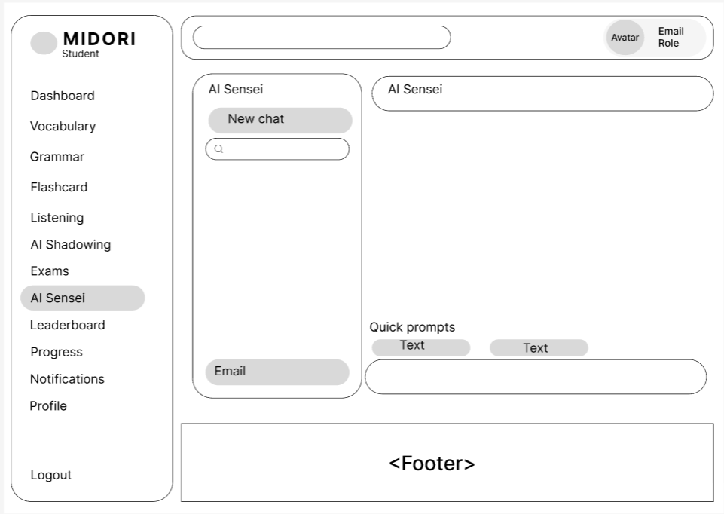

Field Name | Field Type | Description
AI Sensei (Active Menu) | Sidebar Item | Highlights the primary item block layout on the Student left navigation sidebar menu grid, validating that the active application view context is situated inside the AI Sensei chat ecosystem.
New chat | Action Button | Action execution control situated at the top margin of the left chat panel, enabling the student to instantly trigger and instantiate a completely fresh communication thread with the artificial intelligence engine.
Search History Input | Text Input | Integrated text field input asset featuring a magnifying glass icon element Q built to help students query historical conversational session topics via dynamic character string matching.
History Session Email | Text Label | Supplementary layout text string placed inside the lower boundary layer of the session history container panel to render the active student account email configuration parameters.
Chat Window Header | Text Label | Structural header status strip situated at the top margin of the primary interaction dashboard layout, displaying the verbatim title "AI Sensei" to confirm the connected chatbot profile.
Quick prompts Title | Text Label | Context orientation typography segment rendering the literal string "Quick prompts" to categorize and guide user interaction paths toward automated prompt execution items.
Prompt Pill Buttons | Action Button | Array of horizontal pill button containers displaying placeholder template contents ("Text"), capturing click actions to dispatch standardized pre-formatted grammar or lexical prompts directly to the AI model.
Message Input Field | Text Input | Elongated rounded input text canvas located at the bottom framework layer of the workspace layout, enabling the student to construct free-form text inquiries, Japanese dialogue strings, or explanation requests.

Database Access
Table | CRUD | Description
AI_Chat_Sessions | R/C | Scans existing individual student historical chat headers to construct the left panel list layout and creates fresh instance keys when the "New chat" button event handles execution.
AI_Chat_Messages | R/C | Pulls the absolute back-and-forth conversational response array mapped to a chosen session ID and records new dialogue transaction elements whenever user inputs submit.

SQL Commands:
-- Query student historical chat thread parameters filtered by user search criteria strings
SELECT session_id, session_title, created_at FROM AI_Chat_Sessions WHERE student_id = :student_id AND (:search_keyword = '' OR session_title LIKE CONCAT('%', :search_keyword, '%')) ORDER BY updated_at DESC;

-- Insert a granular chat node row capturing fresh user inquiries or AI model responses inside the active thread
INSERT INTO AI_Chat_Messages (session_id, sender_role, message_text, sent_at) VALUES (:session_id, :sender_role, :message_text, NOW());

4.9 View Rankings
This screen allows user to be authenticated to the system screens/functionalities.
Related use cases:
- UC-41 View Ranking

UI Design
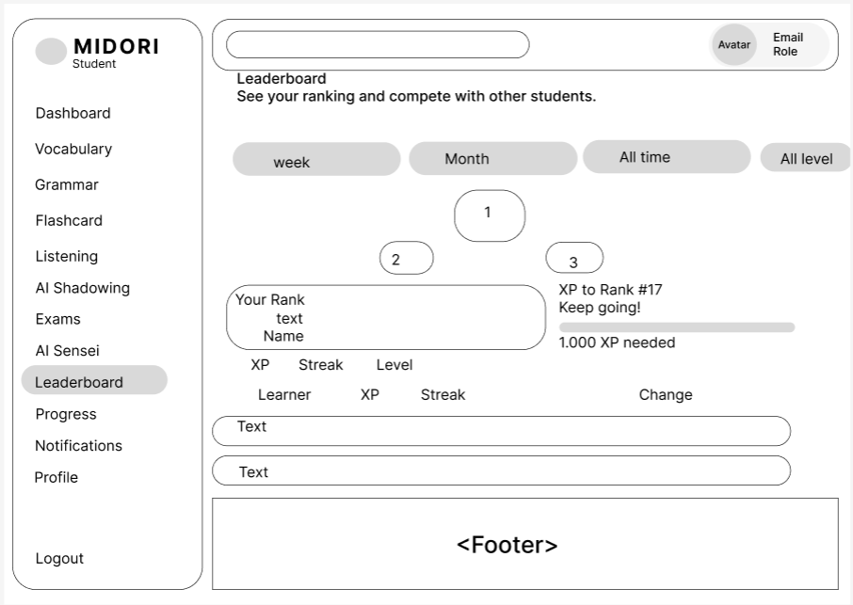
Field Name | Field Type | Description
Leaderboard (Active Menu) | Sidebar Item | Highlights the primary target item on the Student left navigation sidebar grid assembly, validating that the active workflow is centered within the Leaderboard competition workspace.
Section Title & Subtitle | Label Group | Typography block architecture rendering the main functional header text "Leaderboard" backed directly by the contextual descriptive label "See your ranking and compete with other students."
Timeframe Filter Tabs | Tab Control / Pills | Horizontal segmented pill controls including week, Month, and All time configurations built to shift the temporal aggregation window for ranking metrics calculations.
Level Filter Dropdown | Dropdown / Pill | Contextual filtering layout element exhibiting the literal string "All level" configured to restrict dataset rows based on specific standardized JLPT tier metrics.
Top Podium Badges (1, 2, 3) | Graphic Badges | Spatial circular graphical nodes containing indices "1", "2", and "3" arranged vertically to emulate a visual podium layer for the top three leading students.
Your Rank Snapshot Container | Container Block | Bounded container card on the left layout framing personalized student context tracking inputs including "Your Rank", rank node ("text"), account username ("Name"), alongside statistical attributes row indicators (XP, Streak, Level).
Target Progression Section | Widget Content | Informational status column layout on the right displaying structural text prompts "XP to Rank #17", milestone prompt "Keep going!", a linear progression track, and a target gap indicator label ("1.000 XP needed").
Leaderboard Grid Headers | Table Header | Dataset alignment row mapping columns for the main ranking data list view, identifying parameters including Learner, XP, Streak, and Change.
Leaderboard Data Rows | List Row / Card | Elongated rounded list data row panels housing default generic variable blocks ("Text") that extract and present individual user evaluation summaries inside the main scrollable container.

Database Access
Table | CRUD | Description
Student_Profiles | R | Extracts core user reference records including profile name, avatar file directory, and active learning grade parameters to mount snapshot cards and data rows.
Student_Leaderboard_Points | R | Scans, parses, and accumulates aggregate experience points (XP) records and recurring log frequencies across user nodes to construct relational sequence positions.

SQL Commands:
-- Fetch leading student performance logs bounded by temporal filters while initializing dynamic window rank positions
SELECT u.display_name, p.current_level, l.total_xp, l.current_streak, l.rank_change, DENSE_RANK() OVER (ORDER BY l.total_xp DESC) AS system_rank FROM Student_Leaderboard_Points l JOIN Student_Profiles p ON l.student_id = p.student_id JOIN Users u ON p.user_id = u.id WHERE (:timeframe = 'week' AND l.reset_period_start >= DATE_SUB(NOW(), INTERVAL 1 WEEK)) OR (:timeframe = 'Month' AND l.reset_period_start >= DATE_SUB(NOW(), INTERVAL 1 MONTH)) OR (:timeframe = 'All time') ORDER BY system_rank ASC LIMIT 100;

IV. Appendix

1. Assumptions & Dependencies
Assumptions:
● AS-1: Users will have stable internet access to use the Midori Japanese learning platform.
● AS-2: Users have basic knowledge of using web applications to access learning features.
● AS-3: Students, Teachers, and Admins will actively use the system according to their assigned roles.
● AS-4: Learning content and user-provided information will be accurate and reliable.
● AS-5: The development team and stakeholders will provide timely feedback and support during the project.
Dependencies:
● DE-1: The project depends on modern web technologies such as React, TypeScript, Spring Boot, and REST API.
● DE-2: The system relies on a PostgreSQL database hosted on Supabase for storing application data.
● DE-3: The authentication system depends on JWT, Google OAuth 2.0, and email OTP services.
● DE-4: The project depends on third-party services such as Supabase storage and external libraries/frameworks.
● DE-5: Successful implementation depends on cooperation between frontend, backend, testing teams, and stakeholders.

2. Limitations & Exclusions
● LI-1: Mobile Application: The initial release will not include a dedicated mobile application; users can only access the platform through web browsers.
● LI-2: Offline Learning Mode: The system will not support offline learning or downloading lessons for offline use in the initial release.
● LI-3: Advanced AI Features: Advanced AI learning recommendations and personalized learning analysis will not be included in the initial version.
● LI-4: External Learning Platform Integration: The system will not integrate with external Japanese learning platforms or third-party education systems during the initial release.
● LI-5: Real-time Communication: The platform will not provide real-time chat or video communication between students and teachers in the initial release.
● LI-6: Advanced Analytics: Detailed learning analytics and performance prediction features will not be available in the initial version.

3. Business Rules

ID | Category | Rule Definition
BR-01 | Validation | Notify Guests with MSG01 if they don't provide a valid email address.
BR-02 | Validation | Notify Users with MSG02 if they provide an invalid password (more than 8 characters).
BR-03 | Integrity | Notify Guest with MSG03 if the provided email has already been used to register.
BR-04 | Authorization | Notify User with MSG04 if incorrect login credentials are provided, redirect to guest homepage; notify with MSG05 if correct credentials are provided, redirect to user homepage.
BR-05 | Validation | Notify Users with MSG06 if they provide an invalid old password.
BR-06 | Validation | Notify with MSG07 if the email is not registered, notify with MSG08 if it is registered.
BR-07 | Validation | Notify with MSG09 if OTP is incorrect, reload OTP form; if OTP is correct, notify with MSG010 and redirect to reset password.
BR-08 | Validation | Notify User with MSG11 if the re-entered password is incorrect.
BR-09 | Authorization | Role selection form appears for first-time login (Student, Teacher, Admin); does not apply to Admin accounts.
BR-10 | Integrity | If a Gmail account is registered with a password, the same account is accessed when using Gmail login.
BR-11 | Notification | Notify guests with MSG06 if profile update and database save is successful.
BR-12 | Validation | Notify the user with MSG12 if the re-entered password is the same as the old password.
BR-13 | Authorization | Only Admin users can approve or reject pending exams.
BR-14 | Integrity | The system changes the exam status to Approved or Rejected and records the action.
BR-15 | Notification | Notify users with MSG13 if the requested operation cannot be completed.
BR-16 | Authorization | Only Admin users can approve or reject pending flashcard sets.
BR-17 | Integrity | The system changes the flashcard set status to Approved or Rejected after successful validation
BR-18 | Authorization | Only Admin users can approve or reject pending grammar lessons.
BR-19 | Integrity | The system changes the grammar lesson status to Approved or Rejected after successful validation.
BR-20 | Authorization | Only Admin users can lock or unlock user accounts.
BR-21 | Integrity | The system records account lock and unlock actions in the Activity Log.
BR-22 | Authorization | Only Admin users can approve or reject Teacher accounts.
BR-23 | Validation | Notify Admin with MSG69 if the Teacher certificate is missing or invalid.
BR-24 | Integrity | The system records Teacher account approval or rejection actions in the Activity Log.
BR-25 | Authorization | Only Admin users can access Analytics information.
BR-26 | Integrity | The system generates analytics data from user activities stored in the database.
BR-27 | Authorization | Only approved Teacher accounts can create, edit, or delete learning materials.
BR-28 | Validation | Notify Teachers with MSG69 if required Vocabulary information is missing.
BR-29 | Integrity | The system stores Vocabulary information after successful validation.
BR-30 | Validation | Notify Teachers with MSG22 if the selected Vocabulary does not exist.
BR-31 | Validation | Require Teacher confirmation before deleting Vocabulary.
BR-32 | Integrity | The system permanently removes the selected Vocabulary after confirmation.
BR-33 | Validation | Notify Teachers with MSG69 if required Grammar Lesson information is missing.
BR-34 | Integrity | The system stores Grammar Lesson information after successful validation.
BR-35 | Validation | Notify Teachers with MSG22 if the selected Grammar Lesson does not exist.
BR-36 | Integrity | The system permanently removes the selected Grammar Lesson after confirmation.
BR-37 | Validation | Notify Teachers with MSG29 if the uploaded audio file is invalid.
BR-38 | Integrity | The system stores Listening Lesson information after successful validation.
BR-39 | Validation | Notify Teachers with MSG22 if the selected Listening Lesson does not exist.
BR-40 | Integrity | The system permanently removes the selected Listening Lesson after confirmation.
BR-41 | Validation | Notify Teachers with MSG33 if the uploaded PDF file is invalid.
BR-42 | Integrity | The system assigns Pending status to newly created Exams
BR-43 | Validation | Notify Teachers with MSG22 if the selected Exam does not exist.
BR-44 | Integrity | The system permanently removes the selected Exam after confirmation.
BR-45 | Validation | Notify Teachers with MSG37 if the Shadowing transcript is missing or invalid.
BR-46 | Integrity | The system stores Shadowing Lesson information after successful validation.
BR-47 | Validation | Notify Teachers with MSG22 if the selected Shadowing Lesson does not exist.
BR-48 | Integrity | The system permanently removes the selected Shadowing Lesson after confirmation.
BR-49 | Authorization | Only logged-in Students can access learning features.
BR-50 | Integrity | Learning materials must be approved before Students can access them.
BR-51 | Integrity | The system records learning activities and updates learning progress.
BR-52 | Validation | Students can search learning materials using keywords and view matching results.
BR-53 | Integrity | The system records practice history after each learning activity.
BR-54 | Integrity | The system evaluates Student pronunciation and returns a score for Shadowing practice.
BR-55 | Validation | Students can replay lesson audio during Listening and Shadowing practice.
BR-57 | Integrity | The system calculates scores based on evaluation results.
BR-58 | Notification | Notify Students with MSG49 and highlight incorrect words after Dictation evaluation
BR-59 | Validation | Students can adjust audio playback speed during Dictation practice.
BR-60 | Integrity | Exams are evaluated only after Students submit their answers.
BR-61 | Integrity | The system stores Exam scores and Exam history after evaluation.
BR-62 | Integrity | The system generates learning statistics based on learning records and assessment results.
BR-63 | Authorization | Students can access only their own learning records and statistics.
BR-64 | Availability | Notify Students with MSG58 if the AI service is unavailable.
BR-65 | Integrity | The system forwards Student messages to AI Sensei and displays AI responses.
BR-66 | Integrity | The system stores conversation history after each successful AI interaction.
BR-67 | Integrity | The system deletes conversation history when requested by the Student.

4. Application Messages List

# | Message Code | Message Type | Context | Content
1 | MSG01 | In line | Invalid email format when user fills out the email field | Sai định dạng email
2 | MSG02 | In line | Password does not meet the minimum length of 8 characters | Mật khẩu phải 8 kí tự trở lên
3 | MSG03 | Toast message | Email is already used when attempting to register | Email này đã được dùng để đăng kí
4 | MSG04 | Toast message | Login failed due to incorrect credentials | Đăng nhập thất bại
5 | MSG05 | Toast message | Login succeeded with correct credentials | Đăng nhập thành công
6 | MSG06 | Toast message | Password change failed | Đổi mật khẩu thất bại
7 | MSG07 | Toast message | Gmail has not been registered when attempting to retrieve account | Gmail chưa được đăng kí tài khoản
8 | MSG08 | Toast message | OTP sent successfully for account verification | Đã gửi mã OTP thành công
9 | MSG09 | Toast message | OTP verified successfully during account recovery | Xác thực OTP thành công
10 | MSG10 | Toast message | OTP verification failed during account recovery | Xác thực OTP thất bại
11 | MSG11 | In line | Re-entered password does not match the original password | Mật khẩu nhập lại không đúng
12 | MSG12 | In line | The re-entered password is the same as the old password. | Mật khẩu mới trùng với mật khẩu cũ.
13 | MSG13 | Toast message | System operation failed | Thao tác thất bại
14 | MSG22 | Toast message | Selected data does not exist | Không tìm thấy dữ liệu được chọn
15 | MSG29 | In line | Invalid audio file uploaded | Tệp âm thanh không hợp lệ
16 | MSG33 | In line | Invalid PDF file uploaded | Tệp PDF không hợp lệ
17 | MSG37 | In line | Transcript is missing or invalid | Transcript không hợp lệ
18 | MSG49 | Toast message | Dictation evaluation completed | Các từ sai đã được đánh dấu
19 | MSG58 | Toast message | AI service unavailable | Dịch vụ AI hiện không khả dụng
20 | MSG69 | In line | Required information is missing | Vui lòng nhập đầy đủ thông tin bắt buộc

